

Implementing and Administering Certificate Templates in Windows Server 2008
Microsoft Corporation
Published: June 2008
Authors:
David B. Cross
Brian Komar
Jen Field

Contributor:
Shawn Corey
Abstract
This document details the changes in the Windows Server® 2008 version of Active Directory® Certificate Services (AD CS) from Windows Server 2003, as well as best practices for creating and administering certificate templates by using Windows Server 2008 and Windows Server 2003 enterprise certification authorities (CAs).

Copyright Information
This document is provided for informational purposes only and Microsoft makes no warranties, either express or implied, in this document. Information in this document, including URL and other Internet Web site references, is subject to change without notice. The entire risk of the use or the results from the use of this document remains with the user. Unless otherwise noted, the example companies, organizations, products, domain names, e-mail addresses, logos, people, places, and events depicted herein are fictitious, and no association with any real company, organization, product, domain name, e-mail address, logo, person, place, or event is intended or should be inferred. Complying with all applicable copyright laws is the responsibility of the user. Without limiting the rights under copyright, no part of this document may be reproduced, stored in or introduced into a retrieval system, or transmitted in any form or by any means (electronic, mechanical, photocopying, recording, or otherwise), or for any purpose, without the express written permission of Microsoft Corporation.

Microsoft may have patents, patent applications, trademarks, copyrights, or other intellectual property rights covering subject matter in this document. Except as expressly provided in any written license agreement from Microsoft, the furnishing of this document does not give you any license to these patents, trademarks, copyrights, or other intellectual property.

© 2008 Microsoft Corporation. All rights reserved.

Active Directory, Microsoft, Windows, Windows Server, and Windows Vista are trademarks of the Microsoft group of companies.

All other trademarks are property of their respective owners.

Contents
Implementing and Administering Certificate Templates in Windows Server 2008 5
Certificate Templates Overview 5
CA Terminology 6
Templates in Versions of Windows Earlier than Windows Server 2008 7
Windows Server 2008–Based Templates 7
Kerberos Authentication Template 8
OCSP Response Signing Template 9
Default Templates 10
Installing and Upgrading Certificate Templates 17
Installation Requirements 18
Upgrading a CA to Windows Server 2008 18
Upgrading Certificate Templates from Windows Server 2003 to Windows Server 2008 19
Upgrading Certificate Templates from Windows 2000 Server to Windows Server 2003 20
Creating Certificate Templates 21
Design Guidelines 21
Defining the Subject Name 21
Defining the Certificate Lifetime 22
Determining Certificate Usage 22
Determining Whether to Implement Cryptography Next Generation Algorithms 22
Determining Which Cryptographic Service Provider to Implement 23
Determining Key Length 23
Determining Smart Card Usage 23
Planning Deployment Methods 23
Planning Key Archival 23
Creating a New Certificate Template 24
Defining Application and Issuance Policies 25
Acquiring Object Identifiers 25
Establishing Application Policies 25
Establishing Issuance Policies 26
Mapping Issuance Policies Between PKI Hierarchies 26
Deploying Certificate Templates 27
Best Practices for Deploying Certificate Templates 27
Publishing Certificate Templates 28
Permission Design 29
Autoenrollment Considerations 30
Configuring Permissions for a Certificate Template 31
Publishing a Certificate Template 32
Removing a Certificate Template from a CA 32
Administering Certificate Templates 33
Configuring Certificate Templates 33
General Tab 33
Request Handling Tab 35
Version 2 Templates 35
Certificate Purpose 36
Archive Settings 37
Windows Server 2008 39
Cryptography Tab 41
Subject Name Tab 42
The Issuance Requirements Tab 44
Superseded Templates Tab 47
Extensions Tab 48
Application Policies 49
Certificate Policies 50
Certificate Template Information 51
Key Usage 51
Security Tab 52
Delegating Template Management 53
Modify Existing Templates 54
Create New Templates 54
Full Delegation 54
Allowing the Creation and Modification of any Certificate Template 55
Replace an Existing Certificate Template with a New Certificate Template 56
Re-enroll Certificate Holders 56
Certificate Templates Appendixes 56
Wireless Certificates 56
Certificate Templates Schema 57
Version 1 Certificate Template Attributes 57
Versions 2 and 3 Certificate Template Attributes 58
Flags 59
References 62

Implementing and Administering Certificate Templates in Windows Server 2008
Certificate templates can greatly simplify the task of administering a certification authority (CA) by allowing an administrator to identify, modify, and issue certificates that have been preconfigured for selected tasks.
This document includes concepts, procedures, and best practices for designing, administering, and implementing certificate templates by using enterprise CAs on computers running the Windows Server® 2008 Enterprise, Windows Server® 2008 Datacenter, Windows Server 2003 Enterprise Edition, or Windows Server 2003 Datacenter Edition operating system. Also included are new features introduced in certificate templates in Windows Server 2008.
• Certificate Templates Overview
• Installing and Upgrading Certificate Templates
• Creating Certificate Templates
• Deploying Certificate Templates
• Administering Certificate Templates
• Certificate Templates Appendixes

Certificate Templates Overview
Enterprise certification authorities (CAs) use certificate templates to define the format and content of certificates, to specify which users and computers can enroll for which types of certificates, and to define the enrollment process, such as autoenrollment, enrollment only with authorized signatures, and manual enrollment. Associated with each certificate template is a discretionary access control list (DACL) that defines which security principals have permissions to read and configure the template, as well as to enroll or autoenroll for certificates based on the template. The certificate templates and their permissions are defined in Active Directory® Domain Services (AD DS) and are valid within the forest. If more than one enterprise CA is running in the Active Directory forest, permission changes will affect all enterprise CAs.
Note
When a certificate template is defined, the definition of the certificate template must be available to all CAs in the forest. This is accomplished by storing the certificate template information in the Configuration naming context (CN=Configuration,DC=ForestRootName). The replication of this information depends on the Active Directory replication schedule, and the certificate template may not be available to all CAs until replication is completed. The storage and replication are accomplished automatically.

CA Terminology
The following terms and acronyms are used throughout this document.
Authority information access. A certificate extension that contains URLs where the issuing CA certificate can be retrieved. The authority information access extension can contain Hypertext Transfer Protocol (HTTP), File Transfer Protocol (FTP), Lightweight Directory Access Protocol (LDAP), or FILE URLs.
Certificate revocation list (CRL). A digitally signed list issued by a CA that contains certificates that have been revoked. The list includes the serial number of the certificate, the date that the certificate was revoked, and the revocation reason. Applications can perform CRL checking to determine a presented certificate's revocation status. CRLs can also be referred to as base CRLs to differentiate them from delta CRLs.
Certificate template. A preconfigured list of certificate settings that allows users and computers to enroll for certificates without having to create complex certificate requests.
• Version 2 certificate templates are customizable certificate templates that are supported with Windows Server® 2008 Enterprise–based CAs or Windows Server 2003 Enterprise Edition–based CAs. Version 2 certificate templates enable advanced CA features such as key archival and recovery and certificate autoenrollment.
• In order to use version 2 templates, Active Directory must be upgraded to support Windows Server 2008 or Windows Server 2003 schema changes.
• Standard editions of Windows Server 2008 and Windows Server 2003 support only version 1 certificate templates, which are not customizable and do not support key archival or autoenrollment.
• Version 3 certificate templates are new in Windows Server 2008. Version 3 certificate templates function similarly to version 2 templates, and they support new Active Directory Certificate Services (AD CS) features available in Windows Server 2008. These features include Cryptography Next Generation (CNG), which introduces support for Suite B cryptographic algorithms such as elliptic curve cryptography (ECC).
CRL distribution point. A certificate extension that indicates where the CRL for a CA can be retrieved. This extension can contain multiple HTTP, FTP, FILE, or LDAP URLs for the retrieval of the CRL.
Delta CRL. A type of CRL that contains the list of certificates revoked since the last base CRL was published. Delta CRLs are often used in environments where numerous certificates are revoked to optimize bandwidth use.
Enterprise CA. Enterprise CAs are integrated with AD DS. They publish certificates and CRLs to AD DS, use information stored in AD DS such as user accounts and security groups to approve or deny certificate requests, and use certificate templates stored in AD DS to generate a certificate with the appropriate attributes.
Online Certificate Status Protocol (OCSP). A protocol that allows high-performance validation of certificate status. Windows Server 2008 introduces an online revocation provider (Online Responder) as an optional role service within AD CS.
Public key infrastructure (PKI). A PKI consists of CAs that issue digital certificates, directories that store certificates and policies (including AD DS), resources that provide revocation and validation information for certificates, and the X.509 certificates that are issued to security entities on the network.
Security principal. A user, security group, or computer account that can be assigned permissions in a DACL.
Stand-alone CA. Stand-alone CAs do not require AD DS and do not use certificate templates.

Templates in Versions of Windows Earlier than Windows Server 2008
A number of predefined certificate templates were first introduced in Microsoft Windows® 2000, but attributes of those version 1 certificate templates could not be modified, except the permissions specified in the DACL. This was done through the advanced view of the Active Directory Sites and Services snap-in and allowed administrators to specify which users and groups could read, update, and enroll for certificates that use the templates.
With Windows Server 2003, the introduction of version 2 certificate templates meant that more customization was possible, and management was done through the Certificate Templates snap-in rather than through the Active Directory Sites and Services snap-in.
With Windows Server 2003–based CAs, the Certificate Templates snap-in allowed you to define specific attributes for certificates that meet your organization's business needs. For example, you could:
• Define whether the private key associated with a certificate can be exported.
• Define whether the certificate request must be approved by a certificate manager, and define how many managers must approve a request before the certificate is issued.
• Define which cryptographic service providers (CSPs) are supported by a certificate template.
• Define issuance and application policy for issued certificates.

Windows Server 2008–Based Templates
Windows Server 2008 introduced version 3 certificate templates. These certificate templates have been updated to support new features available in the Windows Server 2008–based CA, including CNG, which introduces support for Suite B cryptographic algorithms such as ECC. For more information about CNG in Windows Server 2008, see Active Directory Certificate Services (http://go.microsoft.com/fwlink/?LinkID=85613).
CNG encryption and hash algorithms can be specified for:
• Certificate requests
• Issued certificates
• Protection of private keys for key exchange and key archival scenarios
Administrators can configure support for these new certificate template features using the template properties options in the Certificate Templates snap-in in Windows Server 2008.
AD CS includes two new certificate templates: Kerberos Authentication (delivered as a version 2 template) and OCSP Response Signing (delivered as a version 3 template). These templates are installed in AD DS when the first Windows Server 2008–based CA is installed, or the first time the Certificate Templates snap-in is opened from Windows Server 2008, after an upgrade to a Windows Server 2008–based CA.

Kerberos Authentication Template
The purpose of the Kerberos Authentication template is to issue certificates to domain controllers, which present the certificates to client computers during user and computer network authentication. Certificates issued via this new template contain two specific attributes. Rather than relying on the DNS name of the computer, applications can verify the following:
• The enhanced key usage extension of the certificate contains Key Distribution Center (KDC) authentication.
• The domain name is in the subject alternative name extension of the certificate.
By the authority of the issuing CA, these attributes prove that the computer presenting the certificate is a domain controller for the domain contained in the subject alternative name. This new template is recommended for domain controllers running Windows Server 2008. For domain controllers running Windows Server 2003, the Domain Controller Authentication template or the Kerberos Authentication template can be used.
Notes
• If a domain controller running Windows Server 2003 with Service Pack 1 (SP1) or Windows Server 2003 R2 obtains a certificate based on the Kerberos Authentication template, the following error might appear on the domain controller.
• Automatic certificate enrollment for local system detected the DNS name in the Kerberos Authentication certificate does not match the DNS name of the local computer. A new enrollment for one Kerberos Authentication certificate will be performed in 24 hours.
• This is a known issue. It occurs because the autoenrollment client computer running Windows Server 2003 compares the local computer's DNS name to the contents of the certificate subject alternative name.
Client computers running Windows Vista or Windows Server 2008 can be configured to check for the new enhanced key usage entry by enabling strong KDC validation on the following registry entry:
HKLM\SYSTEM\CurrentControlSet\Control\Lsa\Kerberos\Parameters\kdcvalidation
The default value of 0 disables strong KDC validation. To enable strong KDC validation, set this DWORD value to 2.
The following table shows which certificate template can be used for CAs running different versions of Windows, based on which version of Windows the domain controller is running.

Domain controller | Windows 2000 Server–based CA (version 1 only) | Windows Server 2003–based CA | Windows Server 2008–based CA
Windows 2000 Server  (enroll for version 1 templates only) | Domain Controller | Domain Controller | Domain Controller
Windows Server 2003 | Domain Controller | Domain Controller  or  Domain Controller Authentication  Directory E-mail Replication | Kerberos Authentication or Domain Controller Authentication  Directory E-mail Replication
Windows Server 2008 | Domain Controller | Domain Controller  or  Domain Controller Authentication  Directory E-mail Replication | Kerberos Authentication  Directory E-mail Replication

Note
If the CA administrator has not manually assigned the Domain Controller Authentication and Directory E-mail Replication certificate templates to a Windows Server 2003–based CA or a Windows Server 2008–based CA, domain controllers running Windows Server 2003 still use the default Domain Controller certificate template. If a Windows Server 2008–based CA is available and configured to issue the Kerberos Authentication template, a domain controller running Windows Server 2003 or Windows Server 2008 will enroll for a Kerberos Authentication certificate, even if it already has a Domain Controller Authentication certificate.
The Kerberos Authentication certificate template is fully backward-compatible with the previous domain controller templates; for example, when the domain controller has a Kerberos Authentication certificate, smart card logon can be performed even with a client computer running Windows 2000 Professional.

OCSP Response Signing Template
The second new template introduced in Windows Server 2008 is the OCSP Response Signing template. An Online Responder based on the OCSP standard is an optional component in Windows Server 2008. This template issues certificates for computers running an Online Responder, enabling the Online Responder to provide signed responses to client computers requesting revocation information on certificates issued by the same CA that signed the OCSP signing certificate. The characteristics of OCSP signing certificates are:
• The "OCSP Signing" entry exists in the enhanced key usage extension.
• Revocation is not selected (no authority information access or CRL distribution point extensions).
• By default, the validity period is two weeks.
• The Network Service account on the computer to which the OCSP signing certificate is issued will be granted Read permission on the private key by default. This allows the OCSP service to use the private key.
For more information about the Online Responder and OCSP in Windows Server 2008, see Installing, Configuring, and Troubleshooting the Online Responder (Microsoft's OCSP Responder) (http://go.microsoft.com/fwlink/?LinkId=101269).

Default Templates
When a Windows Server 2008–based CA is installed, a set of default certificate templates is assigned to the CA so that the CA is immediately able to issue certificates for those templates.
Note
This behavior can be changed by setting the LoadDefaultTemplates=0 parameter in the CAPolicy.inf file prior to CA installation.
The list of which default templates are assigned has been updated in Windows Server 2008. The following table shows the default templates in Windows Server 2008 and Windows Server 2003.

Template name | Windows Server 2003 | Windows Server 2008
Administrator | X | X
Basic EFS | X | X
Computer | X | X
Directory E-mail Replication |  | X
Domain Controller | X | X
Domain Controller Authentication | X
EFS Recovery Agent | X | X
Kerberos Authentication |  | X
Subordinate Certification Authority | X | X
User | X | X
Web Server | X | X

In AD CS, the following preconfigured certificate templates are listed in the Certificate Templates snap-in.
Note
The Kerberos Authentication and OCSP Response Signing templates are new in Windows Server 2008 and were not installed by default with Windows Server 2003 enterprise CAs.
Default templates in Windows Server 2008

Name | Description | Key usage | Subject type | Applications used for enhanced key usage | Application policies or enhanced key usage
Administrator | Allows trust list signing and user authentication | Signature and encryption | User | Microsoft trust list signing  Encrypting File System (EFS)  Secure e-mail  Client authentication | 4.1
Authenticated Session | Allows subjects to authenticate to a Web server | Signature | User | Client authentication | 3.1
Basic EFS | Used by EFS to encrypt data | Encryption | User | EFS | 3.1
CA Exchange | Used to protect private keys as they are sent to the CA for private key archival | Encryption | Computer | Private key archival | 106.0
CEP Encryption | Allows the holder to act as a registration authority for Simple Certificate Enrollment Protocol (SCEP) requests; used by the Network Device Enrollment Service for its key exchange certificate | Encryption | Computer | Certificate request agent | 4.1
Code Signing | Used to digitally sign software | Signature | User | Code signing | 3.1
Computer | Allows a computer to authenticate itself on the network | Signature and encryption | Computer | Client authentication  Server authentication | 5.1
Cross-Certification Authority | Used for cross-certification and qualified subordination | Signature  Certificate signing  CRL signing | Cross-certified CA |  | 105.0
Directory E-mail Replication | Used to replicate e-mail within AD DS | Signature and encryption | Directory e-mail replication | Directory service e-mail replication | 115.0
Domain Controller | Used by domain controllers as all-purpose certificates and is superseded by two separate templates: Domain Controller Authentication and Directory E-mail Replication | Signature and encryption | Directory e-mail replication | Client authentication  Server authentication | 4.1
Domain Controller Authentication | Used to authenticate Active Directory computers and users | Signature and encryption | Computer | Client authentication  Server authentication  Smart card logon | 110.0
EFS Recovery Agent | Allows the subject to decrypt files that are encrypted with EFS | Encryption | User | File recovery | 6.1
Enrollment Agent | Used to request certificates on behalf of another user | Signature | User | Certificate request agent | 4.1
Enrollment Agent (Computer) | Used to request certificates on behalf of another computer | Signature | Computer | Certificate request agent | 5.1
Exchange Enrollment Agent (Offline request) | Used to request certificates on behalf of another user and supply the user name in the request; used by the Network Device Enrollment Service for its enrollment agent certificate | Signature | User | Certificate request agent | 4.1
Exchange Signature Only | Used by the Microsoft Exchange Key Management service to issue certificates to Exchange users for digitally signing e-mail | Signature | User | Secure e-mail | 6.1
Exchange User | Used by the Microsoft Exchange Key Management service to issue certificates to Exchange users for encrypting e-mail | Encryption | User | Secure e-mail | 7.1
IPSec | Used by IP security (IPsec) to digitally sign, encrypt, and decrypt network communication | Signature and encryption | Computer | IPsec Internet Key Exchange (IKE) intermediate | 8.1
IPSec (Offline request) | Used by IPsec to digitally sign, encrypt, and decrypt network communication when the subject name is supplied in the request  The Network Device Enrollment Service in Windows Server 2008 uses this template by default for device certificates | Signature and encryption | Computer | IPSec IKE intermediate | 7.1
Kerberos Authentication | New in Windows Server 2008, this template is similar to the Domain Controller Authentication template and offers enhanced security capabilities for Windows Server 2008 domain controllers authenticating Active Directory users and computers | Signature and encryption | Computer | Client authentication  Server authentication  Smart card logon  KDC authentication | 110.0
Key Recovery Agent (KRA) | Recovers private keys that are archived on the CA; for more information, see Key archival and recovery (http://go.microsoft.com/fwlink/?LinkID=89551). | Encryption | Key recovery agent | Key recovery agent | 105.0
OCSP Response Signing | New in Windows Server 2008, this template issues certificates used by the OCSP service provider to sign OCSP responses; by default, these certificates contain a special OCSP no revocation checking extension and no authority information access or CRL distribution point extensions | Signature | Computer | OCSP signing | 101.0
Remote Access Service (RAS) and Internet Authentication Service (IAS) Server | Enables RAS and IAS servers to authenticate their identity to other computers | Signature and encryption | Computer | Client authentication  Server authentication | 101.0
Root CA | Used to prove the identity of the root CA | Signature  Certificate signing  CRL signing | CA |  | 5.1
Router (Offline request) | Used by a router when requested through SCEP from a CA that holds a CEP Encryption certificate | Signature and encryption | Computer | Client authentication | 4.1
Smart Card Logon | Allows the holder to authenticate its identity by using a smart card | Signature and encryption | User | Client authentication  Smart card logon | 6.1
Smart Card User | Allows the holder to authenticate its identity and protect e-mail by using a smart card | Signature and encryption | User | Secure e-mail  Client authentication  Smart card logon | 11.1
Subordinate CA | Used to prove the identity of the subordinate CA; it is issued by the parent or root CA | Signature  Certificate signing  CRL signing | CA |  | 5.1
Trust List Signing | Allows the holder to digitally sign a trust list | Signature | User | Microsoft trust list signing | 3.1
User | Used by users for e-mail, EFS, and client authentication | Signature and encryption | User | EFS  Secure e-mail  Key usage | 3.1
User Signature Only | Allows users to digitally sign data | Signature | User | Secure e-mail  Client authentication | 4.1
Web Server | Proves the identity of a Web server | Signature and encryption | Computer | Server authentication | 4.1
Workstation Authentication | Enables client computers to authenticate their identity to servers | Signature and encryption | Computer | Client authentication | 101.0

Installing and Upgrading Certificate Templates
Recall that when you install an enterprise certification authority (CA), you must be logged on as a user who is a member of the Enterprise Admins group. This is because certificate templates, along with other required public key infrastructure (PKI) elements, are installed in Active Directory® Domain Services (AD DS) in the Configuration naming context. The following figure shows the specific containers installed in AD DS.
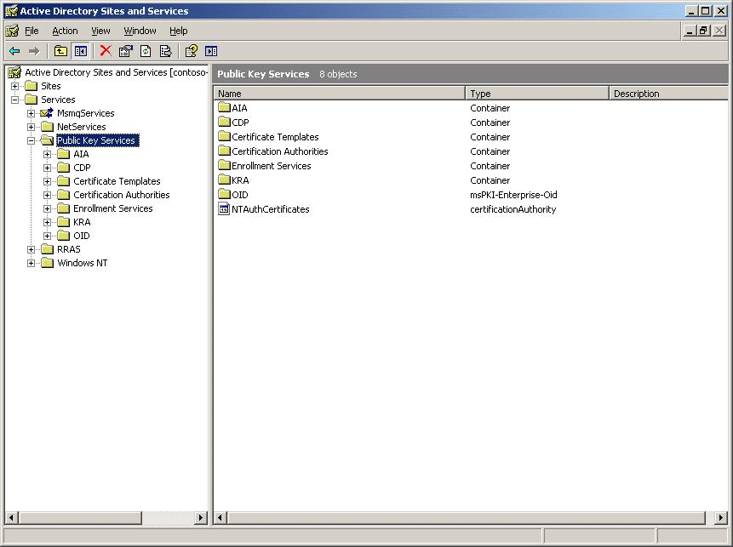

Certificate templates are installed in AD DS when an enterprise CA is installed, and any required additions or changes to templates are performed when an enterprise CA is upgraded or when the first CA of a new Windows version is installed in a forest that contains templates.

Installation Requirements
CAs support certificate templates as follows:
• CAs installed on computers running Windows Server® 2008 Enterprise and Windows Server 2008 Datacenter support version 1, version 2, and version 3 templates.
• CAs installed on computers running Windows Server 2003 Enterprise Edition and Windows Server 2003 Datacenter Edition support version 1 and version 2 templates.
• CAs installed on computers running Windows Server 2008 Standard and Windows Server 2003 Standard Edition support only version 1 templates.
• Certificates based on version 2 or version 3 templates can only be issued by an enterprise CA and require an Active Directory environment based on Windows Server 2003 or higher.
• A Microsoft Windows® 2000 Server domain must be upgraded to the Windows Server 2003 schema to support certain features of the enterprise CA, including version 2 or later certificate templates, delta CRLs, and key archival and recovery. A Windows Server 2008–based CA or a Windows Server 2003–based CA installed with a Windows 2000 Server–based schema can use only version 1 certificate templates and will lack the other advanced features described previously. For more information about version 1, version 2, and version 3 certificate templates, see Certificate Templates Overview.

Upgrading a CA to Windows Server 2008
For comprehensive information about upgrading a Certificate Services infrastructure, see the Active Directory Certificate Services Upgrade and Migration Guide (http://go.microsoft.com/fwlink/?LinkId=116454). This guide provides an overview of the upgrade requirements and illustrates the considerations and specific steps for certificate templates.
The following table illustrates the supported upgrade paths for CAs from earlier versions of Windows to Windows Server 2008. The table applies to both 32-bit versions and 64-bit versions. Upgrades from 32-bit versions to 64-bit versions are not supported.

Windows version | Upgrade to Windows Server 2008
Windows 2000 Server | No; not supported
Windows Server 2003 Standard Edition with Service Pack 1 (SP1), Windows Server 2003 Standard Edition with Service Pack 2 (SP2), or Windows Server 2003 R2 Standard Edition | Standard and Enterprise Editions
Windows Server 2003 Enterprise Edition with SP1, Windows Server 2003 Enterprise Edition with SP2, or Windows Server 2003 R2 Enterprise Edition | Enterprise Edition
Windows Server 2003 Datacenter Edition | Datacenter Edition
The 64-bit versions of Windows Server 2003 | No; not supported

Upgrading Certificate Templates from Windows Server 2003 to Windows Server 2008
Windows Server 2008 includes two new Active Directory templates: Kerberos Authentication and OCSP Response Signing. For more information about these templates, see Certificate Templates Overview.
When you install a new Windows Server 2008–based CA in a forest that already contains an enterprise CA of an earlier Windows version, the installation of new Active Directory objects is performed as part of the CA installation process. However, when upgrading an existing Windows Server 2003–based CA to Windows Server 2008, the installation of new Active Directory templates must be performed as a separate step, after the CA upgrade.
To upgrade Active Directory templates after upgrading a CA to Windows Server 2008
1. Log on to a computer running Windows Server 2008 with a user account that is a member of the Enterprise Admins group.
2. Open the Certificate Templates snap-in (certtmpl.msc).
3. When prompted to write new certificate templates, click OK.
The user performing these updates should be a member of the Enterprise Admins group to have full control of the following Active Directory objects and containers:
• CN=Certificate Templates,CN=Public Key Services,CN=Services,CN=Configuration,DC=ForestRootDomain container
• Certificate template objects in the CN=Certificate Templates,CN=Public Key Services,CN=Services,CN=Configuration,DC=ForestRootDomain container
• Container objects within the CN=OID,CN=Public Key Services,CN=Services,CN=Configuration,DC=ForestRootDomain container
Note
Permissions on these containers are not inherited from permissions on higher-level containers; for example, the access control list (ACL) on certificate template objects is not inherited from the container.
To verify that the upgrade to Windows Server 2008 was successful
1. Open the Certificate Templates snap-in.
2. Confirm that there are two new certificate templates: Kerberos Authentication and OCSP Response Signing.

Upgrading Certificate Templates from Windows 2000 Server to Windows Server 2003
When you install a Windows Server 2003–based CA into an Active Directory domain with a Windows Server 2003 schema, the current certificate templates are updated during the installation or upgrade process. The update modifies default settings for the Windows 2000 Server version 1 certificate templates. When installing a Windows Server 2003 Enterprise Edition–based CA, version 2 certificate templates are also installed.
The upgrade process of an enterprise CA must be performed by an administrator who is a member of the forest root Domain Admins group and the Enterprise Admins group. This is because the upgrade makes modifications to the Configuration naming context in Active Directory. Specifically, the administrator performing the upgrade must have the following permissions through group memberships (these are the default permissions):
• Full Control permissions on the following container: CN=Certificate Templates,CN=Public Key Services,CN=Services,CN=Configuration,DC=ForestRootDomain
• Full Control permissions on the following container: CN=OID,CN=Public Key Services,CN=Services,CN=Configuration,DC=ForestRootDomain
• Full Control permissions for each certificate template object in the following container: CN=Certificate Templates,CN=Public Key Services,CN=Services,CN=Configuration,DC=ForestRootDomain
Note
Delegation over the Certificate Templates container will have no effect on individual certificate templates. In other words, the ACL on certificate templates is not inherited from the ACL on the container.
Perform the following procedure after the upgrade for a CA to Windows Server 2003 or the installation of a new Windows Server 2003–based CA on the network.
To upgrade certificate templates after upgrading a CA to Windows Server 2003
1. Upgrade Active Directory to the Windows Server 2003 schema.
Important
After the Active Directory schema has been upgraded to Windows Server 2003, the schema will also be able to support any Windows Server 2008 AD CS features, including version 3 certificate templates.
2. Log on to a Windows Server 2003 Enterprise Edition-based CA as a member of the forest root Domain Admins group and the Enterprise Admins group.
3. Open the Certificate Templates snap-in.
Note
Alternatively, the Certificate Templates snap-in can be run from a Windows XP Professional–based computer with the Windows Server 2003 Administration Pack (Adminpak.msi) installed. The same permissions apply as noted previously.
4. When prompted to write new certificate templates, click OK.
To verify that the upgrade to Windows Server 2003 was successful
1. Open the Certificate Templates snap-in.
2. Confirm that there are 29 certificate templates. The version numbers of templates should all exist and be in the format of xxx.x; for example, 100.2. Version 1 certificate templates use a single digit for the primary version number. The Administrator certificate template version number is 3.1. Primary version numbers for version 2 certificate templates are three digits in length. For example, the version number for the Key Recovery certificate template is 105.0.
Note
An upgrade of the certificate templates is performed if a new Windows Server 2003–based CA is installed in the forest. If a Windows 2000 Server–based CA is upgraded to Windows Server 2003, the template upgrade is not performed automatically and will only be performed when the Certificate Templates snap-in is opened for the first time. You can still verify that the update has taken place, but the process is performed automatically.

Creating Certificate Templates
This topic includes design guidelines for creating certificate templates and the procedures for creating a new certificate template.

Design Guidelines
When you are creating a version 2 or 3 certificate template, consider the following design guidelines.

Defining the Subject Name
The holder of the private key associated with a certificate is known as the subject. This can be a user, a computer, a program, or virtually any object or service. Because the subject can vary greatly depending on who or what it is, you need some flexibility when providing the subject name in the certificate request. A Windows Server® 2008–based certification authority (CA) or a Windows Server 2003–based CA can either obtain the subject name automatically or request it from the subject. If the CA automatically provides the subject name, it obtains the information from Active Directory® Domain Services (AD DS). You can configure this process to include or exclude information that is useful in the environment. If it is configured to manually provide the subject name, the subject supplies that information in the certificate request by using the Web-based enrollment pages.

Defining the Certificate Lifetime
Certificate-based cryptography uses public key cryptography to protect and digitally sign data. Over time, it is theoretically possible to collect data protected with the public key and attempt to derive the private key from it. Given enough time and resources, this private key could be compromised, effectively rendering all protected data unprotected. Because certificates can be compromised over time, a finite certificate lifetime should be established.

Determining Certificate Usage
It is possible to issue many specific certificates that can only be used for a single purpose or to issue fewer certificates that have broad usage. This decision depends on the environment, the level of administration desired, and the possible effects on the subjects, as well as the effects of multiple certificates on applications that will use them.
One strategy of certificate administration is to create a number of specific templates—one for each function, such as file encryption or code signing. Subjects can then enroll for each certificate as needed for the appropriate function. This allows subjects to start with few certificates and obtain only new certificates that they need over time. The drawback to this strategy is that the subject may accumulate a large number of certificates and private keys that become more difficult to manage over time.
Alternatively, you could create a few broad certificate templates that encompass functions for the most common groups of subjects. For example, if most employees use their certificates for e-mail signing and encryption as well as file encryption, you can create one template that allows all these functions in the same certificate. This allows most subjects to obtain a single, all-purpose certificate. The drawback to this strategy is that there is no detailed control of the usage of the certificates. The administrator cannot decide that subgroups cannot encrypt e-mail without modifying the template or changing the strategy.

Determining Whether to Implement Cryptography Next Generation Algorithms
For Windows Server 2008–based version 3 certificate templates, the option exists to configure advanced cryptographic algorithms such as elliptic curve cryptography (ECC). Before configuring these settings, ensure that the operating systems and applications deployed in your environment can support these cryptographic algorithms.

Determining Which Cryptographic Service Provider to Implement
A version 2 certificate template allows you to define one or more cryptographic service providers (CSPs) as usable by a template. This allows the administrator to control the types of cryptography that subjects can use within an enterprise. This is useful when security is most important. Because subjects use the CSP for both portions of any cryptographic service—either encryption and decryption or signing and confirming signatures—it is necessary to ensure that all subjects can use the same CSP. The easiest way to do this is to configure each certificate template to identify one CSP. The administrator should determine the CSP to use for each template, depending on the level of security required, the intended purposes of the certificate, and the presence of security hardware, such as smart cards.

Determining Key Length
Each Cryptography Next Generation (CNG) algorithm provides choices for key length, and each CryptoAPI CSP provides one or more cryptographic algorithms for encryption or digital signature. You can define a minimum key size allowed for a certificate template. In general, larger keys provide more protection than shorter keys for the same algorithm, but larger keys take longer to generate and use. You should select a minimum key size that ensures the necessary amount of protection without affecting performance.

Determining Smart Card Usage
Each type of smart card has at least one associated CSP that must be implemented by the certificate template to allow the smart card to be used. If the correct smart card CSP is not associated with the template, the smart card will not be recognized and the template will fail. Ensure that you enable all smart card CSPs for the smart cards deployed in your environment within the certificate template.

Planning Deployment Methods
Certificates are deployed either manually or automatically. Manual enrollment can take place by using either the Web enrollment pages, the Certificates snap-in, or through CryptoAPI or CNG programming interfaces. Automatic enrollment requires the configuration described in the "Autoenrollment Considerations" section of Deploying Certificate Templates. In addition, there is a Network Device Enrollment Service component that can enroll certificates on behalf of devices such as routers by using the Simple Certificate Enrollment Protocol (SCEP). This component is included as a role service in Windows Server 2008.

Planning Key Archival
CAs installed on computers running Windows Server 2008 Enterprise, Windows Server 2008 Datacenter, Windows Server 2003 Enterprise Edition, or Windows Server 2003 Datacenter Edition can provide key archival of private keys. When planning key archival settings for a certificate template, consider the following settings:
• Enable archival of the subject's private key
This setting is only available when the issuing CA is installed on a computer running Windows Server 2008 Enterprise, Windows Server 2008 Datacenter, Windows Server 2003 Enterprise Edition, or Windows Server 2003 Datacenter Edition, and the CA is configured for key archival.
• Define whether the private key can be exported
If this setting is enabled, the subject can export the private key for backup or move the private key and certificate to another computer. If key archival is centralized, you may not want to enable this setting because it allows the key to be recovered in a decentralized manner.

Creating a New Certificate Template
You can create a new certificate template by duplicating an existing template and using the existing template's properties as the default for the new template. Different applications and types of CAs support different certificate templates. For example, some certificate templates can be issued and managed only by enterprise CAs on servers running Windows Server 2003, and some may require that the CA server be running Windows Server 2008. Review the list of default certificate templates in Certificate Templates Overview, and examine their properties to identify the existing certificate template that most closely meets your needs. This will minimize the amount of configuration work that you need to do.
Note
To perform any of the tasks associated with creating a certificate template, you must be logged on as a member of the Enterprise Admins group, a member of the forest root domain's Domain Admins group, or as a user who has been granted permission to perform the task.
Note
For detailed explanations of the entries on each tab in the template, see Administering Certificate Templates.
To create a new version 2 or 3 certificate template
1. Open the Certificate Templates snap-in.
2. In the details pane, right-click an existing certificate that will serve as the starting point for the new certificate, and then click Duplicate Template.
3. Choose whether to duplicate the template as a Windows Server 2003–based template or a Windows Server 2008–based template.
4. On the General tab, enter the Template display name and the Template name, and then click OK.
5. Define any additional attributes for the newly created certificate template.

Defining Application and Issuance Policies
When you create a new certificate template, you can define which application and issuance policies are included in the issued certificates. Defining application and issuance policies requires the completion of three tasks:
• Acquire object identifiers for the application and issuance policies.
• Establish the application and issuance policies.
• Map issuance policies between public key infrastructure (PKI) hierarchies.

Acquiring Object Identifiers
If you define a custom application policy or issuance policy, you must obtain an object identifier for the policy.
To acquire an object identifier
1. Open the Certificate Templates snap-in.
2. In the details pane, right-click the certificate template you want to modify, and then click Properties.
3. On the Extensions tab, click Application Policies, and then click Edit.
4. In the Edit Application Policies Extension dialog box, click Add.
5. In Add Application Policy, ensure that the application you are creating does not exist, and then click New.
6. In the New Application Policy dialog box, provide the name for the new application policy, note the generated object identifier, and then click OK.
Note
You can also add new object identifiers by editing certificate policies rather than application policies.

Establishing Application Policies
Once you have defined any custom application policies, you can then associate the application policy with the certificate template.
To associate the application policy with the certificate template
1. Open the Certificate Templates snap-in.
2. In the details pane, right-click the certificate template you want to change, and then click Properties.
3. On the Extensions tab, click Application Policies, and then click Edit.
4. In Edit Application Policies Extension, click Add.
5. In Add Application Policy, click the desired application policy, and then click OK.

Establishing Issuance Policies
Once you have defined any custom issuance policies, you can then associate the issuance policy with the certificate template.
To associate the issuance policy with the certificate template
1. Open the Certificate Templates snap-in.
2. In the details pane, right-click the certificate template you want to change, and then click Properties.
3. On the Extensions tab, click Certificate Policies, and then click Edit.
4. In Edit Issuance Policies Extension, click Add.
5. In the Add Issuance Policy dialog box, click New.
6. Provide the requested information.

Mapping Issuance Policies Between PKI Hierarchies
When performing qualified subordination, it may be necessary to associate issuance policies in your organization with issuance policies defined in another organization. The policy mappings are defined in the Policy.inf file used to generate the cross-certified CA certificate.
In the Policy.inf file, you must include the policy mapping extension that maps the policies listed in the Policy.inf file with policies defined in the other PKI hierarchy. The following code example shows a section of a Policy.inf file that maps issuance policies for high, medium, and low assurance between two organizations.
[PolicyStatementExtension]
Policies = HighAssurancePolicy, MediumAssurancePolicy, LowAssurancePolicy
CRITICAL = FALSE
[HighAssurancePolicy]
OID = 1.3.6.1.4.1.311.21.8.256.257.258.259.1.402
[MediumAssurancePolicy]
OID = 1.3.6.1.4.1.311.21.8.256.257.258.259.1.401
[LowAssurancePolicy]
OID = 1.3.6.1.4.1.311.21.8.256.257.258.259.1.400
[PolicyMappingsExtension]
1.3.6.1.4.1.311.21.8.256.257.258.259.1.400 =
1.3.6.1.4.1.311.21.8.354.232.582.111.1.400
1.3.6.1.4.1.311.21.8.256.257.258.259.1.401 =
1.3.6.1.4.1.311.21.8.354.232.582.111.1.401
1.3.6.1.4.1.311.21.8.256.257.258.259.1.402 =
1.3.6.1.4.1.311.21.8.354.232.582.111.1.402
CRITICAL = YES
This example maps the object identifiers for the high-assurance policies, medium-assurance policies, and low-assurance policies to object identifiers that exist in the other organization's PKI. The other organization must define a Policy.inf file that maps the object identifiers in the opposite direction so that the object identifiers are recognized by both organizations.

Deploying Certificate Templates
After creating a new certificate template, the next step is to deploy the certificate template so that a certification authority (CA) can issue certificates based on it. Deployment includes publishing the certificate template to one or more CAs, defining which security principals have Enroll permissions for the certificate template, and deciding whether to configure autoenrollment for the certificate template.

Best Practices for Deploying Certificate Templates
When planning a certificate template deployment, use the following best practices:
• Do not delete the Certificate Publishers security group.
The Certificate Publishers security group contains each CA's computer account and is used when publishing certificate templates to Active Directory® Domain Services (AD DS). If this group is removed, the CA may not publish certificates to AD DS correctly. To avoid this, the group should not be deleted and its membership should not be modified.
• Add the CA computer accounts to every Certificate Publishers group.
The Certificate Publishers group is a domain local group that exists in every domain in the forest. In each domain, all CA computer accounts should be added to the Certificate Publishers group.
• Do not exceed the certificate lifetime of the issuing CA.
Certificate lifetimes are a subset of the CA's certificate lifetime. All certificates, including the CA certificate, have an expiration date after which they are no longer valid. As a result, a certificate cannot be issued with a lifetime that exceeds the lifetime of the issuing CA. Issuing such a certificate would allow it to be valid for longer than the issuing CA certificate, which violates certificate chaining rules. A CA will therefore continue to issue certificates until the CA's certificate expires or until the requested template's renewal period is greater than the CA's certificate remaining lifetime. If a certificate template requires a lifetime greater than the lifetime of the CA certificate, the validity period of the issued certificate is truncated to the amount of time left in the lifetime of the CA certificate.
• Plan certificate templates before deployment.
Certificates can be issued to subjects in many ways, including manual enrollment, autoenrollment, and Web enrollment. In addition, there are many certificate strategies, including issuing one all-inclusive certificate to all subjects and issuing several application-specific certificates to subjects as needed. Because there are so many options, planning should be done well in advance of certificate deployment.
• Upgrade the Active Directory schema to Windows Server® 2003 before upgrading CAs from Microsoft Windows® 2000 Server.
A Windows 2000 Server domain must be upgraded to the Windows Server 2003 schema to support certain features of the enterprise CA, including version 2 and 3 certificate templates, delta certificate revocation lists (CRLs), and key archival and recovery.
• Duplicate new templates from existing templates closest in function to the intended template.
New certificate templates are duplicated from existing templates. Many settings are copied from the original template. Because of this, duplicating one template to another of a totally different type may carry over some unintended settings. When duplicating a template, examine the subject type of the original template and ensure that you duplicate one that has a similar function to that of the intended template. Although most settings for certificate templates can be edited once the template is duplicated, the subject type cannot be changed.
• Determine publication points for certificate templates.
Determine which CAs will issue specific certificate templates based on both the administration model implemented by the organization and the usage of the certificate template. For example, if the administration model is a project-based management model, it would be appropriate to only assign the certificate template to CAs associated with the project. However, if the certificate template is widely used throughout the organization, it may be appropriate to have all CAs issue the certificate template to provide fault tolerance if a CA is unavailable.
• Minimize the number of issued certificates.
Consider using multipurpose certificates that can be used for more than one function rather than issuing separate certificates for each function. This reduces the number of issued certificates and reduces the complexity when a user must select which certificate to present to an application.

Publishing Certificate Templates
Once a certificate template is created in the Certificate Templates snap-in and has replicated to all domain controllers in the forest, it can now be published for deployment. The main decision in publishing certificate templates is deciding which CA or CAs will issue the certificates based on this certificate template.
Note
Remember that version 2 and 3 certificate templates can only be issued by enterprise CAs running on Windows Server 2008 Enterprise, Windows Server 2008 Datacenter, Windows Server 2003 Enterprise Edition, or Windows Server 2003 Datacenter Edition.
An enterprise CA can only issue certificates based on certificate templates that exist in the Certificate Templates container in the Certification Authority snap-in shown in the following figure.
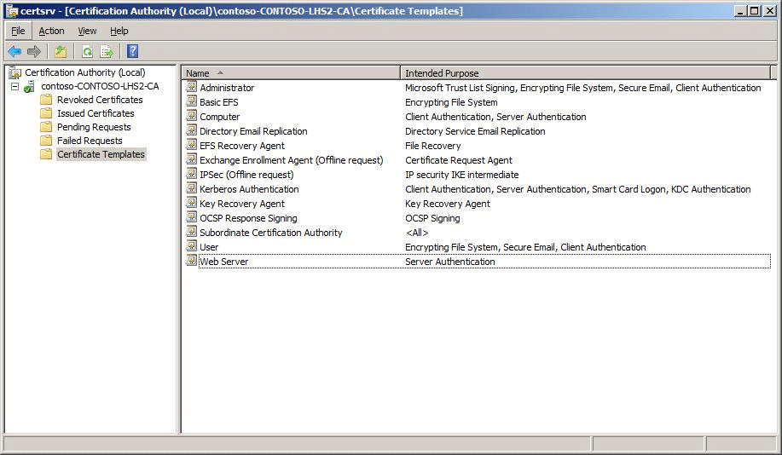

Permission Design
Certificate templates are published to the Configuration naming context, which is stored on every domain controller in the forest in the path: CN=Certificate Templates,CN=Public Key Services,CN=Services,CN=Configuration,DC=ForestRootDomain.
Each certificate template exists as an object in the Configuration naming context and has an associated discretionary access control list (DACL), which defines the specific operations a security principal can perform with the certificate.
Use the following recommendations for permissions assignments:
• Assign permissions only to global groups or to universal groups. It is not recommended to assign permissions to domain local groups. Domain local groups are only recognized in the domain where they exist, and assigning permissions to them can result in inconsistent application of permissions. You should not assign permissions directly to an individual user or computer account.
• To enable autoenrollment, a user or computer must belong to domain groups that are granted Read, Enroll, and Autoenroll permissions.
• To enable enrollment through the Certificates snap-in, Web-based enrollment, or automatic renewal, assign Read and Enroll permissions to either domain or universal groups.
• For certificate renewal, a user or computer must belong to a domain security group with Read and Enroll permissions. This is true whether the certificate is manually renewed or the renewal is implemented by using autoenrollment.
• Restrict Write and Full Control permissions to CA managers to ensure that the templates are not improperly configured.

Autoenrollment Considerations
Autoenrollment allows a CA administrator to configure users and computers to automatically enroll for certificates, retrieve issued certificates, and renew expiring certificates without requiring subject interaction. The autoenrollment process can be configured to function as a background task that does not require any user input.
To properly configure subject autoenrollment, the administrator must plan the configuration of the certificate template that will use autoenrollment. Several settings in the certificate template directly affect the behavior of subject autoenrollment, as follows:
• Require user input for autoenrollment.
On the Request Handling tab of the desired certificate template, the Require user input for auto-enrollment check box changes the behavior of autoenrollment. When this check box is selected, subjects are prompted for any necessary information for obtaining or renewing a certificate. When this check box is cleared, autoenrollment operates without any notice to the subject.
Note
Because smart cards must prompt the user for their personal identification number (PIN), this check box must be selected when a smart card cryptographic service provider (CSP) is selected.
• Limit the number of CSPs for an autoenrollment certificate template.
If more than one smart card provider—either CryptoAPI or Cryptography Next Generation (CNG)—is selected on the Request Handling or Cryptography tab, more than one dialog box might appear when a Windows XP or Windows Vista® client computer retrieves the autoenrolled certificate and begins to install it on the smart card. Only one provider should be selected from this list for each template.
• Do not enable subject creation based on request information.
If the Supply in the request option is enabled on the Subject Name tab, autoenrollment is disabled. This is because enabling the option prompts the subject to interactively create the subject name in the request, which will not work with autoenrollment.
• Do not require more than one authorized signature for issuance.
Configuring more than one authorized signature in the Issuance Requirements tab of the desired certificate template disables subject autoenrollment based on this template. If the authorized signatures value is set to 1, the requestor must sign the request with a private key from a valid certificate in the requestor's certificate store. This certificate must contain the application policy, issuance policies, or both, specified in the Application policy and Issuance policies lists on the same tab. If an appropriate certificate exists in the requestor's certificate store, autoenrollment signs the request with this certificate's private key and will obtain and install the requested certificate automatically. For example, to increase the security for Encrypting File System (EFS) certificate distribution, you can create a version 2 or 3 certificate template that requires the Smart Card Logon object identifier (1.3.6.1.4.1.311.20.2.2) in the signing certificate's application policy.
On the Issuance Requirements tab of the desired certificate template, the Valid existing certificate option may affect subject autoenrollment. If this option is selected, the subject does not need to meet issuance requirements when renewing a valid certificate. Subjects who may have been unable to autoenroll for the initial certificate may be able to use autoenrollment to renew that certificate. For example, a user whose distinguished name has changed may still autoenroll a certificate based on an existing valid certificate, rather than on the user's new credentials.
Note
For more information about template properties see Administering Certificate Templates.
For more information about configuring autoenrollment, see Certificate Autoenrollment in Windows Server 2003 (http://go.microsoft.com/fwlink/?LinkId=115032).

Configuring Permissions for a Certificate Template
This section provides the procedures for defining permissions for specific certificate templates and delegating permission for the management of certificate templates.
Note
To perform the following procedures, you must be logged on as a member of the Enterprise Admins group, a member of the forest root domain's Domain Admins group, or as a user who has been granted permission to perform the task.
To define permissions to allow a specific security principal to enroll for certificates based on a certificate template
1. Open the Certificate Templates snap-in (Certtmpl.msc).
2. In the details pane, right-click the certificate template you want to change, and then click Properties.
3. On the Security tab, ensure that Authenticated users is assigned Read permissions.
This ensures that all authenticated users on the network can see the certificate templates.
4. On the Security tab, click Add. Add a global group or universal group that contains all security principals requiring Enroll permissions for the certificate template, and then click OK.
5. On the Security tab, select the newly added security group, and then assign Allow for the Read and Enroll permissions.
6. Click OK.
To define permissions to allow a specific security principal to autoenroll for certificates based on a certificate template
1. Open the Certificate Templates snap-in.
2. In the details pane, right-click the certificate template you want to change, and then click Properties.
3. On the Security tab, click Add. Add a global group or universal group that contains all security principals requiring Enroll permissions for the certificate template, and then click OK.
4. On the Security tab, select the newly added security group, and then assign Allow for the Read, Enroll, and Autoenroll permissions.
5. Click Apply.

Publishing a Certificate Template
The final task for publishing a certificate template is to select the template you want the CA to issue.
To define which certificate templates are issued by a CA
1. In Administrative Tools, click Certification Authority.
2. In the console tree, expand CAName (where CAName is the name of your enterprise CA).
3. In the console tree, select the Certificate Templates container.
Note
In a Windows 2000 Server–based CA, the container is named Policy Settings.
4. Right-click Certificate Templates, and then click New, Certificate Template to Issue.
5. In the Enable Certificate Templates dialog box, select the certificate template or templates that you want the CA to issue, and then click OK.
Note
If a certificate template is not listed in the Enable Certificate Templates dialog box, the CA is either already configured to issue the certificate template, or replication of the certificate template is not completed to all domain controllers in the forest.
The newly selected certificate template or templates will appear in the details pane.

Removing a Certificate Template from a CA
Removing a certificate template only removes the association between a certificate and a CA instead of deleting it from the certificate template store.
To remove a certificate template from the certificate templates currently issued by a CA
1. In Administrative Tools, click Certification Authority.
2. In the console tree, expand CAName (where CAName is the name of your enterprise CA).
3. In the console tree, select the Certificate Templates container.
Note
In a Windows 2000 Server–based CA, the container is named Policy Settings.
4. In the details pane, right-click the certificate template you want to remove from the CA, and then click Delete.
5. In the Disable Certificate Templates dialog box, click Yes.
The certificate template no longer appears in the details pane.

Administering Certificate Templates
This topic includes detailed descriptions of the specific information that can be configured for certificate templates by using the Certificate Templates snap-in and procedures related to administering templates.

Configuring Certificate Templates
This topic describes the information that can be configured for certificate templates based on the Certificate Templates snap-in available in Windows Server® 2008 and Windows Server 2003. Items that are new in Windows Server 2008 are specifically noted. Items that do not specify an operating system version apply to templates for both Windows Server 2008 and Windows Server 2003.
Notes
• Version 3 certificate templates cannot be managed from the Certificate Templates snap-in available in Windows Server 2003. However, the Certificate Templates snap-in available in Windows Server 2008 can be used to manage all versions of certificate templates.
• To create a new certificate template, first duplicate an existing certificate template that is similar in functionality to the required template. Selecting the correct initial template is important so that the current certificate template settings will serve as a starting point for your certificate template configuration.
• Because certificate templates exist only once within a forest, all changes that are made apply across a forest. If several certification authorities (CAs) exist within one forest, templates can be assigned to CAs through publishing. Nevertheless, all CAs within a forest use one set of templates.

General Tab
The General tab is the first tab that appears when you duplicate an existing certificate template.
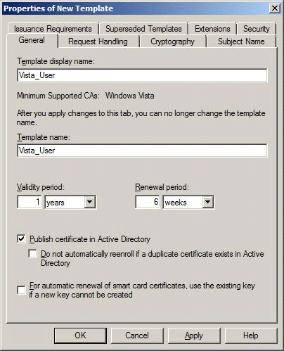

On the General tab, you can configure the following attributes of the certificate template:
• Template display name. This is the display name that is shown in the Certificate Templates snap-in, Certificates snap-in, and in the Certification Authority snap-in.
• Template name. This is the name of the certificate template object created in the following container: CN=Certificate Templates,CN=Public Key Services,CN=Services,DC=ForestRootDomain.
Note
The template display name and template name attributes cannot be changed after the certificate template is created.
• Validity period. This defines the validity period for an issued certificate. The validity period cannot be greater than the validity period of the CA's certificate. The minimum renewal period is 80 percent of the certificate lifetime or six weeks, whichever is greater.
• Renewal period. This is the period of time before the validity period expires when the certificate will be renewed if re-enrollment is supported for the certificate template.
• Publish options. You can choose whether to publish the certificate to Active Directory® Domain Services (AD DS) based on the certificate template. The certificates are published as an attribute of the security principal contained in the subject of the issued certificate.
• Re-enrollment option. If the certificate template is published in AD DS, you can prevent re-enrollment if a valid certificate of the same certificate template exists for the security principal indicated in the subject.
• Smart card certificate keys. For smart card renewal, this option enables the existing key to be used if a new key cannot be created. This helps prevent smart card renewal failures resulting from smart card capacity issues.
Note
Re-enrollment settings mainly affect autoenrollment design in a Windows Server 2003 network. For more information about autoenrollment, see Certificate Autoenrollment in Windows Server 2003 (http://go.microsoft.com/fwlink/?LinkID=115032).

Request Handling Tab
The options on the Request Handling tab differ depending on whether you have duplicated a template to a version 2 certificate template in Windows Server 2003 or a version 3 template in Windows Vista® or Windows Server 2008.

Version 2 Templates
The Request Handling tab in a version 2 template, shown in the following figure, defines the purpose of the certificate template, the supported cryptographic service providers (CSPs), minimum key length, exportability, autoenrollment settings, and whether strong private key protection should be required.
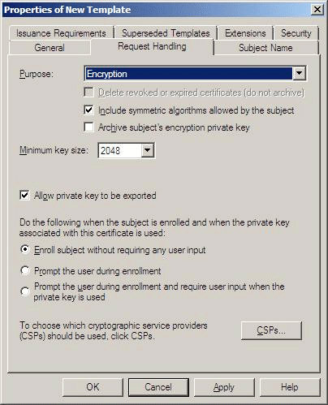

Certificate Purpose
The certificate purpose defines the intended primary use of the certificate. The certificate purpose can be one of four settings:
• Encryption. This certificate contains cryptographic keys for encryption and decryption.
• Signature. This certificate contains cryptographic keys for signing data only.
• Signature and encryption. This certificate includes all primary uses of a certificate's cryptographic key, including encryption of data, decryption of data, initial logon, or digitally signing data.
• Signature and smart card logon. This certificate allows for initial logon with a smart card, and to digitally sign data; it cannot be used for data encryption.
Note
The certificate purpose setting will determine whether key archival can be enabled for a certificate template. Key archival is only possible if the certificate purpose is set to Encryption or Signature and encryption. The recovery of a private key for digitally signing information may result in identity theft and is not supported. Key archival is not supported by most smart card CSPs.

Archive Settings
When subjects lose their private keys due to user profile corruption or stolen computers, any information that was persistently encrypted with the corresponding public key is inaccessible. To help avoid this, a CA running on Windows Server 2008 Enterprise, Windows Server 2008 Datacenter, Windows Server 2003 Enterprise Edition, or Windows Server 2003 Datacenter Edition can archive a subject's keys in its database when certificates are issued. These keys are encrypted and stored by the CA. If subjects lose their keys, the information can be retrieved from the database and securely provided to the subjects. This allows the encrypted information to be recovered instead of lost.
The following key archival settings are defined on the Request Handling tab:
• Delete revoked or expired certificates (do not archive). If a certificate is renewed due to expiration or revocation, the previously issued certificate is removed from the subject's certificate store. By default, the certificate is archived.
• Include symmetric algorithms allowed by the subject. When the subject requests the certificate, a list of supported symmetric algorithms can be supplied by the subject. This option allows the issuing CA to include those algorithms in the certificate, even if they are not recognized or supported by that server. The algorithms are used by applications such as secure e-mail.
• Archive subject's encryption private key. If the issuing enterprise CA is configured for key archival, the subject's private key will be archived.
• Allow private key to be exported. When this option is specified, the subject's private key can be exported for backup or transfer.
To enable key archival and recovery, the following configuration settings in the certificate template and on the CA must be made:
• The specific certificate template must be configured to allow key archival.
• One or more key recovery agents must be identified on the CA, and key recovery agent certificates must be issued to those agents.
• Key archival must be configured on the CA.
In addition to key archival settings, some general options that affect all certificates, including those that do not enable key archival, can be defined. These include:
• Minimum key size. This specifies the minimum size, in bits, of the key that will be generated for this certificate.
• CSPs. This is a list of CSPs that will be used to enroll certificates for the given template. Selecting one or more CSPs configures the certificate to work only with those CSPs. If you do not select a specific CSP, the certificate enrollment will work with any installed CSP but will use the first CSP in the list. The CSP must be installed on the client computer for the CSP to be used during enrollment. If a specific CSP is chosen and not available on a client computer, enrollment will fail.
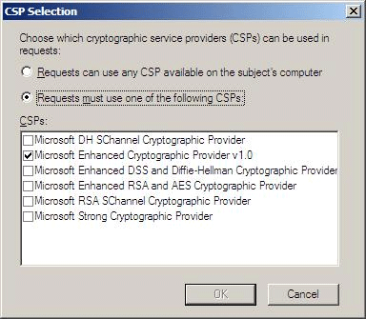

Note
You can add non-Microsoft CSPs by installing the manufacturer's CSP-related files. The newly installed CSP will appear in the list of available CSPs when the Certificate Templates snap-in is opened after CSP installation.
The Request Handling tab also allows several user input settings to be defined for a certificate template. These settings include:
• Enroll subject without requiring any user input. This option allows autoenrollment without any user interaction and is the default setting for both computer and user certificates. This option must not be enabled for computer certificates.
• Prompt the user during enrollment. Although useful when testing initial autoenrollment deployments, typically, this option is disabled. By disabling this option, users do not have to provide any input for the installation of a certificate based on the certificate template.
• Prompt the user during enrollment and require user input when the private key is used. This option enables the user to set a strong private key protection password on the user's private key when the key is generated and requires the user to use it whenever the certificate and private key are used. This option must not be enabled for computer certificates or smart card user certificates.
Note
To enable smart card autoenrollment, the Prompt the user during enrollment option must be enabled so that the user is prompted to insert the smart card in the smart card reader when required.
Important
Strong private key protection with autoenrollment is not supported or enabled for computer certificates and is only available on client computers running Windows Vista, Windows® XP with Service Pack 2 (SP2), or Windows XP with Service Pack 1 (SP1).
You can force strong private key protection for all CSPs through the registry in Windows Server 2003 with SP2, Windows Server 2003 with SP1, Windows 2000 Server with Service Pack 4 (SP4), Windows Vista, Windows XP with SP2, or Windows XP with SP1. Three new keys can be added to HKLM\Software\Policies\Microsoft\Cryptography in the registry:
• ForceKeyProtection. This key will force the Data Protection application programming interface (DPAPI) to disable the option that allows the user to choose whether to use a password to protect their private key. When set, the user must use a password to protect their private key.
<"0"> = Do not force UI on key protection
<"1"> = Default to UI, but let user change selection
<"2"> = Force UI on key protection; disable option for user
• CachePrivateKeys. Contains a 1 if the PrivateKeyLifetimeSeconds registry key is used.
• PrivateKeyLifetimeSeconds. Contains the number of seconds that a key will remain cached without being used. The key cache timer will be reset on every successful use in the CSP.
Caution
Requiring the use of strong private key protection and user prompting on all new and imported keys will disable some applications, such as Encrypting File System (EFS) and wireless (802.1X) authentication that cannot display UI. For more information, see article 320828 in the Microsoft Knowledge Base (http://go.microsoft.com/fwlink/?LinkId=115037).

Windows Server 2008
The Request Handling tab for certificate templates in Windows Server 2008 has been updated to provide support for the new options available on the Cryptography tab, as well as for some additional changes made in Windows Server 2008.
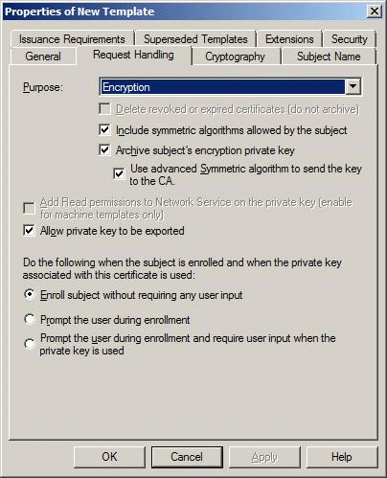

Additions and changes to the Request Handling tab are:
• Use advanced Symmetric algorithm to send the key to the CA. This option allows the administrator to choose the Advanced Encryption Standard (AES) algorithm to encrypt private keys while they are transferred to the CA for key archival. If this option is selected, the client computer will use AES256 symmetric encryption (along with the CA's exchange certificate for asymmetric encryption) to send the private key to the CA for archival. If this option is not selected, the symmetric algorithm used is Triple Data Encryption Standard (3DES). Because key archival is intended for encryption keys (not signing keys), this option is enabled only when Encryption is selected in the Purpose box.
• Add Read permissions to Network Service on the private key. For computer templates, this option grants Read permission to Network Service for the certificate's private key on the computer to which the certificate is issued. This enables services such as the Online Responder and Internet Information Services (IIS) to use certificates and keys issued to the computer on which they run. In previous versions of Windows, these permissions had to be configured manually.
• The Minimum key size option has been enhanced and moved to the new Cryptography tab.
• The CSPs button has been removed.

Cryptography Tab
Windows Server 2008 contains a new Cryptography tab. This tab replaces and extends the CSP Selection dialog box accessible by clicking the CSPs button on the Request Handling tab of a version 2 template.
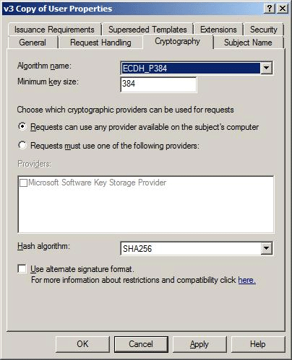

The Cryptography tab contains the following new options:
• Algorithm name. This option introduces the ability to select an advanced algorithm for encryption, signing, or both (depending on the template's purpose). By default, Windows offers the following algorithms: DSA, ECDH_P256, ECDH_P384, ECDH_P521, ECDSA_P256, ECDSA_P384, ECDSA_P521, and RSA.
• Minimum key size. This option introduces the ability to specify a minimum required size for the keys used with the chosen algorithm. The default is the minimum key length supported on the system for the chosen algorithm. However, the administrator can enter any number.
• Providers. Version 2 templates offered a list of CryptoAPI CSPs; version 3 templates offer a dynamically populated list of Cryptography Next Generation (CNG) providers. This list is populated with all providers available on the system that meet the criteria specified by the following configuration options: Algorithm name and Minimum key size on the Cryptography tab, and Purpose and Allow private key to be exported on the Request Handling tab.
• Hash algorithm. This option introduces the ability to choose an advanced hash algorithm. By default, the following algorithms are available: MD2, MD4, MD5, SHA1, SHA256, SHA384, and SHA512.
• Use alternate signature format. When the RSA algorithm is selected, this check box allows the administrator to specify that certificate requests created for this template include a discrete signature in Public Key Cryptography Standards (PKCS) #1 version 2.1 format. Activating this option for any algorithm will force a client computer that uses the certificate autoenrollment functionality or that enrolls a certificate by using the Certificates snap-in to generate a certificate request that includes a discrete signature.
Note
Selecting this option does not mean that a certificate that is issued from this template also includes a discrete signature. The setting applies to the certificate request only. Also, the setting is not relevant for certificate requests that are created by using the Certreq.exe command-line tool.

Subject Name Tab
When establishing a certificate template, the subject name must be defined. This is included in the issued certificate template and must uniquely identify the subject. The subject name can either be built automatically during the certificate request by using the authentication name of the subject, or explicitly defined by the subject and included in the certificate request.
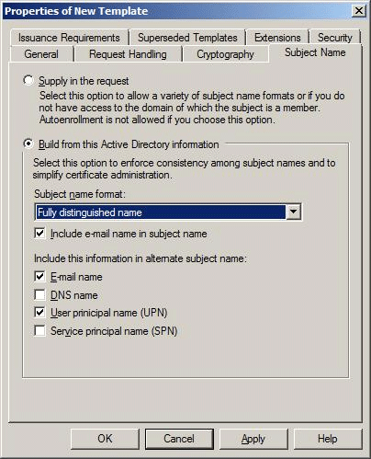

A number of options can be included with the subject name, as well as specific configuration settings for the subject name when the subject name is built from Active Directory information during the certificate request process. The format of the subject name can be defined as follows:
• None. Does not enforce any name format for this field.
• Common name. The CA creates the subject name from the common name (CN) of the requestor obtained from AD DS. These should be unique within a domain but do not have to be unique within an enterprise.
• Fully distinguished name. The CA creates the subject name from the fully distinguished name obtained from AD DS. This ensures that the name is unique within an enterprise.
In addition, you can choose to include the e-mail name in the subject name. This information is populated from the E-mail attribute of an account and is included with either the common name or fully distinguished name as part of the subject name.
In addition to the subject name, you can also choose the name formats to include in the alternate subject name attributes of issued certificates. The alternate subject name formats that are available include:
• E-mail name. If the E-mail name field is populated in the Active Directory user object, that e-mail name will be used for user accounts.
Note
The e-mail name is required for user certificates. If the e-mail name is not populated for a user in AD DS, the certificate request by that user will fail.
• DNS name. The fully qualified domain name (FQDN) of the subject that requested the certificate is used for computer accounts.
• User principal name (UPN). This is part of the Active Directory user object and will be used for user accounts.
• Service principal name (SPN). This is part of the Active Directory computer object and will be used for computer accounts.
If the Subject Name option is set to Supply in the request, you should set one or more issuance requirements for the template to prevent subjects from requesting certificates by using any subject name. Issuance requirements ensure that the certificate request is inspected and validated before the certificate is issued.
The only case in which a subject can request a certificate with a different subject name is when the request holds a certificate based on the Enrollment Agent template. The Enrollment Agent template allows a subject to request a certificate on behalf of another subject.

The Issuance Requirements Tab
The Issuance Requirements tab allows certificates with a higher assurance level to be placed in a pending state until the certificate is reviewed before issuance. This allows for multiple signers of a Common Messaging Calls (CMC) request to exist. For more information about CMC, see Request for Comment (RFC) 2797, "Certificate Management Messages over CMS." You can obtain RFCs and Internet drafts from the Internet Engineering Task Force Web site (http://go.microsoft.com/fwlink/?LinkId=121).
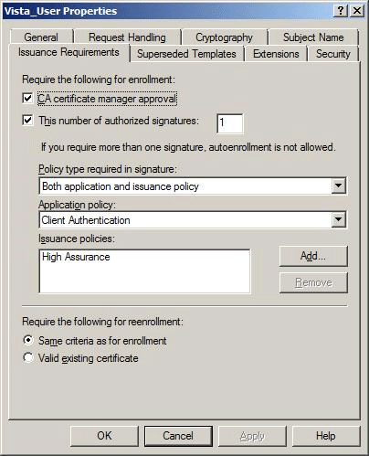

When CA certificate manager approval is selected, the certificate is placed into a pending state, rather than being issued immediately. In its pending state, the certificate request can be reviewed by certificate managers, ensuring a higher level of assurance for the issued certificate.
The following settings configure the authentication and signature requirements for issuance certificates that are based on a template.
• CA certificate manager approval. All certificates are placed into the pending container for a certificate manager to issue or deny. Any defined certificate manager can issue or deny a certificate request of this type.
• This number of authorized signatures. This setting requires the CMC certificate request to be digitally signed by one or more authorized parties before it can be issued.
Note
Defining the number of authorized signatures enables several other configuration parameters.
• Policy type required in signature. This option is only enabled when the number of authorized signatures value is set. This option defines which specific application policy, issuance policy, or both are required in the signing certificate. This is how the CA determines whether the signature is appropriate for authorizing the issuance of the subject's certificate.
• Application policy. This option specifies the application policy that must be included in the signing certificate used to sign the certificate request. It is enabled when Policy type required in signature is set to either Application policy or Both application and issuance policy.
• Issuance policy. This option specifies the issuance policy that must be included in the signing certificate used to sign the certificate request. This option is enabled when Policy type required in signature is set to either Issuance policy or Both application and issuance policy.
An example of where issuance requirements are defined is for the issuance of cross-certified CA certificates. The template for this certificate requires that the signing certificate includes the Qualified Subordination object identifier as shown in the following figure.
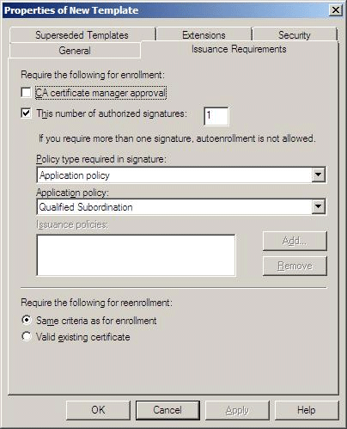

In addition, you can also determine whether the same issuance requirements are upheld for certificate renewal, or if the existence of a valid existing certificate of the same template in the certificate store meets the minimum requirements for certificate issuance.
Note
For more information about including application and issuance policy object identifiers in an issued certificate, see Extensions Tab.

Superseded Templates Tab
The Superseded Templates tab, shown in the following figure, allows you to supersede existing certificate templates with a modified version 2 certificate template.
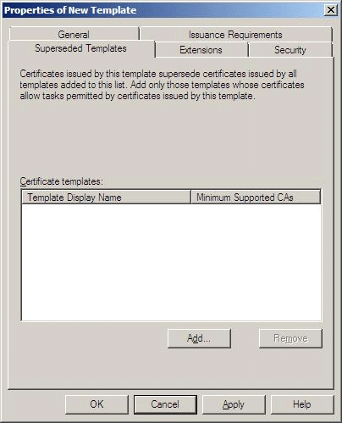

This tab allows you to redeploy certificates and ensure that the updated certificates replace previous versions of the certificate or other certificate templates that were used for the same purposes. You can supersede the following:
• A version 1, 2, or 3 certificate template with a version 2 or 3 certificate template
• Multiple existing certificate templates with a common version 2 or 3 certificate template
Note
You can force the application of the updated certificate template by forcing all certificate holders to re-enroll the updated certificate template. For more information, see Re-enroll Certificate Holders.

Extensions Tab
The Extensions tab shown in the following figure allows you to define specific application policies, issuance policies, certificate subject types, and key usage attributes for a certificate template. The following sections provide specific information about each form of extension defined in a certificate template.
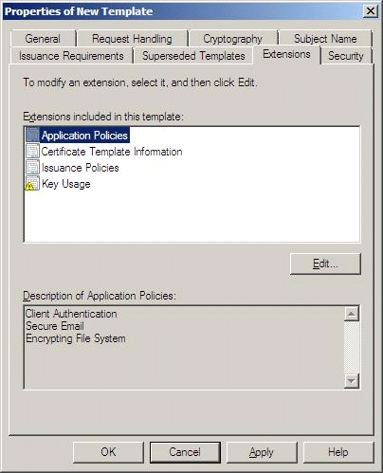

Application Policies
Application policies enable you to decide which certificates can be used for certain purposes. You can issue certificates widely without being concerned that they are misused for an unintended purpose.
Application policies are settings that inform a target that the subject holds a certificate that can be used to perform a specific task. They are represented in a certificate by an object identifier that is defined for a given application. This object identifier is included in the issued certificate. When a subject presents its certificate, it can be examined by the relying party to verify the application policy and determine if it can perform the requested action.
Note
Application policies are similar to the extended key usage attribute in version 1 certificate templates. Because some implementations of public key infrastructure (PKI) applications cannot interpret application policies, both application policies and enhanced key usage sections appear in certificates issued by a Windows–based CA.
The following table shows some of the more commonly used application policies and their related object identifiers.

Application policy | Object identifier
Client Authentication | 1.3.6.1.5.5.7.3.2
CA Encryption Certificate | 1.3.6.1.4.1.311.21.5
Smart Card Logon | 1.3.6.1.4.1.311.20.2.2
Document Signing | 1.3.6.1.4.1.311.10.3.12
File Recovery | 1.3.6.1.4.1.311.10.3.4.1
Key Recovery | 1.3.6.1.4.1.311.10.3.11
Microsoft Trust List Signing | 1.3.6.1.4.1.311.10.3.1
Qualified Subordination | 1.3.6.1.4.1.311.10.3.10
Root List Signer | 1.3.6.1.4.1.311.10.3.9
OCSP Signing | 1.3.6.1.5.5.7.3.9

For Windows Server 2008–based CAs, the new OCSP Response Signing default template contains an additional custom extension called OCSP no revocation checking. This template extension instructs the CA to include the OCSP no revocation checking (id-pkix-ocsp-nocheck) extension in the issued certificate and not to include the commonly used authority information access and CRL distribution point extensions in the certificate. This is because OCSP Response Signing certificates are not checked for revocation status. Instead, they tend to be relatively short-lived certificates (the default template validity period is two weeks). Note that the extension only has this effect if the certificate request contains OCSP Response Signing in the enhanced key usage and application policies, as shown in the following figure.
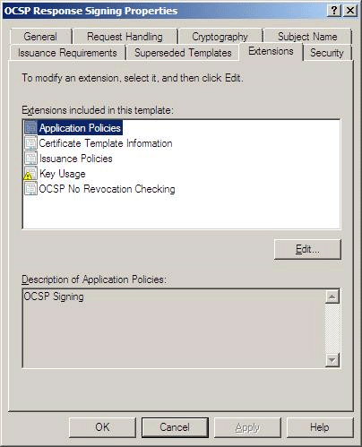

Certificate Policies
Certificate policies, also referred to as issuance policies, define the level of assurance for an issued certificate. A CA processes each certificate request by a defined set of rules. The CA may issue some certificates with no proof of identification and require subjects of another type to submit proof. This provides different levels of assurance for different certificates. These levels of assurance are represented in certificates as issuance policies.
Note
Certificate policies refer to the certificate policies extension identifier described in RFC 3280, "Internet X.509 Public Key Infrastructure Certificate and Certificate Revocation List (CRL) Profile." You can obtain RFCs and Internet drafts from the Internet Engineering Task Force Web site (http://go.microsoft.com/fwlink/?LinkId=121).
An issuance policy is a group of administrative rules that are implemented when issuing certificates. They are represented in a certificate by an object identifier that is defined at the CA. This object identifier is included in the issued certificate. When a subject presents its certificate, it can be examined by the target to verify the issuance policy and determine if that level of issuance policy is sufficient to perform the requested action.
An issuance policy describes the conditions under which a certificate is issued. This provides a level of assurance that the subject's certificate request was verified in a specific way.
One or more issuance policies may be selected for a certificate template. Because these issuance policies are simply text labels with an associated object identifier, no options are associated with them. The only special issuance policy is All issuance policies, which indicates that this policy includes all others. This is normally reserved for certificates held by CAs.
Issuance policies are often used when configuring qualified subordination (cross-certification) between PKI hierarchies to ensure that certificates recognized by another organization's PKI meet issuance requirements required by your organization.

Certificate Template Information
The certificate template information, also referred to as the Certificate subject type, defines the purpose of a certificate template. Six subject types are recognized:
• Key recovery agent
• Directory e-mail replication
• Cross-certified CA
• CA
• Computer
• User
The certificate template information extension cannot be edited. If you require a specific subject type to be applied to a certificate, you should duplicate a certificate template that includes the required subject type. Some of the internal flags that are defined for specific subject types limit the display of the certificate template to computers or users. Choosing to duplicate an incorrect certificate template will prevent the certificate template from being displayed to the desired enrollment audience. For example, a computer certificate template cannot be enrolled for use by a user account.

Key Usage
A certificate enables the subject to perform a specific task. To help control the usage of a certificate outside its intended purpose, restrictions are automatically placed on certificates. Key usage is a restriction method and determines what a certificate can be used for. This allows the administrator to issue certificates that can only be used for specific tasks or certificates that can be used for a broad range of functions. If no key usage is specified, the certificate can be used for any purpose.
For signatures, key usage can be limited to one or more of the following purposes:
• Digital signature
• Signature is a proof of origin (nonrepudiation)
• Certificate signing
• CRL signing
For encryption key usage, the following options are available:
• Key exchange without key encryption
• Key exchange only with key encryption

Security Tab
The Security tab, shown in the following figure, allows you to define the discretionary access control list (DACL) for a specific certificate template. The permissions that you assign to the certificate template define which security principals can read, modify, enroll, or autoenroll for a specific certificate template.
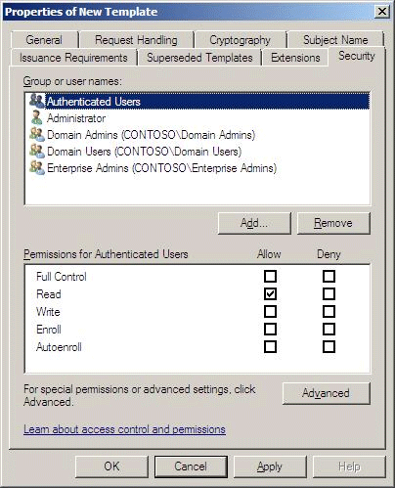

The permissions that you can assign to a certificate template include:
• Full Control. This allows a security principal to modify all attributes of a certificate template, including the permissions for the certificate template.
• Read. This allows a security principal to see the certificate template when enrolling for certificates. It is required for a security principal to enroll or autoenroll a certificate; it is required by the certificate server to find the certificate templates in AD DS.
• Write. This allows a security principal to modify the attributes of a certificate template, including the permissions assigned to the certificate template.
• Enroll. This allows a security principal to enroll for a certificate based on the certificate template. To enroll for a certificate, the security principal must also have Read permission for the certificate template.
• Autoenroll. This allows a security principal to receive a certificate through the autoenrollment process. Autoenrollment permissions require that the user has both Read and Enroll permissions in addition to the Autoenroll permission.
Note
Certificate template permissions should be assigned only to global groups or universal groups. Because the certificate template objects are stored in the Configuration naming context, you cannot assign permissions by using domain local groups. To simplify administration, you should not assign certificate template permissions to individual user or computer accounts.
It should be considered a best practice to keep the Read permission assignment for the Authenticated Users group. This permission assignment allows all users and computers to view the certificate templates in AD DS. This includes the CA running under the System context of a computer account to view the certificate templates when issuing certificates to users and computers.

Delegating Template Management
You can delegate the ability to manage individual certificate templates or to create any certificate templates by defining appropriate permissions to global groups or universal groups that a user belongs to.
There are three levels of delegation for certificate template administration:
• Modify existing templates
• Create new templates (by duplicating existing templates)
• Full delegation (including modifying all existing templates and creating new ones)
Note
To perform any administrative tasks, you need to be a member of the Enterprise Admins group, a member of the forest root domain's Domain Admins group, or a user who has been granted permission to perform the task.

Modify Existing Templates
To delegate modification of a specific certificate template, assign a global or universal group the Read and Write permissions on the Security tab (see Security Tab) of the certificate template. Once a delegated administrator has Write permission on a template, the administrator needs to take ownership of the specific template before applying any changes.
To take ownership of a template
1. Open the Certificate Templates snap-in.
2. Double-click the appropriate template.
3. On the Security tab, click Advanced.
4. In the Advanced Security Settings dialog box, on the Owner tab, select the current user's name, and then click Apply.
5. Ensure that the Current owner of this item dialog box displays the current user's name, and then click OK.

Create New Templates
To delegate the ability to create certificate templates to users who are not members of the Domain Admins group in the forest root domain, or members of the Enterprise Admins group, it is necessary to define the appropriate permissions in the Configuration naming context of AD DS.
To delegate the ability to duplicate and create new certificate templates, you must make the following permission assignments to a global or universal group of which the user is a member:
• Grant Create All Child Objects permission on the following container: CN=Certificate Templates,CN=Public Key Services,CN=Services,CN=Configuration,DC=ForestRoot.
• Grant Full Control permission to every certificate template in the following container: CN=Certificate Templates,CN=Public Key Services,CN=Services,CN=Configuration,DC=ForestRoot. The permissions assigned to the Certificate Templates container are not inherited by the individual certificate templates.
• Grant Create All Child Objects permission on the following container: CN=OID,CN=Public Key Services,CN=Services,CN=Configuration,DC=ForestRoot container.

Full Delegation
To delegate the ability to modify all existing templates and create new ones
1. For existing templates, follow the steps in Modify Existing Templates, and delegate the Write permission.
2. Add the following access control entries (ACEs) on the Template container objects:
• Grant Create All Child Objects and Delete All Child Objects permissions on the following container: CN=Certificate Templates,CN=Public Key Services,CN=Services,CN=Configuration,DC=ForestRoot.
• Grant Create All Child Objects and Delete All Child Objects permissions on the following container: CN=OID,CN=Public Key Services,CN=Services,CN=Configuration,DC= ForestRoot.
Note
Your delegated administrator will still be required to take ownership of a template before applying changes.

Allowing the Creation and Modification of any Certificate Template
Being able to administer all templates includes the ability to duplicate and create new templates.
To delegate administration of all templates
1. Open the ADSI Edit snap-in (Adsiedit.msc).
2. In the console tree, right-click ADSI Edit, and then click Connect to.
3. In the Connection dialog box, in the Connection Point section, click Naming Context, select Configuration Container, and then click OK.
4. In the console tree, double-click ADSI Edit.
5. In the console tree, double-click Configuration Container.
6. In the console tree, double-click CN=Configuration,DC=ForestRootDomain (where ForestRootDomain is the LDAP distinguished name of your forest root domain).
7. In the console tree, double-click CN=Services.
8. In the console tree, double-click CN=Public Key Services.
9. In the console tree, right-click CN=Certificate Templates, and then click Properties.
10. In the CN=Certificate Templates Properties dialog box, on the Security tab, click Add. Add a global or universal group that contains the users you want to delegate certificate creation and management permissions to, and then click OK.
11. On the Security tab, select the newly added security group, ensure that the security group is assigned Allow for the Full Control permission, and then click OK.
12. In the console tree, right-click CN=OID, and then click Properties.
13. In the CN=OID Properties dialog box, on the Security tab, click Add. Add a global or universal group that contains the users you want to delegate certificate creation and management permissions to, and then click OK.
14. On the Security tab, select the newly added security group, ensure that the security group is assigned Allow for the Full Control permission, and then click OK.
15. Close ADSI Edit.
16. Ensure that the security group assigned Full Control permissions to the CN=Certificate Templates and CN=OID containers is also assigned Full Control permissions for all certificate templates listed in the Certificate Templates snap-in (Certtmpl.msc).

Replace an Existing Certificate Template with a New Certificate Template
This process, also referred to as superseding an existing template, defines which existing templates a version 2 or 3 certificate is replacing.
To replace an existing certificate template with a new certificate template
1. Open the Certificate Templates snap-in.
2. In the details pane, right-click the certificate template you want to change, and then click Properties.
3. Click the Superseded Templates tab, and then click Add.
4. Click one or more templates to supersede, and then click OK.

Re-enroll Certificate Holders
If you make modifications to a certificate template that you want implemented immediately for all existing certificate holders, you can force re-enrollment.
To force re-enrollment
1. Open the Certificate Templates snap-in.
2. In the details pane, right-click the certificate template that you want to re-enroll for all certificate holders, and then click Reenroll all Certificate Holders.

Certificate Templates Appendixes
This document includes the following appendixes:
Wireless Certificates
Certificate Templates Schema
References

Wireless Certificates
Windows® XP introduced native support for 802.1X and wireless networks. To enable strong security, both users and computers need authentication certificates to authenticate to a RADIUS authorization point. Microsoft Windows 2000 Server–based certification authorities (CAs) support 802.1X certificate requirements for computers with the version 1 computer certificate template and user certificates with any of the certificate templates that contain the Client Authentication enhanced key usage. If version 2 or 3 templates are used for computer autoenrollment, it is important to configure the certificate template properly. When the computer template is cloned to a new template, the administrator must ensure that the DNS name is included in the subject name of the certificate. The Windows XP and Windows Vista® wireless client computers require the DNS name of the computer to be contained in the subject for proper usage and authentication to the RADIUS server.
Important
If the DNS fully qualified domain name (FQDN) is longer than 64 characters, the name will be truncated during certificate enrollment and the name will not be valid for wireless authentication.
For more information, see Wireless Networking in Windows Vista (http://go.microsoft.com/fwlink/?LinkID=89054).

Certificate Templates Schema
The Certificate Templates container contains the certificate templates that are defined within an Active Directory® forest. Each certificate template is a member of the class pKICertificate. Each certificate template is managed by using the Certificate Templates snap-in and is stored in the following location in the Configuration naming context: CN=TemplateName,CN=Certificate Templates,CN=Public Key Services,CN=Services,CN=Configuration,DC=ForestRootDomain.

Version 1 Certificate Template Attributes
The following version 1 certificate template attributes are defined in the Active Directory schema.

Attribute | Description
Cn | Common name of the certificate type
distinguishedName | Distinguished name of the certificate type
displayName | Display name of a certificate type
pKIExtendedKeyUsage | Array of extended key usage object identifiers
pKIDefaultCSPs | Default cryptography service provider (CSP) list; DWORD value, CSP name
pKICriticalExtensions | List of critical extensions
revision | Major version of the templates
templateDescription | Obsolete attribute
flags | General enrollment flags
pKIDefaultKeySpec | Specifications of the default key length and construct
NTSecurityDescriptor | Security descriptor name
pKIKeyUsage | Key usage extension
pKIMaxIssuingDepth | Basic constraints; DWORD value
pKIExpirationPeriod | Validity period; negative FILETIME value
pKIOverlapPeriod | Renewal period; negative FILETIME value

Versions 2 and 3 Certificate Template Attributes
The following certificate template attributes defined in the Active Directory schema are applicable to template versions 2 and 3.

Attribute | Description
msPKI-Template-Schema-Version | Schema version of the templates
msPKI-Template-Minor-Revision | Minor version of the templates
msPKI-RA-Signature | Number of registration authority signatures required on a request referencing this template
msPKI-Minimal-Key-Size | Minimal key size required
msPKI-Template-Cert-Template-OID | Object identifier of this template
msPKI-Supersede-Templates | Name of the template that this template supersedes
msPKI-RA-Policies | Object identifiers required for the registration authority issuer policy
msPKI-RA-Application-Policies | Object identifiers required for the registration authority application policy
msPKI-Certificate-Policy | The certificate issuer policy object identifiers that are placed in the OID_CERT_POLICIES extension by the policy module
msPKI-Certificate-Application-Policy | Certificate application policy object identifiers
msPKI-Enrollment-Flag | Enrollment flags
msPKI-Private-Key-Flag | Private key flags
msPKI-Certificate-Name-Flag | Subject name flags

Flags
The following enrollment flags are defined in the Active Directory schema.

Attribute | Description
CT_FLAG_INCLUDE_SYMMETRIC_ALGORITHMS  • 0x00000001 | Include the Secure/Multipurpose Internet Mail Extensions (S/MIME) symmetric algorithms in the requests.
CT_FLAG_PEND_ALL_REQUESTS  • 0x00000002 | All certificate requests are set to pending.
CT_FLAG_PUBLISH_TO_KRA_CONTAINER  • 0x00000004 | Publish the certificate to the KRA container in Active Directory Domain Services (AD DS).
CT_FLAG_PUBLISH_TO_DS  • 0x00000008 | Publish the resultant certificate to the userCertificate property on the user object in AD DS.
CT_FLAG_AUTO_ENROLLMENT_CHECK_USER_DS_CERTIFICATE  • 0x00000010 | The autoenrollment client computer will not enroll for a new certificate if the user has a certificate previously published to the userCertificate property in AD DS with the same template name.
CT_FLAG_AUTO_ENROLLMENT  • 0x00000020 | This certificate is appropriate for autoenrollment.
CT_FLAG_PREVIOUS_APPROVAL_VALIDATE_REENROLLMENT  • 0x00000040 | A previously issued certificate will validate subsequent enrollment requests.
CT_FLAG_DOMAIN_AUTHENTICATION_NOT_REQUIRED  • 0x00000080 | This flag is obsolete.
CT_FLAG_USER_INTERACTION_REQUIRED  • 0x00000100 | User interaction is required to enroll by using autoenrollment.
CT_FLAG_ADD_TEMPLATE_NAME  • 0x00000200 | This flag is obsolete.
CT_FLAG_REMOVE_INVALID_CERTIFICATE_FROM_PERSONAL_STORE  • 0x00000400 | Remove an expired or revoked certificate from the personal store on the local client computer during autoenrollment.

The following subject name flags are defined in the Active Directory schema.

Attribute | Description
CT_FLAG_ENROLLEE_SUPPLIES_SUBJECT  • 0x00000001 | The enrolling application must supply the subject name in the request.
CT_FLAG_ENROLLEE_SUPPLIES_SUBJECT_ALT_NAME  • 0x00010000 | The enrolling application must supply the alternate subject name in the request.
CT_FLAG_SUBJECT_REQUIRE_DIRECTORY_PATH  • 0x80000000 | The subject name must be the distinguished name based on the Active Directory path.
CT_FLAG_SUBJECT_REQUIRE_COMMON_NAME  • 0x40000000 | The subject name must be the common name.
CT_FLAG_SUBJECT_REQUIRE_EMAIL  • 0x20000000 | The subject name must include the e-mail name.
CT_FLAG_SUBJECT_REQUIRE_DNS_AS_CN  • 0x10000000 | The subject name must include the DNS name as the common name.
CT_FLAG_SUBJECT_ALT_REQUIRE_DNS  • 0x08000000 | The alternate subject name must include the DNS name.
CT_FLAG_SUBJECT_ALT_REQUIRE_EMAIL  • 0x04000000 | The alternate subject name must include the e-mail name.
CT_FLAG_SUBJECT_ALT_REQUIRE_UPN  • 0x02000000 | The alternate subject name requires the user principal name (UPN).
CT_FLAG_SUBJECT_ALT_REQUIRE_DIRECTORY_GUID  • 0x01000000 | The alternate subject name requires the directory globally unique identifier (GUID) that is used by domain controllers.
CT_FLAG_SUBJECT_ALT_REQUIRE_SPN  • 0x00800000 | The alternate subject name requires the service principal name (SPN).

The following template private key flags are defined in the Active Directory schema.

Attribute | Description
CT_FLAG_ALLOW_PRIVATE_KEY_ARCHIVAL  • 0x00000001 | Archival of the private key is allowed or required.
CT_FLAG_EXPORTABLE_KEY  • 0x00000010 | The private key is marked as exportable.

The following template general flags are defined in the Active Directory schema.

Attribute | Description
CT_FLAG_MACHINE_TYPE  • 0x00000040 | Computer certificate type
CT_FLAG_IS_CA  • 0x00000080 | CA certificate type
CT_FLAG_IS_CROSS_CA  • 0x00000800 | Cross-certified CA certificate type
CT_FLAG_IS_DEFAULT  • 0x00010000 | Default certificate type that is set on all version 1 templates that cannot be changed
CT_FLAG_IS_MODIFIED  • 0x00020000 | The type has been modified (read-only)
CT_MASK_SETTABLE_FLAGS  • 0x0000ffff | Obsolete

References
• Troubleshooting Certificate Status and Revocation (http://go.microsoft.com/fwlink/?LinkID=18753)
• Windows Server 2008 Help for certificate templates
(http://go.microsoft.com/fwlink/?LinkId=115123)

