

White Paper

Key Archival and Management in Windows Server 2003

Abstract Windows Server 2003 Enterprise Edition introduces several new features in the area of Public Key Infrastructure (PKI) technologies and Certificate Authorities (CAs). One area of new functionality is private key archival, recovery, and management. This white paper covers best practices as well as procedural steps in a key recovery strategy as well as migration procedures for moving from an Exchange KMS environment to a Windows Server 2003 Certificate Authority.

Author: David B. Cross

Acknowledgements

Eduard Koller, Software Design Engineer, Microsoft Corporation
Jan De Clerq, Senior Consultant, Hewlett-Packard

Introduction

Windows Server 2003 Enterprise Edition introduces significant advancements in the area of data protection and private key recovery. Key Recovery has existed previously with the Microsoft Exchange Key Management Server to recover private keys used by the Outlook and Exchange mail clients for encrypted mail. Windows 2000 introduced the capability for data recovery with the implementation of Encrypting File System (EFS). EFS in both Windows 2000 and Windows Server 2003 supports the use of Data Recovery Agent(s) to decrypt files that have been encrypted by other users.

With the expanded functionality of the Windows Server 2003 Certificate Services to offer key archival and recovery services, an enterprise may choose to implement different strategies based on the needs for data protection and data recovery. Combined with the other low total cost of ownership features of Windows Server 2003, such as certificate auto-enrollment, the Windows Server 2003 PKI solution can provide a cost-effective and easy-to-use security solution for almost any organization. The simplicity of the Windows Server 2003 PKI solution enables administrators to deploy a fully functional PKI environment and applications in a matter of a few days versus weeks or months for other solutions.

The Windows Server 2003 key archival solution also provides migration flexibility to organizations that desire to migrate their existing Exchange 2000 KMS solution to a more integrated archival solution in the Windows Server 2003 CA or for those customers who have public key certificates from third-party CAs. The Windows Server 2003 PKI solution allows import and migration of third-party public keys and certificates into the Windows Server 2003 CA as an escrow solution as well.

Key Recovery Overview
Key recovery implies that the private key portion of a public-private key pair may be archived and recovered. Private key recovery does not recover any data or messages, it merely enables a user to retrieve lost or damaged keys or for an administrator to assume the role of a user for data access or data recovery purposes. In many applications, data recovery cannot occur without first performing key recovery. See Figure 1.

Figure 1: Key Recovery

Microsoft first offered key archival and recovery features in the Exchange Server 4.0 product line through the Key Management Server (KMS) component of the Exchange Server. The Key Management Server can act as a Registration Authority (RA) to a Microsoft Certificate Server to provide user registration, key archival, key recovery, and certificate publishing capabilities to an Exchange Server e-mail and collaboration system. The Key Management Server allows an administrator to recover the lost or corrupted encryption private keys of an Outlook user and generate a new signing key. The Outlook client as well as many other S/MIME-enabled mail clients supports the use of separate signing and encryption key pairs. This method helps to isolate an organization from non-repudiation issues. For more information on Key Management Server and Windows PKI interoperability, see the following white paper at

http://support.microsoft.com/support/exchange/content/whitepapers/win2k_kms.doc

Best Practices
Some key best practices should be followed when implementing key archival and recovery in an organization. First, it should be noted that key recovery by an administrator implies impersonation and that administrators who perform key archival should be highly trusted. Implementation of operations of a key archival and recovery solution should be carefully planned and monitored for security purposes.

Other Best Practices

- If a key is known to be compromised, it should be immediately revoked and never used again.
- Keys or certificates that are used to secure high-value transactions, or are identified as high-value certificates should not be recovered except under extreme circumstances.
- Private keys that are used for signing should never be archived or recovered as this introduces non-repudiation issues.
- When a key has been compromised or lost, it should be revoked before allowing key recovery. Despite key compromise, it may be necessary to recover a key for the purpose of decrypting old data and encrypting with a new key.
- Issue the least number of certificates and key pairs possible to ease in key management and reduce user confusion.
- Issue only one valid key pair for a given application purpose at one time.
- Develop a recovery process that combines role separation of Certificate Managers and Key Recovery Agents.
- Minimize the number of CAs that archive keys for a certificate purpose. That is, if possible, do not archive keys for users across a large number of CAs as recovery operations become confusing.
- If performing key archival over the Certificate Server web enrollment pages, it is important to use SSL on the enrollment Web site to protect the enrollment traffic from tampering.

When To Use Data Recovery versus Key Recovery

It should be first noted that there is no definitive answer to the question of whether key recovery or data recovery should be used over the other option. Both solutions have technical advantages and disadvantages and the decision to use one or both is a subjective one. Both are viable solutions separately and in summation. This section is written solely to identify some of the key advantages and disadvantages so that an organization may make an informed decision.

Key Recovery should be used when the policy of a given company or enterprise permits the private keys and certificates of a given user(s) to be retrieved. Key archival and recovery implies that a person other than the original user may gain access to the private keys of another user. If a company or enterprise does not permit a person other than the original requestor to ever have access to private keys of other users, then key archival and recovery should not be used.

Data recovery should be used when a company or enterprise requires the ability to recover data, but not access to the individual private keys of a user. For example, when private key recovery is provided, new operations can be performed when using the key, not just data decryption. An organization may disable the ability to perform data recovery in a domain (Active Directory) environment by first enabling a Data Recovery Agent (DRA) in the domain and then destroying the private keys associated with the DRA. This has the net effect of enabling EFS, but disabling the ability to recover data through a second entity. This would be performed by an organization that wants to ensure no person other than the owner may ever access a given file.

Data recovery and key recovery should not be used when a company or enterprise wants to protect data from all parties except the original user. If data should not be accessed or recovered by any person other than the author/owner, neither data recovery nor key recovery processes should be implemented.

Advantages of Key Recovery

- The user does not have to perform re-enrollment for certificates, change security settings, and so on.
- Existing certificates may not have to be revoked.
- The user does not have to recover any data or e-mail due to lost private keys.
- All data encrypted by a public key in a certificate can be recovered after a private key has been recovered.

Disadvantages of Key recovery

- User key recovery is a manual process involving administrators and users.
- Key recovery allows administrative access to private keys of the user.
- Non-repudiation assurance may not be available with key archival and recovery.

Manual Key Archival
Manual key archival is supported on the Windows Server 2003 certificate authority as a separate operation from enrollment while still offering centralized key archival. A user(s) may export their private keys into *.pfx files (PKCS #12 standard format) or through Outlook into the *.epf format. The following section describes the procedure to export private keys manually from a Windows client so that they may be manually archived on the certificate authority. This is especially useful for user(s) who have enrolled with third-party certificate authorities that do not support key archival.

Exporting Keys and Certificates

Keys and certificates may be exported on Windows clients by one of two methods:

- PKCS #12 (*.pfx file) export from the Certificates MMC snap-in on Windows 2000 or Windows Server 2003
- EPF file format from the Outlook 2000 or Outlook 2002 client

If a user has enrolled for Exchange Advanced Security with version 1 certificates (first offered with Exchange 5.0 Key Management Server), then direct export from Outlook into the EPF format will be necessary. X.509 version 1 certificates and keys may not be exported into PKCS #12 format on the Windows client.

If only X.509 version 3 certificates have been used (first offered with the Exchange 5.5 Key Management Server SP1 and/or the NT 4.0 Certificate Server 1.0), then the PKCS #12 format may be used.

To Export Keys from MMC
To export the certificate and private key while logged in as the user, perform the following steps:

- On the Start menu, select Run.
- Type mmc.exe and press ENTER.
An empty MMC shell starts up.
- Select the Console menu, and then select Add/Remove Snap-In.
A dialog box appears with a list of all the snap-ins that have been added to this MMC shell.
- Click Add.
A list appears of all the registered snap-ins on the current machine.
- Double-click the Certificates snap-in, choose My User Account, and then click Finish.
- On the Add Stand-alone Snap-In dialog box, click Close. On the Add/Remove Snap-in dialog box, click OK.
The MMC now contains the personal certificate store for Administrator.
- Expand the tree view of the certificate store. Click through Certificates, Current User, Personal, and then Certificates as shown in Figure 2. When you click the Certificates folder on the left, the right-hand pane will display a list of all the certificates for the currently logged on user.

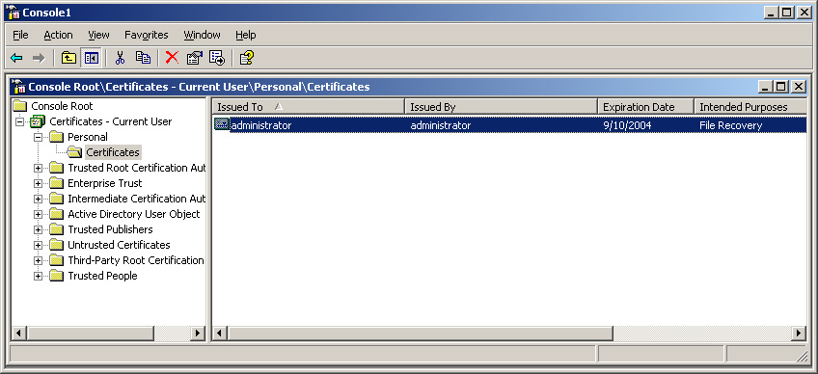
Figure 2: Exporting a Certificate and Private Key

- Right-click the certificate intended for export.
- Choose All Tasks, and then Export on the Context menu.
A wizard will guide you through the export process.
- Click Yes, export the private key (see Figure 3), and then click Next.

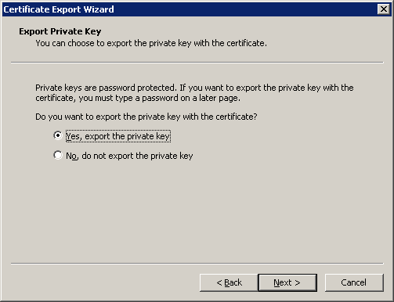
Figure 3: Exporting the Private Key

Important It is important to ensure that the “Yes, export the private key” radio button is selected in the wizard to guarantee that the private key is included in the export file.

When exporting a private key, the *.PFX file format is used. The *.PFX file format is based on the PKCS #12 standard, which is used to specify a portable format for storing or transporting a user's private keys, certificates, miscellaneous secrets, and so on. For more information, see the PKCS #12 standard in the Related Links section.

As a best practice, strong private key protection should also be used as an extra level of security on the private key when exporting. The private key should be deleted only if you are performing archival and will no longer use the key on that machine.

- Check the appropriate check boxes (see Figure 4) and click Next.
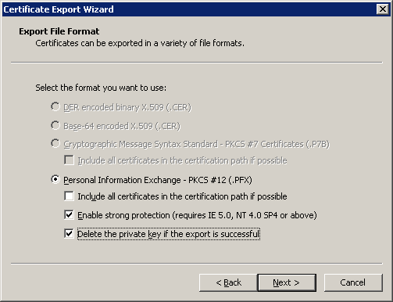
Figure 4: Choosing Export Options

- The *.PFX file format (PKCS #12) allows a password to protect the private key stored in the file. Choose a strong password, and then click Next.
- The last step is to save the actual *.PFX file. The certificate and private key can be exported to any writeable device, including a network drive or disk. After typing or browsing for a file name and path, click Next.

Once the *.PFX file and private key have been exported, the file should be secured on a stable media and transferred in a secure manner to the CA on which the key will be imported in accordance with the organization’s security guidelines and practices.

To Export Keys from Outlook

- In Outlook, go to Tools > Options, choose the Security tab, and then click Import/Export.

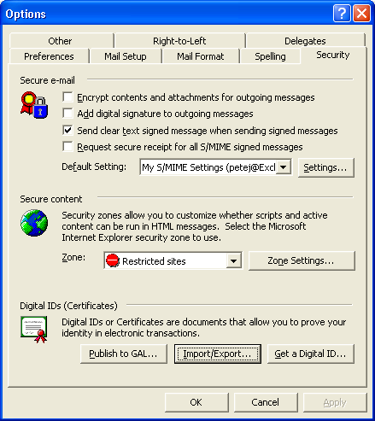
- Click Export your Digital ID to a file, and complete the Filename, Password, and Confirm (password confirmation) text boxes.

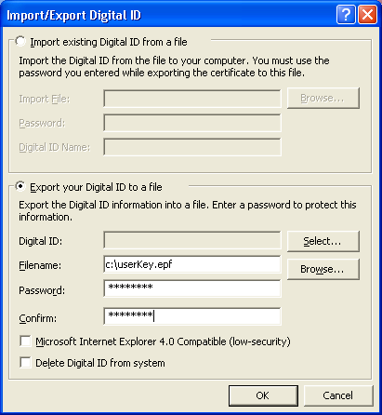

- Copy this file to a location accessible by the Certificate Server or manually transport it using a disk.

Importing a Key Manually on a CA

On the Certificate Server, open a command prompt window, and run the following command:

C:\CertUtil.exe –f –importKMS <name of file>

Note The –f flag is required when the key and certificate pair have not been issued from the CA in question.

The file may be in one of three formats:

- KMS export file
- PKCS #12 format (*.pfx file)
- Outlook export format (*.epf)

Key Archival and Recovery
The following sections document in detail how the key archival and key recovery processes work in Windows Server 2003 as well as step-by-step guides for implementing the features in production.

Understanding the Archival Process
The general steps in the archival of a user’s private key are described in the following steps and in Figure 5:

- The client finds a CA in Active Directory (enrollment services container in the configuration partition) and makes an authenticated DCOM connection to the CA.
- The client requests the Certification Authority’s exchange certificate (encryption certificate).
- The CA sends the exchange certificate to the client.
- The client validates that the CA’s exchange certificate has been signed by the same key as the CA signing certificate and performs a revocation status check. This ensures that only the intended CA may decrypt the certificate request containing the private key.
- The client encrypts the private key corresponding to the request with the CA exchange certificate public key, builds a CMC request, and sends a CMC full PKI request to the Certification Authority.
- The CA validates that the encrypted private key cryptographically pairs with the public key in the certificate request.
- The CA validates the signature on the request with the public key in the request.
- The CA encrypts the private key from the user request with a random 3DES symmetric key and then encrypts the symmetric key with one or more Key Recovery Agent (KRA) public keys.
- The CA saves the encrypted key blob containing the encrypted private key and the symmetric key encrypted with one or more KRA public keys to the CA database.
- The CA processes the certificate request normally.
- The CA responds to the client with a CMC full PKI response.

Note Only RSA encryption keys may be archived in the CA database. Signature only keys as well as non-RSA key pairs will not be archived. Denied and resubmitted requests will also not archive private keys.
Figure 5: The Protocol for Key Archival

Certificate Request
A certificate request can be driven from at least three different sources in Windows Server 2003. The sources built into the operating system are the Web browser (Internet Explorer), the certificate enrollment wizard, and auto-enrollment. All three methods call xenroll.dll (Microsoft Enrollment Control), which provides various methods to support certificate request generation and certificate installation. The certificate request uses the CMC protocol for certificate requests, which supports an optional encrypted data payload. Technically, any client that supports the CMC protocol may enroll with a Microsoft Enterprise CA and request that the private key be archived by the CA. The CA enforces the archival option through a template flag. For more information on the CMC request format, see the Appendix.

CA Exchange Certificate Retrieval
Before the private key can be encrypted and delivered to the CA server, the client must first retrieve the CA’s exchange certificate. The CA exchange certificate is an encryption certificate for the Certification Authority that can be used by clients to encrypt their private keys as part of their certificate request. The CA exchange certificate is issued by the CA itself where the subject and issuer are almost the same. However, the subject contains a suffix to distinguish the certificate from a root CA. Getting the CA exchange certificate can be accomplished using the existing ICertRequest::GetCACertificate method. The caller of the ActiveX xenroll.dll control will need to retrieve this certificate and verify it prior to calling xenroll.dll to create the request and to encrypt the private key. Xenroll will also perform this action. The client will verify that the exchange certificate is signed by the same key that issued the CA certificate. A CA may not use a certificate issued by another CA for an exchange certificate.

CA Exchange Certificate Generation
A Windows Server 2003 CA will automatically generate a short-lived exchange certificate for use of the key archival mechanisms. By default, if the CA Exchange template is available, it will be used for extensions and the validity and overlap periods. If the validity and overlap periods in the registry differ from the template, the registry values are rewritten, so there will be consistent behavior if the template is unavailable in the future. If the template is not available, the template will be ignored and the hard-coded extensions will be used along with the registry validity and overlap periods.
If the following registry flag is configured using certutil.exe, the template must be available or the attempt to generate a CA Exchange cert will fail. In addition, the machine object of the CA (LOCAL SYSTEM) must have enroll access to the template. This flag is not currently set by setup; it must be manually applied.
certutil –setreg ca\CRLFlags +CRLF_USE_XCHG_CERT_TEMPLATE
The CA Exchange certificate template has a default expiration of one week and a template overlap period of one day. Note that the above settings apply to both enterprise and stand-alone CAs.

Preventing Key Archival
Windows Server 2003 may be effectively prevented from archiving private keys through the use of qualified subordination and policy constraints. When submitting and processing a request to a parent or root CA for a subordinate CA certificate, the parent CA may exclude the key archival policy in the subordinate CA. For more information, see the Qualified Subordination white paper.

Private Key Payload
For Windows Server 2003 clients and servers, the encrypted private key is stored in an unauthenticated attribute as a CMS EnvelopedData object. This poses no concern from a security perspective as the private key is later validated to cryptographically match the public key in the certificate request, which is also signed by the same private key. For more information on the format and object structure, see the Appendix.

Key Verification
The CA must check that the encrypted private key is cryptographically associated with the public key in the certificate request. Because the client encrypted the private key using the public key from the CA’s exchange certificate, the CA can decrypt the private key payload contained in the request. For encryption keys, the CA encrypts randomly generated data with the public key in the request, and then decrypts the data with the private key passed in the unauthenticated attributes of the CMC request. The decrypted data is verified against the original random data. If any of the validation steps fail, or if the data does not match, the request is rejected. For signing keys, the CA will reject the request and will not archive a key that is marked for signature only.

To verify the cryptographic association between the public and private keys, the CA loads the key pair into a CSP that supports the specified algorithms. The CA will use the default enhanced RSA CSP on the CA by default or a hardware CSP, if available. Both the encrypted private key material payload and the private key loaded into the server-based CSP are securely discarded since the private key will be archived using a different key controlled by a recovery agent and are not available for the CA after verification of the payload. The decrypted private key memory is zeroed out prior to freeing the memory.

Key Encryption
Once the private key has been successfully verified, the CA must then encrypt the private key and archive it for future recovery. The CA will not encrypt the private key using its own key(s) to provide separation between the recovery agent role and the CA administrator role. The certificate request process and certificate issuance are completed after key archival has occurred. For more information on role separation, see the Configuring the CA to Allow Key Archival section.

The private key will be encrypted by the CA using a dynamically generated symmetric key that is itself encrypted using a public key from a Key Recovery Agent certificate (or certificates) configured on the CA. Each certificate request and private key archival operation will generate a new random 3DES symmetric using the same CSP that was used to generate the CA signing key. This ensures that an HSM can be used to generate the long-term keys that protect the individual private keys. The symmetric key algorithm is 3DES by default and cannot be changed.

If multiple recovery agents are associated with the CA, then the symmetric key will be encrypted individually with each recovery agent’s public key to allow any one recovery agent to perform a recovery operation. The actual KRA(s) used may randomly vary if a round robin selection of KRAs is chosen. For example, if a CA Admin configures four KRA certificates on a CA for use, but requires a minimum of two KRAs to be used, when the CA service starts, a random start point in the KRA list is chosen. Two of the four KRAs will be chosen from that start list start point and then for each subsequent archival operation, the list order will be incremented by two. Therefore, a round robin affect is achieved for all key archival operations. These encrypted keys along with the issued certificate will be collectively referred to as the recovery blob and are stored as a PKSC #7 encrypted blob in the database.

Key Archival
The private key database is the same as the database used to store the certificate requests. The Windows Server 2003 Certification Authority database has been extended to support storing the encrypted private key along with the associated encrypted symmetric key and issued certificate. The recovery blob will be stored in the same row as the signed certificate request and any other information the CA persists in its database for each request transaction. The actual encrypted blob is stored as an encrypted PKCS #7 blob.

The Microsoft Certification Authority uses the JET database engine upon which various JET utilities may be used for maintenance purposes.

Key Recovery
A recovery operation is initiated by an end-entity that has lost access to a private key. The end-entity is typically a user or an administrator of a machine who notifies a recovery agent about lost private key material. The recovery agent must have a Key Recovery Agent certificate (described in next section) that was used to protect the symmetric key on the private key(s) of the user in question. The recovery agent may also be a CA Officer (Certificate Manager) for that user on the CA that issued the certificate(s) in question to the user. Certificate Managers are defined in a separate configuration tab of a Certification Authority. It is at the discretion of organizational policy whether a KRA and a Certificate Manager may be combined into one role or separate roles.

The actual key recovery process retrieves the PKCS #7 encrypted recovery blob first from the database. The encrypted blob(s) is protected by ACLs to ensure that only a valid Certificate Manager is able to copy the blob from the database. The encrypted PKCS# 7 blobs in the database contain the Issuer name and serial number of each KRA certificate for KRA identification purposes during recovery.
The recovery blob consists of wrapping the encrypted PKCS#7 in the database in another (signed) PKCS#7 to allow a number of certificates to be included in the recovery blob. The returned certificates include the full chain of the user certificate being recovered, the chain of the signing CA certificate (which may differ from the CA certificate under which the user certificate was issued), and the KRA certificates to which the key was encrypted. The szOID_ARCHIVED_KEY_CERT_HASH(1.3.6.1.4.1.311.21.16) is an attribute containing the SHA-1 hash of the cert for the key being recovered, attached as an authenticated attribute to the CA signature of the recovery blob. This allows certutil -recoverkey recoveryblobfile to also display the Subject name of the KRA certificate(s) used to protect the private key blob.

It should be noted that since the Windows Server 2003 Certification Authority supports role separation, an organization could implement a two-step process to recover the private key(s) of a user. For example, a CA Officer can recover the encrypted blob of the user from the CA and a second person that holds a valid KRA certificate and private key can actually decrypt the encrypted blob. For more information, see the Key Recovery Process section.

Key Recovery Agent Certificate
A new certificate template exists in the Windows Server 2003 schema to support the key recovery agent role. This certificate will use a unique Extended Key Usage extension to identify a KRA certificate. A Windows Server 2003 Certification Authority will only use certificates that have been properly formatted as per the information provided below, although it is not necessary for the certificate to contain the Microsoft-specific extensions.

KRA certificates, when issued by a Microsoft Enterprise CA, are automatically published in the configuration container of Active Directory. The actual certificates are published to the userCertificate attribute of the KRA object. The location in the configuration container is as follows:

(CN=KRA,CN=Public Key Services,CN=Services,CN=Configuration,DC=<domainname>).

The Key Recovery Agent certificate contains the following X.509v1 fields:
- Version
- Serial Number
- Signature Algorithm
- Valid From
- Valid To
- Subject
- Issuer
- Public Key

The Key Recovery Agent certificate contains the following X.509v3 extensions identified in RFC 2459:
- Authority Key Identifier
- Subject Key Identifier
- Authority Information Access
- Key Usage
- Subject Alternative Name
- CDP (CRL Distribution Point)
- Extended Key Usage (Key Recovery OID = 1.3.6.1.4.1.311.21.6)
- Application Policies (Policy Identifier = Key Recovery Agent)

The Key Recovery Agent certificate will contain the following X.509v3 extensions specific to Microsoft:
- Certificate Template Name
- Certificate Template Information

Note None of the extensions is marked as critical; however, the Key Recovery OID must exist in the Extended Key Usage extension for the certificate to be used.

Key Archival and Recovery Walkthrough

Requirements
Key Archival and Recovery using a Windows Server 2003 certificate authority has several technical dependencies:

- Enrollment requires the CMC protocol, which is only available in Windows XP client, Windows Server 2003 clients, and through xenroll ActiveX control in the CA Web enrollment interface. Through the Web enrollment interface, Windows 2000 and Windows ME may enroll for certificates with key archival.
Note Windows 2000 and Windows ME require that the key be marked for export during key archival enrollment.

- Active Directory must have the Windows Server 2003 schema extensions.

- Mandating key archival requires a version 2 certificate template.

- Key archival is only available on a CA running Windows Server 2003 Enterprise Edition.

- Only an Enterprise Certification Authority may be used.

Note Clients running down-level operating systems, such as NT 4.0 or Windows 98, will not be able to view certificate templates that allow key archival in the Web enrollment interface.

Configuring the Certificate Server for Key Archival
The first step in enabling key archival on a CA is enrolling for one or more key recovery agent certificates.

Step 1: Enrolling a Key Recovery Agent

Configuring the Certificate Templates
A certificate template suitable for creating KRA certificates is installed in Active Directory. By default, only an Enterprise Administrator or a Domain Administrator may request a Key Recovery Agent certificate as defined by the default ACLs on the Key Recovery Agent certificate template. The certificate template ACLs are viewed in Active Directory Sites and Services MMC snap-in. Certificate templates can be cloned or edited using the Certificate Templates MMC snap-in.

Note Only a domain with the Windows Server 2003 schema will support version 2 templates and only a Windows Server 2003 Enterprise Edition may issue a version 2 template certificate.

Steps:
- Log on as an Enterprise or Domain Administrator.

- In Administrative Tools, open Active Directory Sites and Services.

- In the console tree, click Active Directory Sites and Services.

- On the View menu, enable Show Services Node.

- In the console tree, expand Services, expand Public Key Services, and then click Certificate Templates.

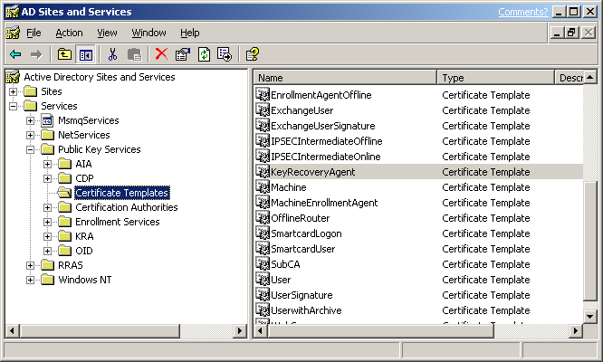

- In the details pane, double-click KeyRecoveryAgent.

- In the KeyRecoveryAgent Properties dialog box, click the Security tab.

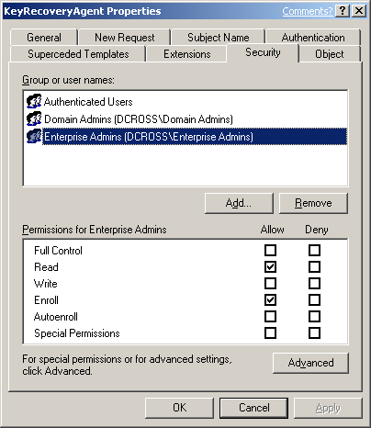

- Add the appropriate user(s) or group(s) with both Read and Enroll permission.

- Click OK to close the snap-in.

Note The previous steps may also be performed using the Certificate Templates MMC snap-in.

- Next, the Certification Authority must be configured to issue this type of certificate.

Certificate Template Permissions
For a user or a computer to enroll for a certificate template, it must have appropriate permissions (ACEs) set on the template in Active Directory. A user or computer must have both Enroll and Read permissions to enroll for a selected certificate template. The Read permission allows the template to be discovered by the user and the Enroll permission is enforced by the Enterprise Certificate Authority when a user requests a certificate for a selected template. The Enterprise Certification Authority must also have Read permissions on a template to enumerate the template in the directory and issue certificates based on that template. Normally, the Enterprise Certificate Authority is included in the Authenticated Users group which has Read permissions by default on a template.

The Full Control permission is given to Enterprise Administrators by default on installation of a fresh Windows Server 2003 domain. If a domain has been upgraded from Windows 2000, Enterprise Administrators will not have this permission by default and the Full Control permission allows a user to set or modify the permissions on a selected template.

The Autoenroll permission is set on a template when it is desired for a user or computer to automatically enroll for a selected certificate template. The Autoenroll permission is needed in additional to the Enroll permission for a user to enroll for a given certificate template.

The Write permission allows a user to modify the contents of a certificate template. It should be noted that only a version 2 certificate with a Windows Server 2003 schema may be modified and version 1 certificate templates may only have the ACLs modified.

Smartcard Support
Smartcards are supported for use in conjunction with KRA certificates. It may be necessary to use a Smartcard and CSP that supports at least an 8K Smartcard to enroll for a KRA certificate on a Smartcard. If a Smartcard does not have adequate memory to support a KRA certificate, the following error will be generated on enrollment:

Error: 0x80100028
An attempt was made to write more data than would fit in the target object

All recovery operations are supported using a Smartcard. The system will prompt the recovery agent to insert an appropriate Smartcard when the key is needed to decrypt the recovery blob. For additional information, see the Recovering Private Keys section.

Configuring an Enterprise CA
A Microsoft Enterprise CA must be configured to issue a Key Recovery Agent Certificate.

Steps:

- From Administrative Tools, open the Certification Authority snap-in.

- In the console tree, expand the Certification Authority, and then click Certificate Templates.

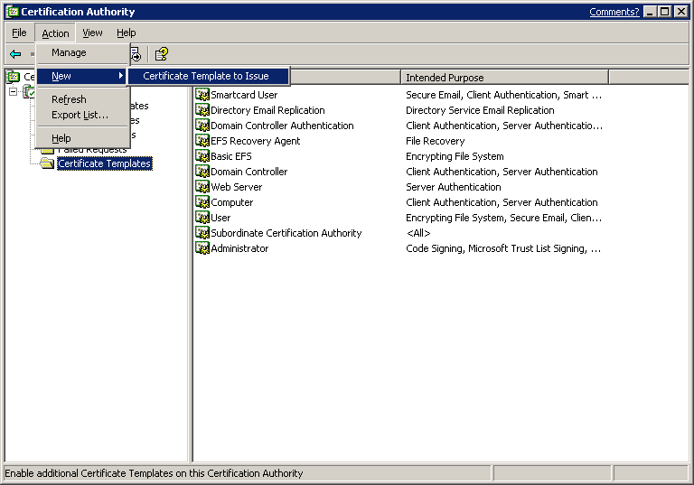

- Right-click Certificate Template, click New, and then click Certificate to Issue.

- In the Select Certificate Template dialog box, click Key Recovery Agent, and then click OK.

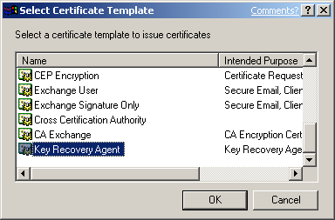

- Close the Certification Authority MMC snap-in.

- The last manual step is to add the Certificate Authority machine account to the Pre-Win2K Compatible Access group in every domain in which users will be using key archival. If this mandatory step is not performed, a CA Officer may not be able to manage groups of users. The Pre-Win2K Compatible Access group allows the CA to enumerate a user account and determine the group membership for CA Manager capability.

Enrolling a User with a KRA Certificate
A user may enroll for a certificate with a CA by using the Certificates MMC snap-in or through the CA Web pages. In the case of the Key Recovery Agent template, the template is marked to be “pended” by the CA, which requires that the certificate request be approved first by a CA Administrator or a Certificate Manager before it is issued. Pended certificate requests may only be retrieved through the Web enrollment interface or through the auto-enrollment process. For more information, see the Auto-Enrollment white paper for Windows XP: http://www.microsoft.com/WindowsXP/pro/techinfo/administration/autoenroll/default.asp

Important It is strongly recommended not to automatically enroll KRA certificates as this may cause confusion for CA Administrators when automatic enrollment is unintentionally initiated resulting in additional KRA certificates in Active Directory.

KRA Web Enrollment
To enroll through a Web page, connect to the CA using a Web URL. Example:

http://<CA Machine Name>/Certsrv

Note The Microsoft Certification Authority uses an ActiveX control known as xenroll.dll which can be downloaded to client browsers that support ActiveX controls. Windows XP and Windows Server 2003 clients both ship with the ActiveX control pre-installed.

- A Web site will open allowing you to request a certificate.

- Select Request a Certificate.

- On the next Web page, select Advanced Certificate Request.

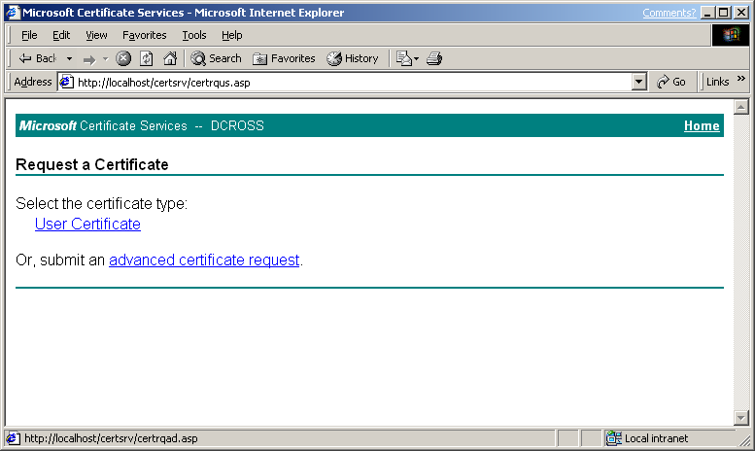

- Select Create and submit a request to this CA.

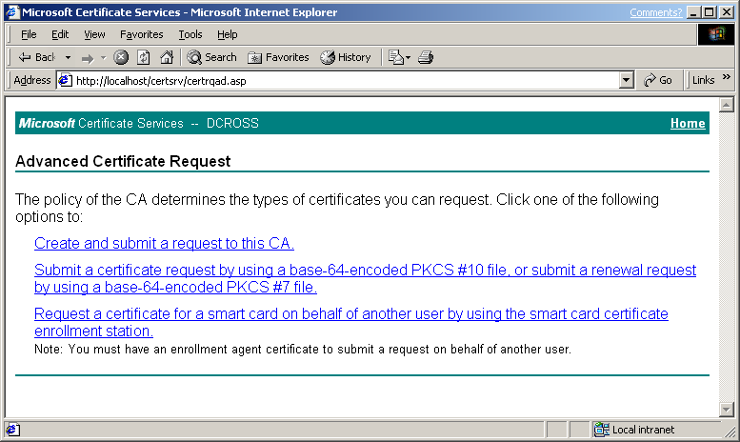

- The following page will allow the user to select various configuration options, including the type of certificate to request. Choose Key Recovery Agent as the Certificate Template.

Warning A key size of 8192 or larger may take several hours to generate on the client (key pairs are always generated by the client CSP, not the CA) and may slow public key operations on the CA when keys are archived. Key sizes of 2048 are much more reasonable for standard security needs; a key size of 8192 is used as an example only.

The keys should be marked as exportable. This will enable an administrator (Key Recovery Agent) to export the private keys from the local store of the workstation to a disk or other medium for safe storage. Strong private key protection is also recommended, as this will require a password to be used when accessing the private key.

- When finished, click Submit.

The Web page will notify that the request is being generated. When the key generation and request is complete, if the request had included Enable strong private key protection, a dialog box will appear notifying that a protected item is being created (KRA private key).

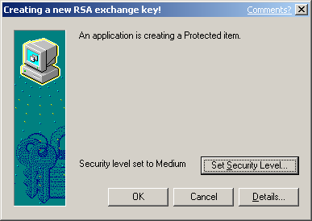

The dialog box will present the opportunity to set the security level on the private key. If the workstation will be used for KRA operations and the private key is to be kept in the protected store, it is recommended that the security level be set to High. This will ensure that access to the private key will require a separate password.

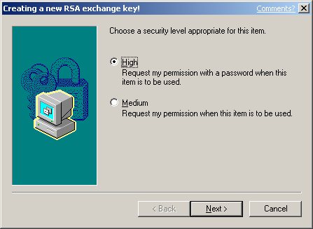

- Click Next.

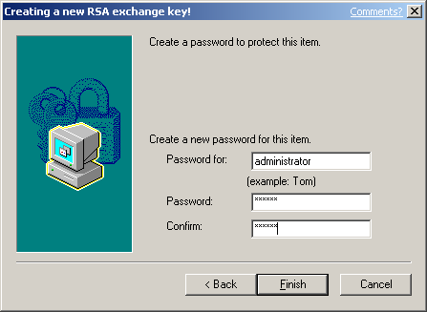

- Choose a password, confirm it, and then click Finish.

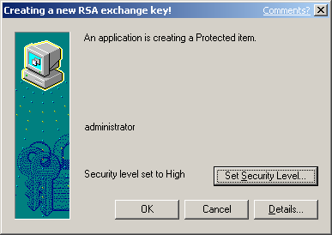

Click OK to confirm. The Web page will return and offer a link to install the certificate. If the Certification Authority is configured to set all certificate requests to pending, then the user will have to return to the Web link to install the certificate after the CA administrator or a CA Officer has approved the request.

Important The user may have to return to the Web link using the same machine that was used to generate the request. This is due to the fact that certificate pending information is stored as a browser cookie. If auto enrollment is enabled in Active Directory for the user, the user will not be required to actually return to the Web page. The auto-enrollment process will automatically retrieve the certificate for the user when available. For more information on the auto-enrollment process, see the Certificate Auto-Enrollment in Windows XP white paper.

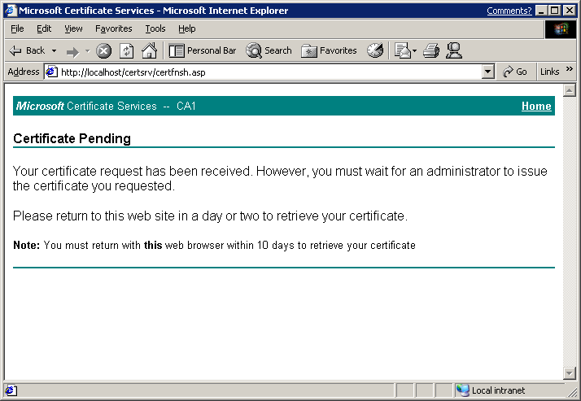

Important If the issuing CA is in a hierarchy, a second option will appear in the Web page to download the entire path (certificate chain). You should choose to download the entire chain.

The default Key Recovery Agent certificate template requires that the certificate request be pended and not issued automatically. When a certificate request is pended, a CA Officer (Certificate Manager) must manually issue the certificate, assuming that the request was valid. Pending certificate requests can be issued through the Certification Authority MMC and selecting the pending request node.

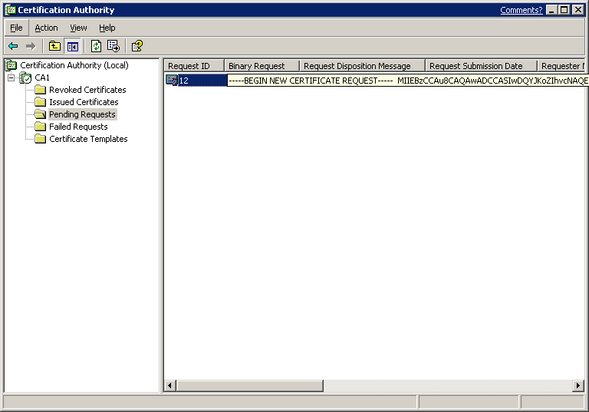

The Certificate Manager (or administrator of the server, if role separation is not enabled) can right-click the certificate request and choose to issue or deny the request. For more information on Certificate Managers, see the Configuring Certificate Managers section.

After the certificate has been issued, the user (KRA) can return to the Web pages to retrieve the pending request.

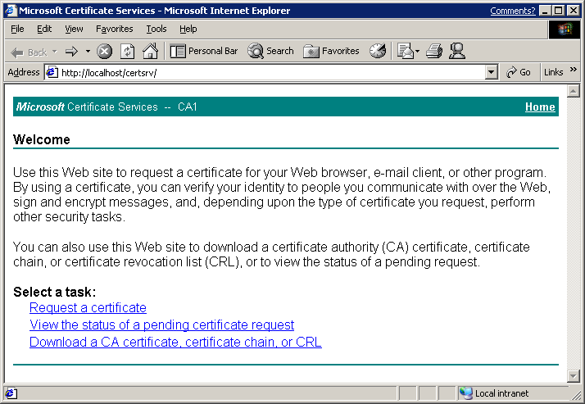

The user should select View the status of a pending certificate request.

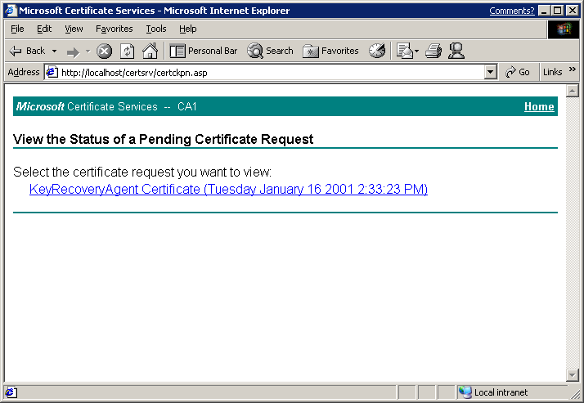

The Web page will display all the pending requests for that user that have been requested from that machine. As mentioned previously, this is managed through Web browser cookies. The user should select the appropriate certificate.

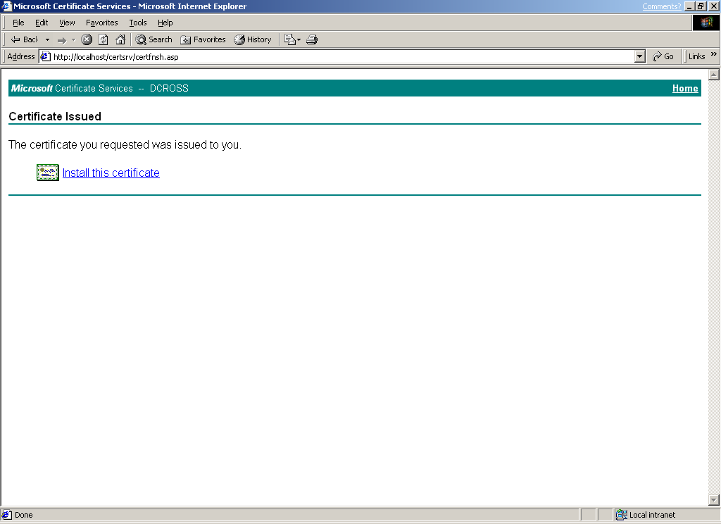

The last page allows the user to install the selected certificate and private key into the local “MY” store of the user.

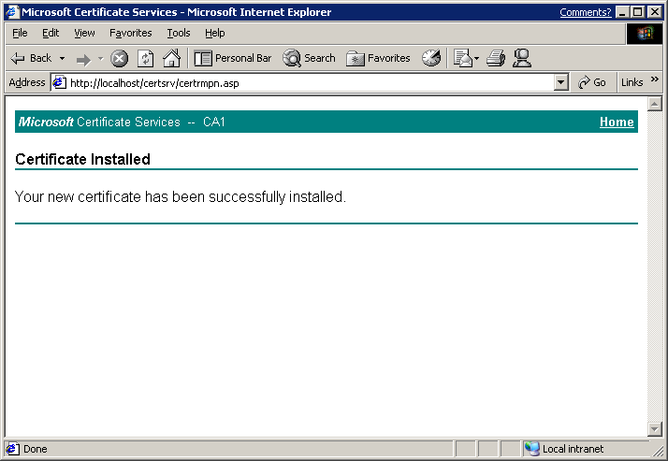

Configuring the CA to Allow Key Archival
Note If the Certification Authority is enabled to enforce role separation, only a CA Admin may configure KRAs on a CA. Role separation is enabled through the registry and only a local server administrator may configure the registry. The easiest way to enable the CA for role separation is to use the certutil.exe command-line utility:

certutil -setreg ca\RoleSeparationEnabled 1

It is necessary to stop and start certificate services for the setting to take effect.

Note Certutil.exe and other utilities may be installed on a Windows XP Professional machine by installing the Administrative Tools (adminpak.msi) that are found in the \i386 directory on all Windows Server 2003 CD-ROM media.

Enabling a Key Recovery Agent

- Logon as administrator of the server or CA Admin, if role separation is enabled.
- In Administrative Tools, open Certification Authority.
- In the console tree, select the CA.
- Right-click the CA name, and then click Properties.

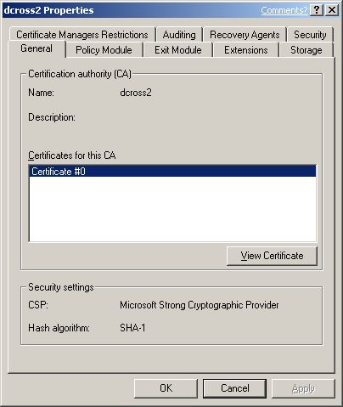

- Click the Recovery Agents tab.

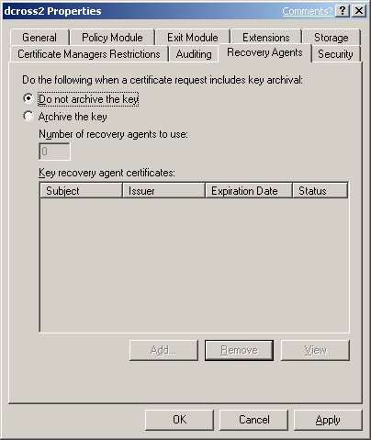

- To enable key archival, select the Archive the key button.

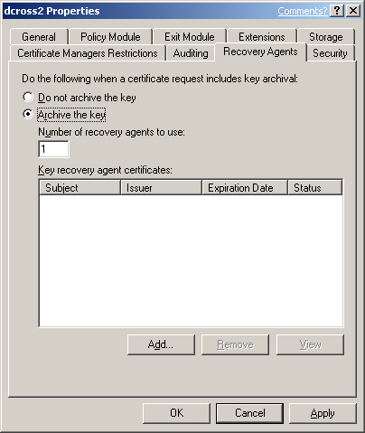

- By default, the CA will only use one Key Recovery Agent. However, a KRA certificate must first be selected for the CA to begin archival. To select a KRA certificate, click Add.

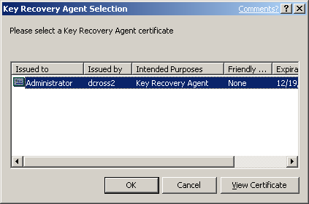

- The system will find valid KRA certificates and display the available key recovery agent certificates.

KRA certificates are normally published to Active Directory by an Enterprise CA when enrollment occurs. KRA certificates are stored under the KRA container in the Public Key Services branch of the configuration partition in Active Directory. Since a CA may issue multiple KRA certificates, each KRA certificate will be added to the multi-valued userAttribute attribute of the CA object.

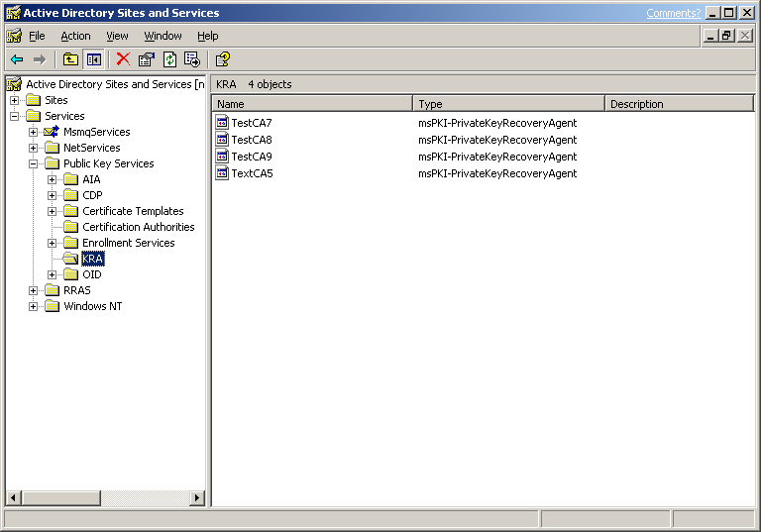

- Select one certificate and click OK. You may view the highlighted certificate to ensure you have selected the intended certificate.

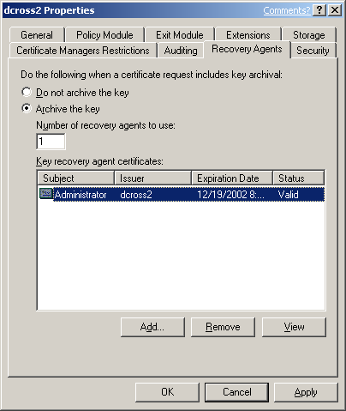

- After one or more KRA certificates have been added, click OK to enable key archival on the CA. However, Certificate Services must be stopped and started to enable the use of the selected KRAs. KRA certificates are only processed at service start. The following dialog box will appear.



Configuring Certificate Managers
To recover the private keys of a user, the CA enforces that a person be a Certificate Manager (if defined) and also holds a private key for a valid KRA certificate. As a best practice, most organizations separate these two roles. By default, the CA Admin is a Certificate Manager for all users unless otherwise explicitly defined. A KRA is not necessarily a CA Officer (Certificate Manager). They may be segmented as separate roles. A KRA is defined as a person who holds a private key for a valid KRA certificate.

A CA Officer is defined as a Certificate Manager who has the security permission on the CA to Issue and Manage Certificates. The security permissions are configured on a CA using the Security tab on the CA properties in the Certification Authority MMC snap-in.

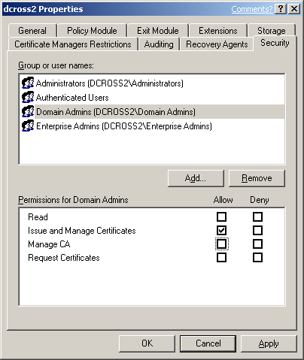

A CA Admin can define more granular CA Officer roles on a Certification Authority by using the Certificate Managers Restrictions tab. By default, any user or group that has the permission to Issue and Manage Certificates, is also a CA Officer and can issue, revoke, or export a recovery blob for any other user who has been issued a certificate from that CA.

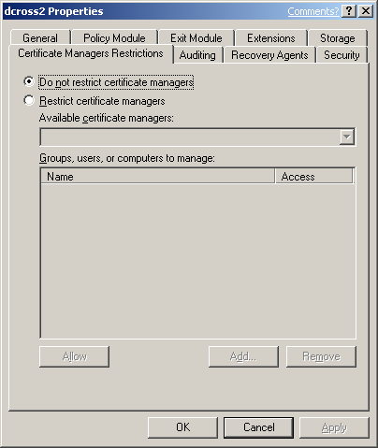

A CA Admin can define individual CA Officers the ability to issue, revoke, and recover certificates for defined sets of user(s) and group(s) by choosing the Restrict certificate managers option button. Once that button has been selected, a CA Admin may define CA Officer roles as required.

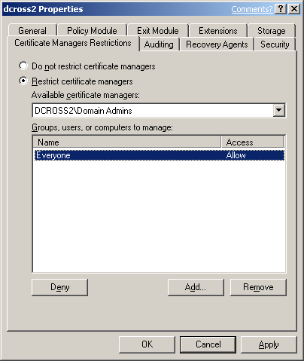

Important Once this is complete, it is also necessary to add the machine account of the CA to the Pre W2K Compatible Access Group of every domain in which users will be archived and recovered. This is necessary to provide proper group membership enumeration for role restriction enforcement when performing recovery functions. Certificate Managers will not be able to recover users unless this task is performed first in every user domain.

Configuring User Templates
To enable a user template for key archival, select the template that should enforce key archival and select the Archive subject’s encryption private key check box. Once selected, the CA will always enforce key archival for that template.

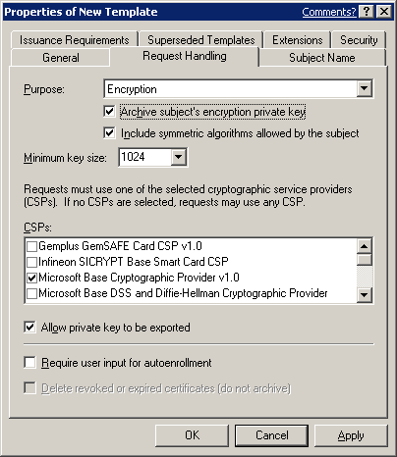

Note A Windows Server 2003 certificate authority will not allow archival of a key marked for signature only and will reject the request, even if sent programmatically to the CA.

Migrating KMS to Windows Server 2003 CA
The following are the summary steps for migrating an Exchange 2000 KMS Server to a Windows Server 2003 Certificate Authority:

- If running Exchange 5.5 KMS, upgrade to Exchange 2000.
- Configure Windows Server 2003 CA for key archival.
- Ensure that the certificate is available for database migration.
- Enable the foreign certificate import option on the CA, if necessary.
- Export the Exchange KMS database.
- Import the Exchange database into the CA.

Important Of major consideration before migrating KMS to a Windows Server 2003 Certificate Authority is the version 1 CRL that is published by the Exchange KMS server for Outlook clients in the Exchange Global Address List (GAL). If KMS is migrated to a Windows Server 2003 CA, the v1 certificates can no longer be revoked and it is recommended that a KMS migration is only performed when all V1 certificates are expired and/or are no longer being issued by KMS. If x.509 version 3 certificates are being issued by KMS with a Windows 2000 CA, the existing CA will need to be maintained to publish CRL(s) until all the original certificates issued by KMS have expired.

Create an Export Certificate on the Certificate Server
When a KMS migration to a Windows Server 2003 CA is performed, the export file from the KMS server must be encrypted with a public key certificate and then subsequently decrypted by the Windows Server 2003 CA. The CA may or may not have an encryption certificate available to be used for this process. It is absolutely critical that an encryption certificate and private key be installed in the machine store (local machine) of the CA to facilitate KMS migration. Since the Certificate Server process runs as SYSTEM, any encryption certificate and private key available in the machine store may be used.

To view the certificates installed in the local machine store, open the Certificates MMC console for the local machine and view the certificates under the Personal store. An SSL or machine authentication certificate will suffice for use in this scenario. The certificate corresponding to the private key that will be used should be manually exported and made available during the KMS migration process. For certificate enrollment, exporting certificates, and so on, see the Windows Server 2003 help files. If importing a certificate and key to be used by the CA (*.pfx file), ensure that the certificate is marked for export when importing on the CA. Otherwise, the CA may not be able to use the key and certificate for key import purposes.

Important A Windows Server 2003 always has an exchange certificate (encryption certificate) available for the purpose of key archival. Do not attempt to use this certificate for the purpose of migrating the KMS database as it will not be usable by the CA for this purpose.

Enable Foreign Certificates Import
If the KMS server contains x.509 version 1 certificates and private keys, and/or if the KMS server was not configured to the use the same CA with Windows 2000, then the foreign certificate import option must be enabled on the Windows Server 2003 CA.

Foreign Certificate Import
By default, a CA does not allow certificates (or keys) to be imported on the CA that were issued by another Certificate Authority. A CA must be enabled to accept certificates and keys into the database that were issued by a foreign CA. (An Exchange 5.5 KMS issuing v1 certs is also considered a foreign CA.) To enable this functionality, perform the following steps:

- Run the following command in a command prompt window on the CA:

certutil –setreg ca\KRAFlags +KRAF_ENABLEFOREIGN

- Once that has competed, restart the certificate server service.

Important When foreign certificates are being imported on a CA, the –f switch must be used with certutil to inform the CA that the keys and certificates will be foreign. The command line would be:

Certutil.exe –f –importKMS [name of import file]

Exporting Users’ Keys from Exchange 2000 KMS
Warning Before an export of data from the KMS server occurs, a full backup of the KMS server should be performed and validated before continuing. An export of data from a KMS server is destructive and will remove the keys from the KMS database.

Important If the KMS Server or the CA is online when the export occurs, the KMS server will attempt to revoke all version 3 certificates that are exported. If this occurs, it is important to re-enroll all users immediately with the Windows Server 2003 CA to allow continued S/MIME encryption operations. Otherwise, take the CA offline, so the KMS export operation will not revoke the existing certificates.

To perform the export operation on the KMS Server

- Start the Exchange System Manager.

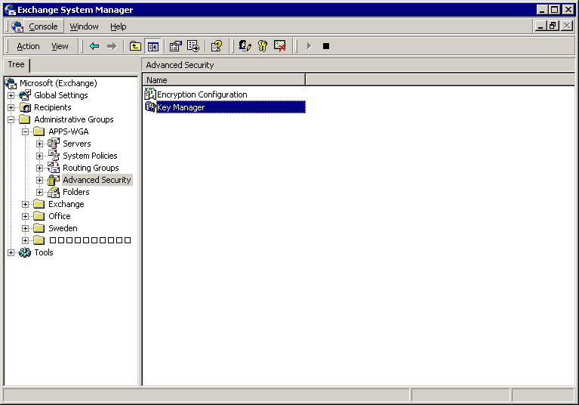

- Locate the Advanced Security node, right-click Key Manager, select All Tasks, and then Export Users.

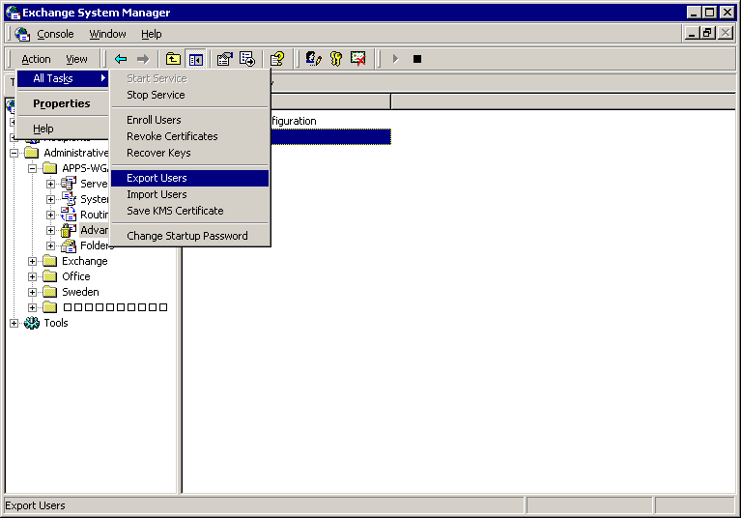

- Enter the KMS password (the default password for KMS is “password”), and then click OK.

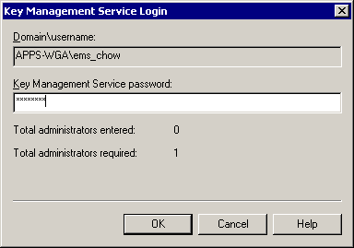

- The Exchange KMS Key Export Wizard will start. Click Next.

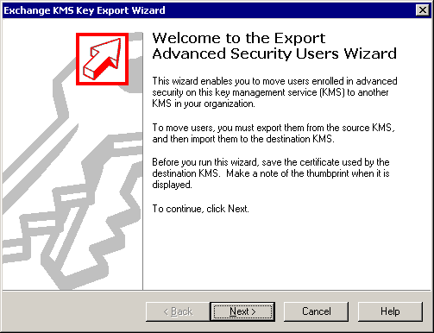

- Click Browse to select the Certificate that will be used to encrypt the export file. This is the certificate file created in the previous section.

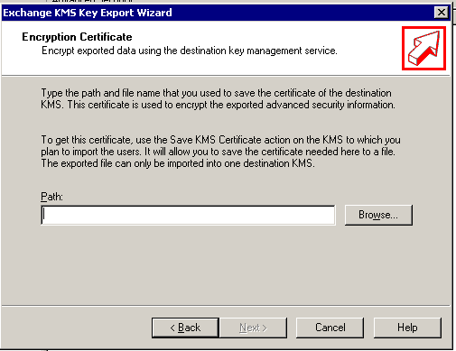

- Browse for the certificate that will be used to encrypt the export file to the CA. This is the certificate created in the previous section. Click Open.

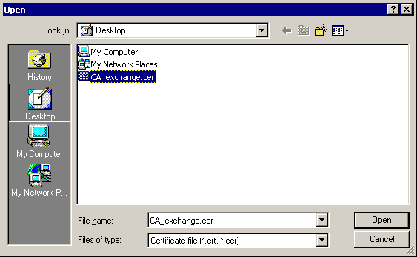

- On the Encryption Certificate screen, click Next.

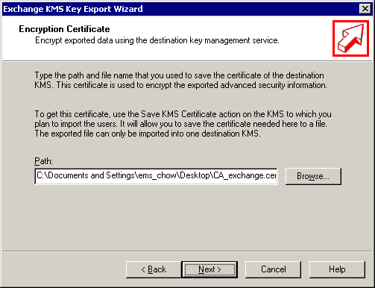

- When you reach this screen, stop for a moment and use Windows Explorer to find and open the Certificate that you chose from the screen in step 6. You will need to validate this certificate with the KMS Export wizard.

- Copy the first eight characters from the Certificate thumbprint field in the certificate chosen to encrypt the KMS export file.

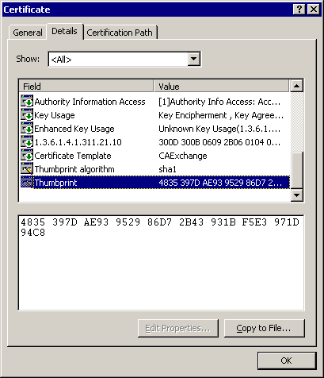

- Type the first eight characters of the certificate thumbprint in the thumbprint field, and then click Next.

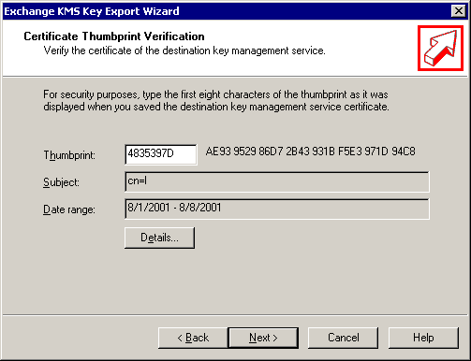

- Type the name of the export file. Do not type in a path, only the file name. It will be saved in the following location by default. This is based on the default installation for Exchange.

C:\program files\exchsrvr\KMSDATA

This file will not have an extension. Click Next.

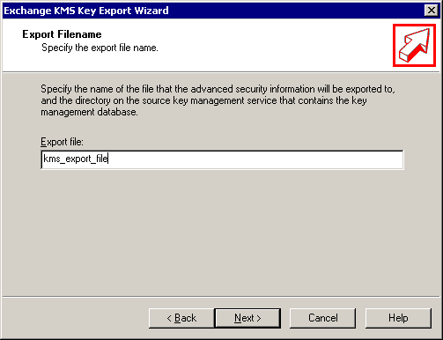

- You may select an alphabetic list of users or select by mailbox store, server, or administrative group.

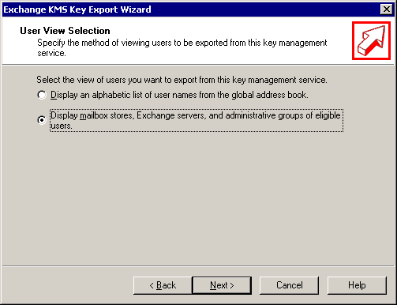

- In this case, select all of the administrative groups, and then click Next.

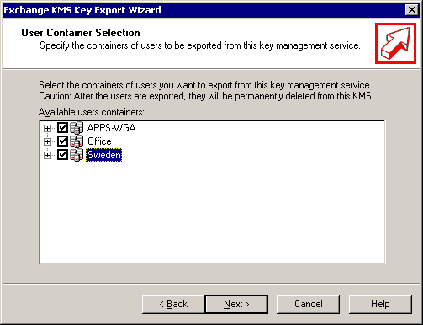

- To start the Export process after selecting the users or administrative group(s), click Next.

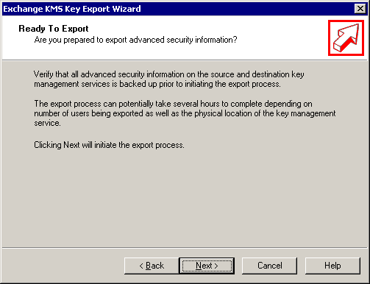

- The records will be exported. On average, approximately 100 records will be exported a minute. The actual performance will vary depending on the hardware configuration.

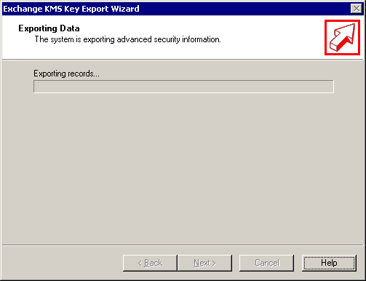

- When complete, click Next.

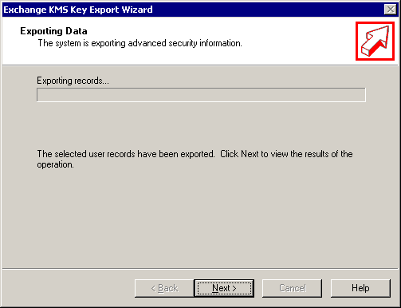

- The results will be displayed. Click Finish.

Note If large numbers of users are exported, KMS may generate multiple export files and split the exported keys across the multiple files. In this case, all export files should be re-imported to the new Certificate Authority.
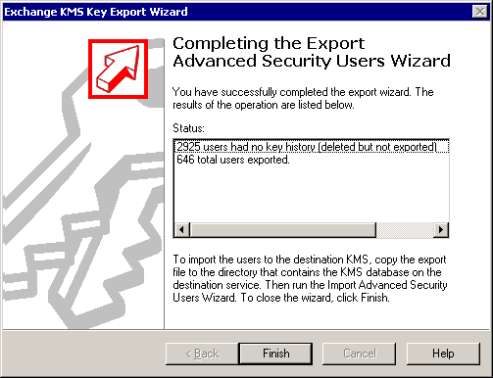

- The export file will be located in the following folder:

C:\program files\exchsrvr\KMSDATA

- Copy the KMS export file to the Certificate server that will accept the import file.

Importing Users’ Keys to the Certificate Server
The Windows Server 2003 Certificate Authority allows not only key archival, but also certificate and key importation to the CA database. Certificate and key importation is very important in providing migration services for Exchange KMS as well as for providing migration and escrow operations for certificates that were enrolled using a third-party CA. The Windows Server 2003 CA supports both certificate import as well as key import. Certificate import does not require that key archival be enabled on the CA, but key import does.

Login to the Certificate Server as the CA Administrator and follow this process:

- Open a command prompt window.

- Change to a directory containing the KMS import file.

- Run the following command:

CertUtil.exe –f –importkms <name of export file>

The output will indicate the status of the import process and the number of user keys imported and archived to the CA. The number of imported user keys should match the output from the KMS server. Sample successful output:

Processing KMS exports from:
O=microsoft, C=US

KMS export file signature verifies
Lock box opened, symmetric key successfully decrypted
..................................

Users: 6

Ignored signature certificates: 25
Certificates with keys: 17
Foreign certificates imported: 17
Certificates imported: 17

Keys: 17
Keys archived: 17
CertUtil: -ImportKMS command completed successfully.

User Key Recovery
Users may require their private keys to be recovered for a multitude of reasons. Key recovery from a Windows Server 2003 certificate authority may be accomplished using the command-line utility, certutil.exe, or through the Windows Server 2003 Resource Kit tool, krecover.exe.

The recovery of a private key is a manual process that requires the user(s) to contact an administrative authority to perform the necessary processes. It should be a best practice of any organization to

- Validate the identity of a user requesting key recovery.

- Separate the roles of CA Officer and KRA as a minimum of two physical persons.

- Develop a mechanism to securely deliver the private keys and passwords to end users. Examples could include e-mail of the *.pfx file and leaving a voice mail with the password for the *.pfx file for the user. Discussion of these best practices is beyond the scope of this technical white paper.

Command Line Key Recovery
To recover a private key for a user, the CA Officer must know one of the following:

- The serial number(s) of the certificate(s) to be recovered
- The cn (CommonName) of the user that requested the certificate
- The UPN (User Principal Name) of the user stored in the certificate
- The hash(es) (SHA-1 thumbprint) of the certificate(s) to be recovered

A CA Officer may determine the serial number of a certificate that has been archived, by completing the following steps:

- Log on to a CA or a Windows XP Professional machine that has the Administration Tools pack installed as a CA Officer who has Certificate Management authority of the user(s) in question.
- From Administrative Tools, open Certification Authority.
- In the console tree, expand Certification Authority, and then click Issued Certificates.
- On the View menu, click Add/Remove Columns.
- In the Add/Remove Columns dialog box, in the Available Column list, select Archived Key, and then click Add.
Archived Key should now appear in the Displayed Columns listing.
- Click OK.
- In the details pane, scroll to the right and ensure that the last issued key has a value in the Archived Key column.
- Double-click the user certificate.
- Click the Details tab
- Write down the serial number of the certificate (do not include spacing between digit pairs). This is required for recovery.
- Click OK.
- Close Certification Authority.

Recovery Batch File
The certutil.exe –getkey command is an advanced tool that can be used with explicit commands and also build batch file syntax to perform a complete recovery operation. The following is the command-line syntax for certutil.exe –getkey:

Usage:
CertUtil -GetKey [Options] SearchToken [RecoveryBlobOutFile]
Retrieve archived private key recovery blob

SearchToken -- Used to select the keys and certificates to be recovered. Can be any of the following:

- Certificate Common Name
- Certificate Serial Number
- Certificate SHA-1 hash
- Requester Name (domain\user)
- UPN (domain@user)

RecoveryBlobOutFile -- output file containing a certificate chain and an associated private key, still encrypted to one or more Key Recovery Agent certificates.

If the following command is performed using any of the previous SearchToken criteria, the certutil.exe utility will output the complete syntax that can be used in an output file. Example:

certutil -getkey user1@northwindtraders.com

@goto start
Querying northwind5.nwtraders.com\TestCA9.....................

"northwind5.nwtraders.com\TestCA9"
Serial Number: 611e23c200030000000e
Subject: E=user1@nwtraders.com, CN=user1, CN=Users, DC=nwtraders, DC=com
UPN:user1@nwtraders.com
NotBefore: 1/12/2002 1:24 PM
NotAfter: 1/12/2003 1:24 PM
Template: EFS2
Version: 3
Cert Hash(sha1): d6 41 99 e7 e7 24 73 34 02 41 53 2d 29 11 a8 3b e6 aa 12 2f

Serial Number: 6131f9c300030000000f
Subject: E=user1@nwtraders.com, CN=user1, CN=Users, DC=nwtraders, DC=com
UPN:user1@nwtraders.nttest.microsoft.com
NotBefore: 1/12/2002 1:45 PM
NotAfter: 1/12/2003 1:45 PM
Template: EFS2
Version: 3
Cert Hash(sha1): 1a cc 8d 26 7f 9f 70 6c 65 05 a0 84 8c 4c e9 b7 b4 6c 66 a3

:start

@echo Version 3 certificates and keys:
CertUtil -config "northwind5.nwtraders.com\TestCA9" -getkey
611e23c200030000000e "user1-611e23c200030000000e.rec"

CertUtil -config "northwind5.nwtraders.com\TestCA9" -getkey
6131f9c300030000000f "user1-6131f9c300030000000f.rec"

CertUtil -p "UQcYLsJ(57s]FuBl" -recoverkey -user "user1-611e23c200030000000e.rec" "
user1-611e23c200030000000e.p12"

CertUtil -p "UQcYLsJ(57s]FuBl" -recoverkey -user "user1-6131f9c300030000000f.rec" "
user1-6131f9c300030000000f.p12"

CertUtil -p "UQcYLsJ(57s]FuBl,iG1-bOt&tqdvJiu1" -MergePFX -user "user1-611e23c20003
0000000e.p12,user1-6131f9c300030000000f.p12" "user1.p12"

@del user1-611e23c200030000000e.rec
@del user1-611e23c200030000000e.p12
@del user1-6131f9c300030000000f.rec
@del user1-6131f9c300030000000f.p12
@echo PASSWORD: "iG1-bOt&tqdvJiu1"

@goto exit
CertUtil: -GetKey command FAILED: 0x8002802c (-2147319764)
CertUtil: Ambiguous name.

The following is an explanation of the previous syntax, which will ultimately be copied into a batch file *.bat and run by Certificate Managers that hold a valid KRA private key:

The first thing the utility does is find all possible CAs that are registered in Active Directory. Then, it will query each CA for keys that have been archived for the specified user:

@goto start
Querying northwind5.nwtraders.com\TestCA9.....................

Next, it will show the archived keys found for the user on each CA that is queried. It will list the most important details on each archived key found that will be useful for Certificate Managers and administrators:

"northwind5.nwtraders.com\TestCA9"
Serial Number: 611e23c200030000000e
Subject: E=user1@nwtraders.com, CN=user1, CN=Users, DC=nwtraders, DC=com
UPN:user1@nwtraders.com
NotBefore: 1/12/2002 1:24 PM
NotAfter: 1/12/2003 1:24 PM
Template: EFS2
Version: 3
Cert Hash(sha1): d6 41 99 e7 e7 24 73 34 02 41 53 2d 29 11 a8 3b e6 aa 12 2f

Serial Number: 6131f9c300030000000f
Subject: E=user1@nwtraders.com, CN=user1, CN=Users, DC=nwtraders, DC=com
UPN:user1@nwtraders.nttest.microsoft.com
NotBefore: 1/12/2002 1:45 PM
NotAfter: 1/12/2003 1:45 PM
Template: EFS2
Version: 3
Cert Hash(sha1): 1a cc 8d 26 7f 9f 70 6c 65 05 a0 84 8c 4c e9 b7 b4 6c 66 a3

Next, it will retrieve the encrypted recovery blob(s) from the CA. Note that the administrator must be a Certificate Manager for the recovered user(s) on the CA:

@echo Version 3 certificates and keys:
CertUtil -config "northwind5.nwtraders.com\TestCA9" -getkey
611e23c200030000000e "user1-611e23c200030000000e.rec"

CertUtil -config "northwind5.nwtraders.com\TestCA9" -getkey
6131f9c300030000000f "user1-6131f9c300030000000f.rec"

Next, it will decrypt the recovery blob(s) and generate *.pfx files (PKCS 312 format) for each recovered key and set a random password as denoted after the –p parameter. Note that the administrator must have a valid KRA private key to perform this step:

CertUtil -p "UQcYLsJ(57s]FuBl" -recoverkey -user "user1-611e23c200030000000e.rec" "
user1-611e23c200030000000e.p12"

CertUtil -p "UQcYLsJ(57s]FuBl" -recoverkey -user "user1-6131f9c300030000000f.rec" "
user1-6131f9c300030000000f.p12"

Next, it will merge the multiple *.pfx files (if applicable) into a single *.pfx file to simplify the process for the user installing recovered keys. The certutil.exe –MergePFX command is automatically used to perform this process:

CertUtil -p "UQcYLsJ(57s]FuBl,iG1-bOt&tqdvJiu1" -MergePFX -user "user1-611e23c200030000000e.p12,user1-6131f9c300030000000f.p12" "user1.p12"

Finally, the utility will clean up any temporary files used during the process:

@del user1-611e23c200030000000e.rec
@del user1-611e23c200030000000e.p12
@del user1-6131f9c300030000000f.rec
@del user1-6131f9c300030000000f.p12
@echo PASSWORD: "iG1-bOt&tqdvJiu1"

@goto exit

Note that the following output is expected when the user has multiple archived keys:

CertUtil: -GetKey command FAILED: 0x8002802c (-2147319764)
CertUtil: Ambiguous name.

Recovery Using the Certificate Serial Number
Once the serial number(s) is known, key recovery can occur through the certutil.exe command- line utility. It is not necessary to run certutil.exe from the Certification Authority; it may be run from any Windows XP workstation in the domain that has the Windows Server 2003 Administration Tools Pack installed, provided the user has Certificate Manager permissions on the CA. If the CA` name is not specified on the command line, certutil.exe will check Active Directory for all CAs listed, and then query all identified CAs for the information. The certutil.exe command structure was designed to perform batch and scripted processes.

To recover private key(s)

- Open a command prompt window.
- At the command prompt, type
“Certutil -getkey #################### outputblob”
where #################### is the serial number of the certificate that should be recovered and outputblob is the file name of the encrypted blob that is extracted from the CA database.
- If a specific CA is to be targeted instead of all Enterprise CAs in the forest, use the following syntax:
“Certutil -config <machine name\CA name> -getkey #################### outputblob”
- The outputblob file is a PKCS#7 file containing the KRA cert(s) and the user certificate with its entire certificate chain. The inner content is an encrypted PKCS#7 structure containing the private key (encrypted to the KRA cert(s)).
- To decrypt the PKCS#7 encrypted blob, the logged on user must have the private key of one or more of the KRAs for the target encrypted blob. If the CA Officer is not a Key Recovery Agent, the CA Officer must transfer the encrypted blob file to a user that holds a KRA private key for further processing.
- At the command prompt, type “Certutil -recoverkey outputblob user.pfx –p password” where:
  - outputblob is the encrypted PKCS#7 file to be decrypted.
  - user.pfx is the output file name for the user private keys in PKCS #12 format.
  - password is the password for the *.pfx file.

- The PKCS#12 format allows for the private key file to be protected with a password. Certutil.exe will prompt the KRA for a password when generating the PKCS#12 file.
- Enter and confirm a password for the file that cannot be randomly guessed. The user should be given the password through a secure out-of-band mechanism that is separate from the file itself to ensure strong security in the recovery process.

Note An event log message will be generated when a private key is recovered from the database. The event log message will be similar to the following:

Event Type: Success Audit
Event Source: Security
Event Category: Object Access
Event ID: 787
Date: 2/19/2001
Time: 5:23:45 PM
User: NWTRADERS\User1
Computer: SERVER1
Description: Certificate Services retrieved an archived key. Request ID 12

Finding Recovery Candidates
A CA Officer (Certificate Manager) can perform recovery of private key(s) using the CN (CommonName), UPN (UserPrincipalName), down-level name (domainname\username), or certificate serial number of the user who enrolled for a certificate with private key archival. Examples:

- User1@nwtraders.com (denotes UPN)
- nwtraders\user1 (denotes down level name)
- Users\nuser1 (this denotes a user in the default users container of the Active Directory)
- User1 (denotes cn)
- <serial number of the cert>
- <SHA1 hash (thumbprint) of certificate>

The process is known as finding candidate certificates for recovery. To recover a user using their common name (cn), type the following command:

“Certutil -getkey <cn of user> outputblob”

If only one certificate has been issued to that user, that certificate and private key will be generated into the specified <outputblob> file. If more than one certificate has been issued to that cn, certutil.exe will list the serial number(s) of all the certificates issued to that cn name on a specific Certification Authority. Example:

"user1.nwtraders.com\CA1"
Serial Number: 1464be10000000000007
Subject: CN=user1, CN=Users, DC=nwtraders, DC=com
NotBefore: 1/13/2001 11:51 AM
NotAfter: 1/13/2002 11:51 AM
Template: KeyA, KeyArchival
Cert Hash(sha1): a2 7f 77 bc 2f 7b eb 26 bd 3e ed 43 b8 2a 24 04 2e 55 b8 64

Serial Number: 1464fcbc000000000008
Subject: CN=user1, CN=Users, DC=nwtraders, DC=com
NotBefore: 1/13/2001 11:51 AM
NotAfter: 1/13/2002 11:51 AM
Template: KeyA, KeyArchival
Cert Hash(sha1): 21 bd 88 2c 2a 84 0c e5 57 7b 2a bf f0 43 4b b3 ed bf 02 5a

Once the actual serial number of the certificate is known, the command may be run again with the serial number instead of the CN (CommonName) to retrieve the actual recovery blob. The system will search for a valid private key in the store of the logged in user that corresponds to a valid KRA certificate that was used to encrypt the recovery blob. If the user does not have the proper private key in their local store, they will get an error.

Important If a CA Admin has configured the server to use, for example, three KRAs out of a possible five available KRAs, certutil -recoverkey will list the three KRAs that were used to encrypt the selected subject's private key. At the time of archival, the three KRAs were randomly selected (out of five possible) by the CA to encrypt the subjects private key. To perform the recovery operation, it will be necessary to have one of any of the KRAs listed by certutil -recoverkey.

CA Officer Does Not Have a KRA Certificate
As mentioned previously, a CA Officer need not also hold a KRA certificate. In the case where the CA Officer does not hold a valid KRA certificate and only has permissions to retrieve a recovery blob, running certutil.exe –getkey <serial number> with no output file name will list the certificate hashes (thumbprints) of all of the KRA(s) that may be used to decrypt (recover) the recovery blob in question. The CA Officer can then determine which Key Recovery Agent(s) may be used and send the recovery blob to one of the valid KRA(s).

The previous procedure is extremely useful in an organization that has a round-robin selection of KRA(s) when archiving private keys. In a round-robin archival, it may be difficult to always predict which KRA(s) were used to encrypt any specific private key of a user. It is probably a good best practice to keep the list of all KRA certificates hashes accessible so that they may be readily identified in the previous scenario.

The following certutil command may be used to list all the information from the DS, including KRA certificate hashes:

Certutil.exe –DS – v > c:\output.txt

Note This command will dump all PKI information and certificates from Active Directory and may be more usable when placing the output in a text file as shown previously.

Setting the Timeout Option
When keys are recovered from a CA using the command line or the key recovery tool, the recovery tool(s) will build a complete chain for the end-entity certificate, if possible. Sometimes a chain may not be able to be built after a long time due to infrastructure changes, CA certificate availability, and so on, and the tool may timeout when trying to build these chains. The certutil –recoverkey command and other commands that verify chains or construct PFXs accept a –t MilliscondCount option. This allows key recovery to avoid a 15-second timeout for each user key when building a chain. Fetching the AIA URLs can time out when the recovered keys are associated with expired encryption certificates and the CAs have been decommissioned. For more information on certificate chains and status, see the following white paper: http://www.microsoft.com/technet/treeview/default.asp?url=/technet/prodtechnol/WinXPPro/support/tshtcrl.asp

Using the Key Recovery Tool
The key recovery tool is a Windows Server 2003 Resource Kit tool for recovering keys from a Windows Server 2003 CA instead of using the certutil.exe command-line utility.

The tool may be launched from the command line by running krecover.exe. The tool is dependent on the existence of the certutil.exe and other binaries, which are available by default on the server version of Windows Server 2003 and through the Administration tool pack on Windows XP Professional. The tool is also dependent on one dynamically linked library (crutredir.dll) which is installed by the resource kit.

When launched, the tool will look similar to the following.

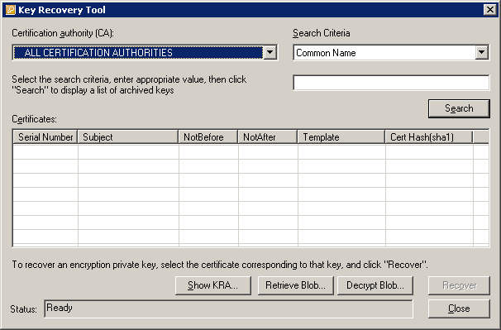
The tool will automatically enumerate the forest for the currently logged on user and identify enterprise CAs that may have archived private keys stored. The tool will filter out the following from the list of available CAs:

- CAs that are not Microsoft Enterprise CAs
- CAs that are not running Windows Server 2003 Enterprise Edition
- CAs that are running Windows 2000
- CAs that the current user does not have CA Admin or CA Manager permissions for

The following are several options enabled by the tool:

- Search – Allows a Certificate Manager to search for archived keys for a user based on several search criteria options
- Recover – Allows a Certificate Manager who holds a KRA private key to recover a user from a CA database
- Show KRA – Displays the valid KRA certificates that may decrypt the user private key
- Retrieve Blob – Allows a Certificate Manager to retrieve the encrypted user’s private key from the database for the purpose of transferring to a KRA
- Decrypt Blob – Allows a KRA to decrypt and create a PFX for an encrypted blob retrieved from the database by a Certificate Manager

If the user does not have adequate permissions on the CA to recover a user or is not a Certificate Manager, an error similar to the following will be displayed:

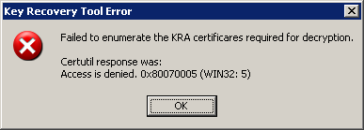

Recovering a User
To recover the private key(s) of a specific user, enter a user name and click List to list all the certificates for that user with an archived key. In the User Name field, enter the user name as above, or domain\user_name, or user_name@northwindtraders.com—any input that is valid for the certutil -getkey command.

Important For the key recovery tool to recover a key for a user, the same permissions apply as in the certutil.exe command line as described in the previous section.

If no key(s) is found for the selected user on the selected CA(s), the following dialog box will appear:

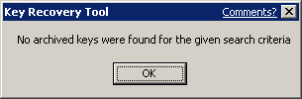
- Or -

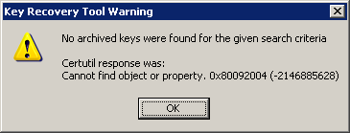
Here you can select one or more certificates to be recovered, and then click Recover. If you select more than one certificate, you will be prompted if you want all the keys to be recovered in a single PFX file, or if you want separate PFXs for every cert.

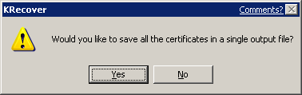

In either case, you will be prompted for a destination for the PFX file. The dialog box looks like the following.

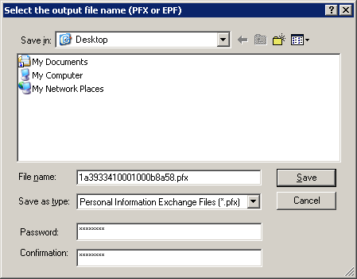
When saving a PFX file, the tool will prompt for a location to save the PFX file and require a password to be set on the PKCS #12 file. When recovering a single private key, the default name for the PFX file will be the certificate serial number that corresponds to the private key. The output file name may be changed.

If the tool cannot recover a key for a user, the following dialog box will be displayed.

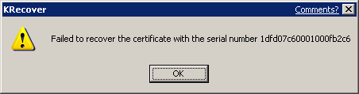
If you do not have a valid certificate and private key for a Key Recovery Agent that was used to encrypt and archive the private key of the user on the CA, the following error will be displayed.

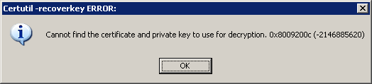

Recovering Version 1 and Version 3 Certificates
A Windows Server 2003 certificate authority may be used to archive both X.509, and version 1 and version 3 certificates as detailed previously in this white paper. The key recovery tool allows recovery of both types, although x.509 version 1 certificates must be exported separately as they may only be exported in the *.epf format for Microsoft Outlook. The Windows Server 2003 certificate authority supports the following version 1 certificates and keys to be imported and exported from the database:

- Profile Version=2, CAST=3, Protection=40, EPFALG_CAST_MD5
- Profile Version=2, CAST=3, Protection=64, EPFALG_CAST_MD5
- Profile Version=3, HashCount=0, Protection=128, EPFALG_RC2_SHA
- Profile Version=3, Protection=128, EPFALG_3DES

If no version 1 certificates are in the recovery selection, the user will not be prompted any differently. If one x.509 version 1 certificate is in the selection, the user will be prompted for an *.epf file name for export. If more than one x.509 version1 certificate is selected, the user will be prompted whether they would like one *.epf file or separate *.epf files for each key recovered. X.509 version 1 certificates will be recovered first and then the x.509 version 3 certificates will be recovered second. If the user has selected both version 1 and version 3 certificates, the user will be prompted twice whether the certificates should be recovered in a single file or separate files. X.509 version 1 and version 3 certificates may not be recovered in a single file together.

Importing Recovered Keys
The following steps would be performed by an end user who has received the recovered key file (*.pfx file) and associated password from an administrator. It is assumed that the password and associated file have been transmitted to the user in a method consistent with the organization’s security policy.

To import a recovered key for an individual user

- Log on as the user who needs to recover their private key(s).
- On the Start menu, select Run.
- Type mmc.exe, and then press ENTER.
An empty MMC shell starts up.
- Select the Console menu, and then select Add/Remove Snap-In.
A dialog box appears with a list of all the snap-ins that have been added to this MMC shell.
- Click Add.
A list of all the registered snap-ins on the current machine appears.
- Double-click the Certificates snap-in, choose My User Account, and then click Finish.
- On the Add Standalone Snap-In dialog box, click Close, and then click OK on the Add/Remove Snap-in dialog box.
The MMC now contains the personal certificate store for the user.
- Expand the tree view of the certificate store. Click Certificates, Current User, Personal, and then Certificates.
- In the console tree, right-click Personal, click All Tasks, and then click Import.
- In the Certificate Import Wizard dialog box, click Next.
- On the Files to Import page, in the File name box, type the name and path of the recovered key file (*.pfx), and then click Next.
- On the Password page, in the Password box, type the password for the key file, and then click Next.
- On the Certificate Store page, click Automatically select the certificate store based on the type of certificate, and then click Next.
- On the Completing the Certificate Import Wizard page, click Finish.
The wizard will report that the import was successful.

Note A *.pfx file can also be selected (double-click) to invoke the certificate import wizard.

Troubleshooting

KRA Configuration Troubleshooting
This section identifies a number of common mistakes in configuring the Key Recovery Agents on a CA. The most common error in archiving user private keys on a CA is that the CA is either not configured for key archival or does not have any valid KRA certificate(s) added.

- The number of recovery agents required by the CA must be less than or equal to the number of available KRA certificates. If an invalid number of recovery agents is entered, the following error message will appear.

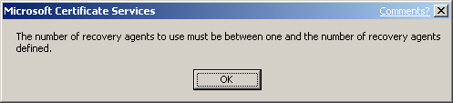

- If an error occurs in trying to validate the KRA certificate when Certificate Services is started, the Recovery Agents tab on the Certification Authority will show that the selected KRA certificate is invalid. This can occur due to a corrupted certificate, corrupted registry entry, deleted certificate, revoked certificate, and so on. The following example of a corrupted certificate or registry entry in the Recovery Agents tab is shown in the Status column of the selected KRA.

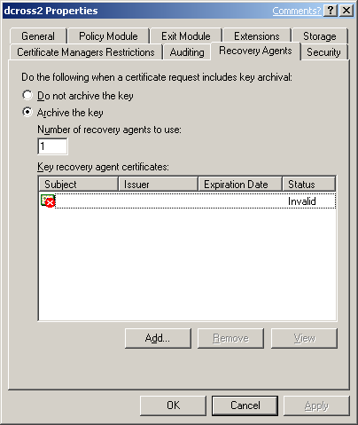

- Similarly, a revoked KRA certificate will also show an error in the Recovery Agents tab when Certificate Services is stopped and started. The error will be displayed in the status column of the Key recovery agents listing.

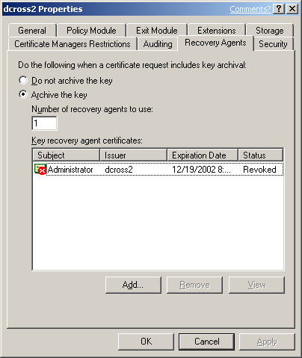

Loading KRA Certificates
When certificate services starts on a Certification Authority, the CA attempts to load the KRA(s) defined by the CA Admin. If the CA is unable to load one or more KRA(s), event log messages will be generated, however, certificate services will continue to start. If the CA is unable to load a KRA(s) successfully as defined by a CA Admin, the CA will deny all requests for key archival and not issue any certificates that have key archival defined in the certificate template. The following event log messages may appear in the Certification Authority’s Application Log when an error occurs in loading Key Recovery Agent certificates. The event log messages indicate that action is required by a CA Admin to properly configure or reconfigure Key Recovery Agents:

Event Type: Error
Event Source: CertSvc
Event Category: None
Event ID: 83
Date: 12/20/2000
Time: 8:24:24 AM
User: N/A
Computer: SERVER1
Description:
Certificate Services encountered an error loading key recovery certificates. Requests to archive private keys will not be accepted. The system cannot find the file specified.
0x80070002 (WIN32: 2)

This is a global error that can be caused by one of several conditions:

- The Certification Authority cannot open the KRA store on the local machine.
- The Certification Authority cannot find a corresponding certificate in the KRA store on the local machine that matches the hash of a certificate set in the registry as a KRA.
- The registry has been edited incorrectly or is corrupted.
- The count of KRA certificate hashes in the registry equals zero.
- A certificate hash in the registry corresponds to a certificate in the KRA store that is not a KRA certificate type.
- The KRA certificates are revoked, expired, or invalid.

Event Type: Error
Event Source: CertSvc
Event Category: None
Event ID: 82
Date: 12/27/2000
Time: 9:05:25 AM
User: N/A
Computer: SERVER1
Description:
Certificate Services could not load any valid key recovery certificates. Requests to archive private keys will not be accepted.

This error is usually caused when none of the certificates specified in the UI (which corresponds to the registry) is a valid KRA certificate. This event log message is usually accompanied by the global event log message above.

Event Type: Error
Event Source: CertSvc
Event Category: None
Event ID: 84
Date: 1/24/2003
Time: 08:49:27
User: N/A
Computer: SERVER1
Description:
Certificate Services will not use key recovery certificate 6 because it could not be verified for use as a Key Recovery Agent. CN=User1, OU=Users, DC=nwtraders, DC=com The revocation function was unable to check revocation because the revocation server was offline. 0x80092013 (-2146885613)

This error usually occurs when the CA receives an error when retrieving the CRL to check the status of the KRA certificate.

Event Type: Error
Event Source: CertSvc
Event Category: None
Event ID: 98
Date: 1/24/2003
Time: 08:49:28
User: N/A
Computer: SERVER1
Description:
Certificate Services encountered errors validating configured key recovery certificates. Requests to archive private keys will no longer be accepted.

Event Type: Error
Event Source: CertSvc
Event Category: None
Event ID: 85
Date: 12/27/2000
Time: 9:05:25 AM
User: N/A
Computer: SERVER1
Description:
Certificate Services ignored key recovery certificate 0 because it could not be loaded. Cannot find object or property. 0x80092004 (-2146885628)

This error usually occurs when a specific KRA certificate cannot be found in the KRA store on the local machine of the Certification Authority. Specifically, a KRA certificate has been specified in the UI or registry and the certificate has been deleted or corrupted in the KRA store. This event log message is usually accompanied by a more global event log message.

KRA Certificate Status
When certificate services starts on a Certification Authority, the CA attempts to load the configured KRA(s). The CA must validate the status of each KRA certificate. If the CA is unable to retrieve a current CRL for each KRA certificate, the CA will not be able to load and use that KRA.

The following event log message will be logged in the application event log of the CA:

Event Type: Error
Event Source: CertSvc
Event Category: None
Event ID: 84
Date: 1/12/2001
Time: 11:47:23 AM
User: N/A
Computer: SERVER1
Description:
Certificate Services ignored key recovery certificate 1 because it could not be verified for use as a Key Recovery Agent. CN=User1, OU=Users, DC=nwtraders, DC=com The revocation function was unable to check revocation because the revocation server was offline.
0x80092013 (-2146885613)

User Enrollment Errors
A user certificate request for a template that requires key archival will be denied if one of the following conditions exists:

- No KRA has been defined on the CA.
- No KRA can be successfully loaded. (KRA certificates are revoked, expired, and so on.)
- The minimum number of KRA certificates defined by the CA admin cannot be loaded.

If the user enrolls through a Web page, the following text will display on the Web page:

Your request failed. An error occurred while the server was processing your request.
Contact your administrator for further assistance.
Request Mode:
newreq - New Request Disposition:
(never set) Disposition message:
(none) Result:
Cannot archive private key. The certification authority is not configured for key archival. 0x8009400a (-2146877430) COM Error Info:
CCertRequest::Submit Cannot archive private key. The certification authority is not configured for key archival. 0x8009400a (-2146877430) LastStatus:
Cannot archive private key. The certification authority is not configured for key archival. 0x8009400a (-2146877430) Suggested Cause:
No suggestions.

If enrolling through the MMC, the following error will be displayed:

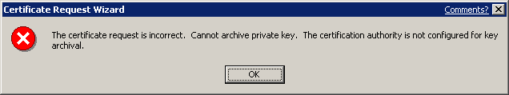

The CA will also log the following error to the application event log of the CA:

Event Type: Error
Event Source: CertSvc
Event Category: None
Event ID: 21
Date: 1/12/2001
Time: 4:23:39 PM
User: N/A
Computer: SERVER1
Description:
Certificate Services could not process request 16094 due to an error: Cannot archive private key. No valid key recovery agent is defined for this certification authority. 0x8009400b (-2146877429). The request was for NWTRADERS\User1.

If the CA is unable to retrieve a current CRL for the CA itself or any of its parent CA(s), it will be unable to issue a certificate when a user submits a request. If the CA does not have a valid CRL for itself, the following error message will be displayed in the application event log of the CA:

Event Type: Warning
Event Source: CertSvc
Event Category: None
Event ID: 53
Date: 1/6/2001
Time: 11:24:05 AM
User: N/A
Computer: SERVER1
Description:
Certificate Services denied request 1471 because the revocation function was unable to check revocation because the revocation server was offline. 0x80092013 (-2146885613). The request was for CN=user1, OU="Test", O="NWTraders", L=Redmond, S=WA, C=US, E=user1@nwtraders.com. Additional information: Denied by Policy Module

Certificate Template Not Supported by the CA

If a user tries to enroll with a CA for a template that is not supported by that CA, the following event log message will be entered in the CA application event log:

Event Type: Warning
Event Source: CertSvc
Event Category: None
Event ID: 53
Date: 1/16/2001
Time: 2:07:02 PM
User: N/A
Computer: SERVER1
Description:
Certificate Services denied request 8 because the requested certificate template is not supported by this CA. 0x80094800 (-2146875392). The request was for NWTRADERS\Administrator. Additional information: Denied by Policy Module The request was for certificate template (1.3.6.1.4.1.311.21.8.4144336743.1329436349.2065260953.3989445610.1.27) that is not supported by the Certificate Services policy.

Client CSP Does Not Permit Key Export
For the client enrollment process to generate and send a private key to the CA, the key must be marked as exportable when the key is generated. If the certificate template is not set to allow key exportable or if the third-party CSP (if applicable) does not support exportable keys, enrollment will fail and the enrollment wizard will return an error that the key is not exportable. Third-party CSPs may report varying errors, such as “catastrophic failure”, when this occurs. If a Windows 2000 or Windows ME client performs enrollment with key archival, the following error may appear if the key is not marked for export:

0x80090009 - NTE_BAD_FLAGS

Note If the CSP supports the one-time flag for key archival, known as (CRYPT_ARCHIVABLE), the key export flag is not required. The Microsoft default software CSPs support this flag. However, Windows 2000 and Windows ME clients do not support this flag and must allow the key to be exported for enrollment to work with key archival.

Certificate Authority CSP Not Supported for Key Archival Functions
If a software or hardware CSP is not capable of performing the symmetric and public operations for encrypting the private key(s) of users in the CA database, the CA will log an event in the application event log:

Event Type: Warning
Event Source: CertSvc
Event Category: None
Event ID: 86
Date: 12/27/2001
Time: 8:13:54 AM
User: N/A
Computer: NORTHWIND5
Description:
Certificate Services could not use the provider specified in the registry for encryption keys. The keyset is not defined. 0x80090019 (-2146893799)

For more information, see the Help and Support Center at http://go.microsoft.com/fwlink/events.asp

Event Type: Warning
Event Source: CertSvc
Event Category: None
Event ID: 88
Date: 12/27/2001
Time: 8:13:54 AM
User: N/A
Computer: NORTHWIND5
Description:
Certificate Services switched to the default provider for encryption keys.

For more information, see the Help and Support Center at http://go.microsoft.com/fwlink/events.asp

To verify which CSP the CA is using for encryption operations associated with key archival, run the following command from the CA:

Certutil –getreg ca\EncryptionCSP\Provider

Certificate and Key Import Issues
If the CA has not been configured for key archival or if the CA has not been configured for foreign key import, the following error will occur when attempting to import a KMS export file or a foreign key import. Note that the keys were not archived in the following message.

Processing KMS exports from:
O=microsoft, C=US

KMS export file signature verifies
Lock box opened, symmetric key successfully decrypted
CertUtil: Invalid Signature.
CertUtil: Invalid Signature.
CertUtil: Invalid Signature.
CertUtil: Invalid Signature.
CertUtil: Invalid Signature.
CertUtil: Invalid Signature.
CertUtil: Invalid Signature.
CertUtil: Invalid Signature.
CertUtil: Invalid Signature.
CertUtil: Invalid Signature.
CertUtil: Invalid Signature.
CertUtil: Invalid Signature.
CertUtil: Invalid Signature.
CertUtil: Invalid Signature.
CertUtil: Invalid Signature.
CertUtil: Invalid Signature.
CertUtil: Invalid Signature.

Users: 6

Ignored signature certificates: 25
Certificates with keys: 17
Certificates not imported: 17

Keys: 17
Keys not archived: 17
CertUtil: -ImportKMS command completed successfully.

Troubleshooting Key Recovery Issues

Unable to Recover User
If a Certificate Authority performing key archival is also enabled for role separation with specific Certificate Manager restrictions, a Certificate Manager may not be able to recover a user certificate until the machine account of the CA has been added to the Pre W2K Compatible Access Group of the domain in which the recover user belongs. This is a necessary requirement for the CA to enumerate the group memberships of Certificate Managers and recovered users to ensure proper restrictions are enforced.

Missing KRA Certificate
If one of the recipient KRA certificates from the HKEY_LOCAL_MACHINE KRA certificate store on the Certification Authority is deleted, key recovery tools such as “certutil –getkey” will fail because the server cannot find the KRA certificate to include in the recovery blob. The following error message will be displayed when this error occurs:

certutil -getkey "1b 4a b7 1e 00 00 00 00 00 1d"
Querying server1.nwtraders.com\CA1............

"server1.nwtraders.com\CA1"
1b4ab71e00000000001d CN="Users
Administrator"
CertUtil: -GetKey command FAILED: 0x80092004 (-2146885628)
CertUtil: Cannot find object or property

Note that the KRA certificate must be available in the registry on the CA, not the machine where the recovery tool(s) are used.

Appendix A: Certificate Request Structure
This appendix provides additional detailed information on the key archival process regarding the certificate request structure.

ASN.1 Structure
A certificate request for key archival to the CA is a CMC Full PKIRequest message. The ASN.1 structure of the new PKIData object is shown below.

PKIData ::= SEQUENCE {
controlSequence SEQUENCE SIZE(0..MAX) OF TaggedAttribute,
reqSequence SEQUENCE SIZE(0..MAX) OF TaggedRequest,
cmsSequence SEQUENCE SIZE(0..MAX) OF TaggedContentInfo,
otherMsgSequence SEQUENCE SIZE(0..MAX) OF OtherMsg
}

The otherMsgSequence body of the PKIData object will be used to carry a hash of the encrypted private key and an identifier reference to the corresponding request carried in the reqSequence field of the PKIData object. The ASN.1 structure of the OtherMsg object is shown below.

OtherMsg ::= SEQUENCE {
bodyPartID BodyPartId,
otherMsgType OBJECT IDENTIFIER,
otherMsgValue ANY DEFINED BY otherMsgType
}

Binary Export

The following is an export of a binary request from the Certificate Authority database. The request included the flag to archive the private key. A binary export can be easily achieved through the Certificate Authority MMC snap-in. To dump a certificate request from the database, first open the CA MMC snap-in. Select the Issued Certificates folder.

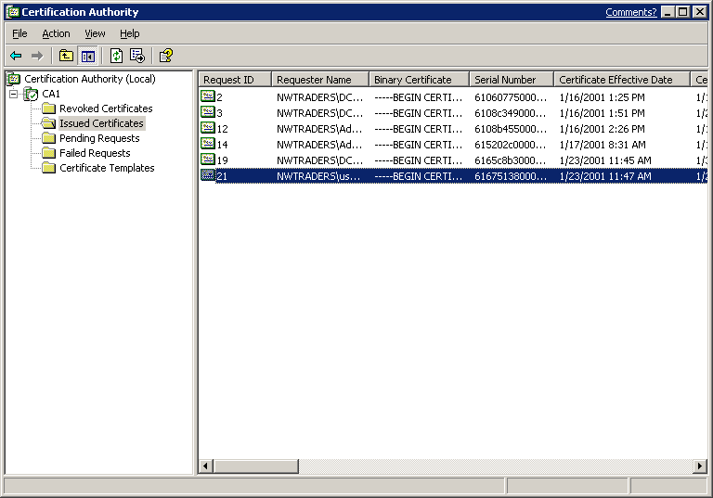

If the binary request column has not been previously added to the database view, it must be added to support a binary request export. To add a column to the view, click View on the menu bar.

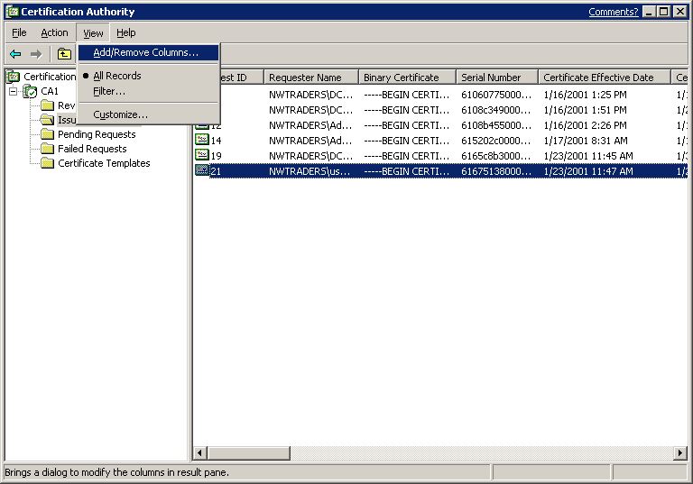

Select Add/Remove Columns.
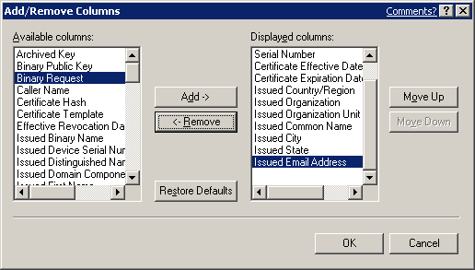

In the Available columns list, select Binary Request, and then click Add. When complete, click OK.

Next, a binary request can be exported. Select a request in the database view and right-click.

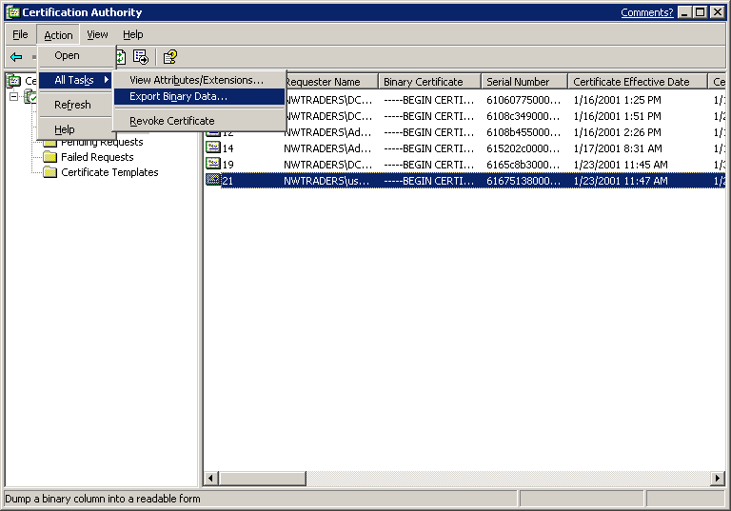

Choose All Tasks, and then Export Binary Data.

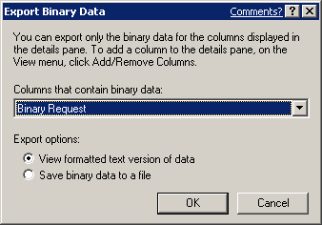

Choose the Binary Request as the column that you want to export. The data will be exported into ASCII format that can be opened with notepad.exe. An example binary request dump of a certificate archival request is shown below.

PKCS7/CMS Message:
CMSG_SIGNED(2)
CMSG_SIGNED_DATA_CMS_VERSION(3)
Content Type: 1.3.6.1.5.5.7.12.2 CMC Data

PKCS7 Message Content:
================ Begin Nesting Level 1 ================
CMS Certificate Request:
Tagged Attributes: 2

Body Part Id: 2
1.3.6.1.5.5.7.7.8 CMC Extensions
Value[0]:
Data Reference: 0
Cert Reference[0]: 1
Extensions: 1
1.3.6.1.4.1.311.21.7: Flags = 0, Length = 31
Certificate Template Information
Template=EFS2(1.3.6.1.4.1.311.21.8.3180530631.1153367023.1878931343.2188495428.1724802048.4174074585)
Major Version Number=100
Minor Version Number=7

Body Part Id: 3
1.3.6.1.4.1.311.10.10.1 CMC Attributes
Value[0]:
Data Reference: 0
Cert Reference[0]: 1
1 attributes:

Attribute[0]: 1.3.6.1.4.1.311.21.21
Value[0][0]:
Unknown Attribute type
Encrypted Key Hash:
7f d6 ee 4d 74 b9 b0 4c 50 f2 52 4f a6 5b e2 39 b9 92 54 c4

Tagged Requests: 1
CMC_TAGGED_CERT_REQUEST_CHOICE:
Body Part Id: 1
================ Begin Nesting Level 2 ================
Element 0:
PKCS10 Certificate Request:
Version: 1
Subject:
EMPTY

Public Key Algorithm:
Algorithm ObjectId: 1.2.840.113549.1.1.1 RSA
Algorithm Parameters:
05 00
Public Key Length: 1024 bits
Public Key: UnusedBits = 0
0000 30 81 89 02 81 81 00 b1 17 7d 08 4c e2 de d5 5c
0010 34 a9 d6 f5 27 cd d4 af 20 a7 2e bc 00 64 e1 38
0020 aa e9 78 a2 71 e3 7c 0c c1 05 5f e1 fe 2f 0c 19
0030 5d 5c bf 5e 8f a9 ba 67 92 01 8f 47 13 62 af 00
0040 a5 f1 e1 bb c4 74 5b ee 2c 27 6c 32 ee 0d 42 78
0050 97 10 60 b0 7e 6d 95 6d fb 66 64 cb 35 67 07 5f
0060 1b 1e ac db 1c ff 31 5e 0e 68 4e bd e0 c7 32 a8
0070 2a 41 b0 6f b6 a3 fe f3 aa 3c 65 3b c1 28 2c c1
0080 4c 19 27 4a 3c b6 33 02 03 01 00 01
Request Attributes: 4
4 attributes:

Attribute[0]: 1.3.6.1.4.1.311.13.2.3 (OS Version)
Value[0][0]:
5.1.3598.2

Attribute[1]: 1.3.6.1.4.1.311.21.20 (Client Information)
Value[1][0]:
Unknown Attribute type
Client Id: = 1
XECI_XENROLL -- 1
User: NWTRADERS\ea
Machine: northwind5.nwtraders.nttest.microsoft.com
Process: iexplore.exe

Attribute[2]: 1.2.840.113549.1.9.14 (Certificate Extensions)
Value[2][0]:
Unknown Attribute type
Certificate Extensions: 4
2.5.29.15: Flags = 1(Critical), Length = 4
Key Usage
Key Encipherment, Data Encipherment (30)

1.2.840.113549.1.9.15: Flags = 0, Length = 37
SMIME Capabilities
[1]SMIME Capability
Object ID=1.2.840.113549.3.2
Parameters=02 02 00 80
[2]SMIME Capability
Object ID=1.2.840.113549.3.4
Parameters=02 02 00 80
[3]SMIME Capability
Object ID=1.3.14.3.2.7
[4]SMIME Capability
Object ID=1.2.840.113549.3.7

2.5.29.14: Flags = 0, Length = 16
Subject Key Identifier
b7 1a b5 92 7e e9 c7 9f be b5 2c 40 5e 6e e1 f5 c0 40 86 9c

1.3.6.1.4.1.311.21.7: Flags = 0, Length = 31
Certificate Template Information
Template=EFS2(1.3.6.1.4.1.311.21.8.3180530631.1153367023.1878931343.2188495428.1724802048.4174074585)
Major Version Number=100
Minor Version Number=7

Attribute[3]: 1.3.6.1.4.1.311.13.2.2 (Enrollment CSP)
Value[3][0]:
Unknown Attribute type
CSP Provider Info
KeySpec = 1
Provider = Microsoft Enhanced Cryptographic Provider v1.0
Signature: UnusedBits=0
0000 00 00 00 00 00 00 00 00 00 00 00 00 00 00 00 00
Remaining 78 bytes are zero
Signature Algorithm:
Algorithm ObjectId: 1.2.840.113549.1.1.5 sha1RSA
Algorithm Parameters:
05 00
Signature: UnusedBits=0
0000 63 1e 75 4a a0 88 ea 84 e6 16 90 2a 1f c4 14 c5
0010 df e9 00 c3 34 68 3a ae d0 8a f9 0f d9 a7 9c 1b
0020 16 a7 07 93 09 4f 46 3f 5a 23 80 b2 e4 6d cb 7a
0030 ef 37 c1 5e ff 7b c3 3e 26 8e 88 fd 1e 5d f1 bc
0040 06 2a aa 1c 56 d0 ae fe f6 73 c1 cf 66 c0 41 1a
0050 e8 82 9c 5d a4 b6 1f 6f f9 cf 7c 83 de a6 3c 09
0060 f9 da e5 5d a1 29 7d b1 7a 39 bc 09 f0 32 26 6c
0070 4d 57 3c 1b e0 1a 94 b9 65 40 19 72 74 3f c3 93
Signature matches Public Key
Key Id Hash(sha1): b7 1a b5 92 7e e9 c7 9f be b5 2c 40 5e 6e e1 f5 c0 40 86 9c
---------------- End Nesting Level 2 ----------------

Tagged Content Info: 0
Tagged Other Messages: 0
---------------- End Nesting Level 1 ----------------

Signer Count: 1

Signer Info[0]:
Signature matches request Public Key
CMSG_SIGNER_INFO_CMS_VERSION(3)
CERT_ID_KEY_IDENTIFIER(2)
0000 b7 1a b5 92 7e e9 c7 9f be b5 2c 40 5e 6e e1 f5
0010 c0 40 86 9c
Hash Algorithm:
Algorithm ObjectId: 1.3.14.3.2.26 sha1
Algorithm Parameters: NULL
Encrypted Hash Algorithm:
Algorithm ObjectId: 1.2.840.113549.1.1.1 RSA
Algorithm Parameters: NULL
Encrypted Hash:
0000 ac 40 5a fe e4 97 76 f0 25 f8 69 4f 24 d3 14 de
0010 9f 2d 7e 7e ff 73 ef 82 f0 a2 44 47 bf 08 cc 64
0020 18 25 8d 82 6f a3 a5 6a 00 56 5c b3 cf 24 f3 40
0030 92 99 d5 22 eb de ec d1 32 0e 03 96 9f 95 3b 36
0040 98 8e c0 13 b8 b7 a3 19 9b 60 96 96 4d 2f 36 e9
0050 9d 61 6d 63 49 1a dc 8b 5d 5a c4 c9 1c 79 13 50
0060 c2 4e ce b6 56 d7 09 7b ad 84 03 00 42 4d a0 2b
0070 be 16 95 45 40 e6 44 cf b5 10 88 ee 78 72 b0 69

Authenticated Attributes[0]:
3 attributes:

Attribute[0]: 1.2.840.113549.1.9.3 (Content Type)
Value[0][0]:
Unknown Attribute type
1.3.6.1.5.5.7.12.2 CMC Data

Attribute[1]: 1.2.840.113549.1.9.4 (Message Digest)
Value[1][0]:
Unknown Attribute type
Message Digest:
fd 0b b2 44 27 14 40 44 cc 07 13 e1 65 87 07 6c 57 a6 2a 97

Attribute[2]: 1.3.6.1.4.1.311.21.20 (Client Information)
Value[2][0]:
Unknown Attribute type
Client Id: = 1
XECI_XENROLL -- 1
User: NWTRADERS\ea
Machine: northwind5.nwtraders.nttest.microsoft.com
Process: iexplore.exe

Unauthenticated Attributes[0]:
0 attributes:

Computed Hash: b0 0d 2b ee 07 d4 5e 2f 23 11 33 83 40 bc 6e 98 72 1a d4 43
No Recipient

No Certificates
No CRLs

For non-Windows Server 2003 clients or servers enrolling to a Windows Server 2003 CA, the format of the request may be different because non-Windows Server 2003 platforms may not support CMC data structures and therefore may not be able to encode the request information inside a PKIData object. Instead, the request information may be inside the Data body but not encoded as a PKIData object.

Certificate Request Response
A full CMC request response can be regenerated from a given request ID in the database. This can be accomplished using the certreq.exe tool where nnnn = the request ID in the CA database, xxx.cer = the file name of the output certificate, yyy.p7b = the file name of the output PKCS#7 file, and zzz.txt = the file name of the output text. Example:

certreq -retrieve nnnn xxx.cer yyy.p7b zzz.txt

Sample output:

PKCS7/CMS Message:
CMSG_SIGNED(2)
CMSG_SIGNED_DATA_CMS_VERSION(3)
Content Type: 1.3.6.1.5.5.7.12.3 CMC Response

PKCS7 Message Content:
================ Begin Nesting Level 1 ================
CMS Response:
Tagged Attributes: 2

Body Part Id: 1
1.3.6.1.5.5.7.7.1 CMC Status Info
Value[0]:
CMC Status Info: CMC_STATUS_SUCCESS(0)
Body Part Id Reference[0]: 1
Status String: Issued
Other Info Choice: CMC_OTHER_INFO_NO_CHOICE(0)

Body Part Id: 2
1.3.6.1.4.1.311.10.10.1 CMC Attributes
Value[0]:
Data Reference: 0
Cert Reference[0]: 1
2 attributes:

Attribute[0]: 1.3.6.1.4.1.311.21.17
Value[0][0]:
Unknown Attribute type
Issued Cert Hash:
15 90 20 2a 10 1c 3b 68 2d 8f 8d 8e 61 07 fb 97 49 4c 01 d7

Attribute[1]: 1.3.6.1.4.1.311.21.21
Value[1][0]:
Unknown Attribute type
Encrypted Key Hash:
7f d6 ee 4d 74 b9 b0 4c 50 f2 52 4f a6 5b e2 39 b9 92 54 c4

Tagged Content Info: 0
Tagged Other Messages: 0
---------------- End Nesting Level 1 ----------------

Signer Count: 1
Signing Certificate Index: 1
-------- CERT_CHAIN_CONTEXT --------
ChainContext.dwInfoStatus = CERT_TRUST_HAS_PREFERRED_ISSUER (0x100)
CertContext.dwRevocationFreshnessTime: 16 Hours, 32 Minutes, 19 Seconds

SimpleChain.dwInfoStatus = CERT_TRUST_HAS_PREFERRED_ISSUER (0x100)
SimpleChain.dwRevocationFreshnessTime: 16 Hours, 32 Minutes, 19 Seconds

CertContext[0][0]: dwInfoStatus=10c dwErrorStatus=0
Issuer: CN=ChrysalisTestCA, DC=nwtraders, DC=nttest, DC=microsoft, DC=com
Subject: CN=ChrysalisTestCA, DC=nwtraders, DC=nttest, DC=microsoft, DC=com
Serial: 55eaac7af0ec319745ecb2ae38aba3f0
Template: CA
9b ee 62 47 fd 37 3f dd ad 4d 31 a5 f8 1c 53 0a 7b db f6 d4
Element.dwInfoStatus = CERT_TRUST_HAS_NAME_MATCH_ISSUER (0x4)
Element.dwInfoStatus = CERT_TRUST_IS_SELF_SIGNED (0x8)
Element.dwInfoStatus = CERT_TRUST_HAS_PREFERRED_ISSUER (0x100)
CRL 18:
Issuer: CN=ChrysalisTestCA, DC=nwtraders, DC=nttest, DC=microsoft, DC=com
87 f2 84 1b f5 26 b2 3d e1 2f 20 af f9 70 9b 1c a4 38 f0 a1
Delta CRL 23:
Issuer: CN=ChrysalisTestCA, DC=nwtraders, DC=nttest, DC=microsoft, DC=com
53 45 91 b2 e6 af c1 5d 01 71 52 69 4c e7 41 86 4a dd aa 28

Exclude leaf cert:
b0 1a 5b fe f7 7d 1b b3 81 3d cc 46 99 9f 6e 11 6d 6d ce 2d
Full chain:
51 f8 56 4e 19 5a ee 55 3b 83 ce af 3b 44 ed da f7 24 17 05
------------------------------------
Verified Issuance Policies: All
Verified Application Policies: All

Signer Info[0]:
Signature matches Public Key
CMSG_SIGNER_INFO_PKCS_1_5_VERSION(1)
CERT_ID_ISSUER_SERIAL_NUMBER(1)
Serial Number: 55eaac7af0ec319745ecb2ae38aba3f0
Issuer: CN=ChrysalisTestCA, DC=nwtraders, DC=nttest, DC=microsoft, DC=com
Subject: CN=ChrysalisTestCA, DC=nwtraders, DC=nttest, DC=microsoft, DC=com
Hash Algorithm:
Algorithm ObjectId: 1.3.14.3.2.26 sha1
Algorithm Parameters: NULL
Encrypted Hash Algorithm:
Algorithm ObjectId: 1.2.840.113549.1.1.1 RSA
Algorithm Parameters: NULL
Encrypted Hash:
0000 4d 77 74 e9 af 1e a6 d6 89 32 6d 3b 19 79 17 79
0010 a4 aa e8 0b c8 9b 5c 74 82 3d 2b f4 23 75 2d 91
0020 5b 0f a3 53 44 ce cf a3 58 28 2e 08 96 bb fd 6d
0030 c2 4c ad 12 18 f0 04 b3 8f 50 1a 9b 85 ff eb 99
0040 2d 75 61 fd fd 90 6c ca 20 13 df 1f ea 8c dd f8
0050 8d 1f 6b 40 7c c9 42 5e 8b cf 69 09 48 f3 3f 40
0060 07 1c 44 2a 07 3a 20 dc a8 57 db b3 d0 d2 02 e0
0070 a9 22 72 8e 1e ca b8 27 b9 19 fb a2 74 f0 4b ae
0080 a9 6e b3 c7 c1 78 aa 37 00 26 69 6e 96 74 35 0c
0090 0e 51 d0 98 e2 e7 49 39 c6 96 72 e7 6c e8 6b 87
00a0 40 eb a1 11 81 ff 34 72 39 7d 4f e1 13 86 62 99
00b0 b9 a3 12 c6 4e ed 42 7a 2d e1 11 93 6c b7 99 fb
00c0 25 9b 9c 03 59 56 79 21 bf 3f 57 90 6d 0c 77 3f
00d0 32 c8 2c 6d ec 80 f0 6f ed f9 96 7e 8a 2f 90 61
00e0 74 b1 42 09 88 7e 8d d2 d1 bf 3a 28 50 60 ec 43
00f0 18 d1 90 65 58 c3 53 c1 36 85 2e 84 fd e1 0c 01

Authenticated Attributes[0]:
2 attributes:

Attribute[0]: 1.2.840.113549.1.9.3 (Content Type)
Value[0][0]:
Unknown Attribute type
1.3.6.1.5.5.7.12.3 CMC Response

Attribute[1]: 1.2.840.113549.1.9.4 (Message Digest)
Value[1][0]:
Unknown Attribute type
Message Digest:
0b dd 03 a9 33 21 be 9c fb 64 7a 56 14 36 eb bb cb 00 28 6c

Unauthenticated Attributes[0]:
0 attributes:

Computed Hash: 8b f0 df 78 57 19 d2 30 9b 32 ac aa 69 cf 39 60 f1 1e bc 23
No Recipient

Certificates:
================ Begin Nesting Level 1 ================
Element 0:
X509 Certificate:
Version: 3
Serial Number: 6165931c000100000019
Signature Algorithm:
Algorithm ObjectId: 1.2.840.113549.1.1.5 sha1RSA
Algorithm Parameters:
05 00
Issuer:
CN=ChrysalisTestCA
DC=nwtraders
DC=nttest
DC=microsoft
DC=com

NotBefore: 12/21/2001 11:26 AM
NotAfter: 12/21/2002 11:26 AM

Subject:
E=ea@nwtraders.com
CN=ea
CN=Users
DC=nwtraders
DC=nttest
DC=microsoft
DC=com

Public Key Algorithm:
Algorithm ObjectId: 1.2.840.113549.1.1.1 RSA
Algorithm Parameters:
05 00
Public Key Length: 1024 bits
Public Key: UnusedBits = 0
0000 30 81 89 02 81 81 00 b1 17 7d 08 4c e2 de d5 5c
0010 34 a9 d6 f5 27 cd d4 af 20 a7 2e bc 00 64 e1 38
0020 aa e9 78 a2 71 e3 7c 0c c1 05 5f e1 fe 2f 0c 19
0030 5d 5c bf 5e 8f a9 ba 67 92 01 8f 47 13 62 af 00
0040 a5 f1 e1 bb c4 74 5b ee 2c 27 6c 32 ee 0d 42 78
0050 97 10 60 b0 7e 6d 95 6d fb 66 64 cb 35 67 07 5f
0060 1b 1e ac db 1c ff 31 5e 0e 68 4e bd e0 c7 32 a8
0070 2a 41 b0 6f b6 a3 fe f3 aa 3c 65 3b c1 28 2c c1
0080 4c 19 27 4a 3c b6 33 02 03 01 00 01
Certificate Extensions: 10
2.5.29.15: Flags = 0, Length = 4
Key Usage
Key Encipherment (20)

1.2.840.113549.1.9.15: Flags = 0, Length = 37
SMIME Capabilities
[1]SMIME Capability
Object ID=1.2.840.113549.3.2
Parameters=02 02 00 80
[2]SMIME Capability
Object ID=1.2.840.113549.3.4
Parameters=02 02 00 80
[3]SMIME Capability
Object ID=1.3.14.3.2.7
[4]SMIME Capability
Object ID=1.2.840.113549.3.7

2.5.29.14: Flags = 0, Length = 16
Subject Key Identifier
b7 1a b5 92 7e e9 c7 9f be b5 2c 40 5e 6e e1 f5 c0 40 86 9c

1.3.6.1.4.1.311.21.7: Flags = 0, Length = 31
Certificate Template Information
Template=EFS2(1.3.6.1.4.1.311.21.8.3180530631.1153367023.1878931343.2188495428.1724802048.4174074585)
Major Version Number=100
Minor Version Number=7

2.5.29.35: Flags = 0, Length = 18
Authority Key Identifier
KeyID=d4 10 c7 4d fa e1 45 44 32 8a c9 8c 21 78 16 c1 12 25 5c 91

2.5.29.31: Flags = 0, Length = 13c
CRL Distribution Points
[1]CRL Distribution Point
Distribution Point Name:
Full Name:
URL=ldap:///CN=ChrysalisTestCA,CN=northwind5,CN=CDP,CN=Public%20Key%20Services,CN=Services,CN=Configuration,DC=nwtraders,DC=nttest,DC=microsoft,DC=com?certificateRevocationList?base?objectClass=cRLDistributionPoint
URL=http://northwind5.nwtraders.nttest.microsoft.com/CertEnroll/ChrysalisTestCA.crl

1.3.6.1.5.5.7.1.1: Flags = 0, Length = 163
Authority Information Access
[1]Authority Info Access
Access Method=Certification Authority Issuer (1.3.6.1.5.5.7.48.2)
Alternative Name:
URL=ldap:///CN=ChrysalisTestCA,CN=AIA,CN=Public%20Key%20Services,CN=Services,CN=Configuration,DC=nwtraders,DC=nttest,DC=microsoft,DC=com?cACertificate?base?objectClass=certificationAuthority
[2]Authority Info Access
Access Method=Certification Authority Issuer (1.3.6.1.5.5.7.48.2)
Alternative Name:
URL=http://northwind5.nwtraders.nttest.microsoft.com/CertEnroll/northwind5.nwtraders.nttest.microsoft.com_ChrysalisTestCA(1).crt

2.5.29.37: Flags = 0, Length = 2e
Enhanced Key Usage
Client Authentication (1.3.6.1.5.5.7.3.2)
Encrypting File System (1.3.6.1.4.1.311.10.3.4)
Secure Email (1.3.6.1.5.5.7.3.4)
Smart Card Logon (1.3.6.1.4.1.311.20.2.2)

1.3.6.1.4.1.311.21.10: Flags = 0, Length = 36
Application Policies
[1]Application Certificate Policy:
Policy Identifier=Client Authentication
[2]Application Certificate Policy:
Policy Identifier=Encrypting File System
[3]Application Certificate Policy:
Policy Identifier=Secure Email
[4]Application Certificate Policy:
Policy Identifier=Smart Card Logon

2.5.29.17: Flags = 0, Length = 4d
Subject Alternative Name
Other Name:
Principal Name=ea@nwtraders.nttest.microsoft.com
RFC822 Name=ea@nwtraders.com

Signature Algorithm:
Algorithm ObjectId: 1.2.840.113549.1.1.5 sha1RSA
Algorithm Parameters:
05 00
Signature: UnusedBits=0
0000 d9 4e 12 70 e5 52 6a 7d ce b3 89 d9 59 de b2 53
0010 33 32 ca 65 04 91 27 8b c2 ba bc cd 11 8e 35 a2
0020 ce 1c 80 42 0b 64 3b 4d a2 18 a9 70 6a d8 8c f0
0030 02 f6 45 e5 fa d4 cf 14 9e 0e 7a e8 2a 27 89 b2
0040 8d e6 dd c6 b5 2d ec 6e c3 b1 b2 59 42 8a 68 09
0050 b4 ae 69 20 96 aa ec 45 ea 4a 71 53 de 57 0a c2
0060 06 03 0b 76 1a c5 5a ec 96 4e de 79 32 76 bf 88
0070 6a 63 02 ae ad 35 8c 4c de 39 72 6e 9b 2f 71 d2
0080 72 e4 36 41 7d ab 85 6b 9e 4b fe 3b 41 ec c4 5d
0090 fa 4e ec d8 87 d6 0c b3 6b 3b ef 1e 10 92 4b 85
00a0 e3 2d 3a 63 23 2a 94 ea e9 b8 39 8c 66 4c 06 b4
00b0 08 3f c4 b3 98 40 59 90 87 19 cb 5f 01 cf a6 6b
00c0 f3 70 d9 8b dc fb 80 ae 09 3b 8a f0 20 2e 67 f4
00d0 43 50 03 41 ff 22 76 de 80 07 e1 fe ae 0b 7a 5c
00e0 b2 6f bc 7e a3 23 18 cc 90 e0 25 bf 22 83 0d 4c
00f0 a0 aa 08 22 af 31 2a 1d c3 7e 0f 9e d4 1a 3f bc
Non-root Certificate
Key Id Hash(sha1): b7 1a b5 92 7e e9 c7 9f be b5 2c 40 5e 6e e1 f5 c0 40 86 9c
Cert Hash(md5): bb 9d 76 1e d3 11 de 73 0f 26 f0 7e 9d 0c a5 82
Cert Hash(sha1): 15 90 20 2a 10 1c 3b 68 2d 8f 8d 8e 61 07 fb 97 49 4c 01 d7
---------------- End Nesting Level 1 ----------------
================ Begin Nesting Level 1 ================
Element 1:
X509 Certificate:
Version: 3
Serial Number: 55eaac7af0ec319745ecb2ae38aba3f0
Signature Algorithm:
Algorithm ObjectId: 1.2.840.113549.1.1.5 sha1RSA
Algorithm Parameters:
05 00
Issuer:
CN=ChrysalisTestCA
DC=nwtraders
DC=nttest
DC=microsoft
DC=com

NotBefore: 11/20/2001 3:39 PM
NotAfter: 12/21/2006 8:57 AM

Subject:
CN=ChrysalisTestCA
DC=nwtraders
DC=nttest
DC=microsoft
DC=com

Public Key Algorithm:
Algorithm ObjectId: 1.2.840.113549.1.1.1 RSA
Algorithm Parameters:
05 00
Public Key Length: 2048 bits
Public Key: UnusedBits = 0
0000 30 82 01 08 02 82 01 01 00 bd 3c 84 b7 14 90 94
0010 fc 37 b7 d5 32 c5 2b fd 2e 03 ad 5f c3 d2 36 08
0020 22 92 7a dc 99 53 47 a2 9e ba 0b 81 0a 0a e1 ad
0030 46 3b 47 ca 58 93 11 d3 25 84 7c 11 1e 8c b9 6f
0040 32 f0 f1 7d db d3 e5 1e c3 b9 15 e1 02 4b 1b 3e
0050 48 75 cd b0 3b 32 47 27 8b a9 14 75 e7 35 00 08
0060 b5 95 81 4a 79 a3 e6 fd d9 f9 c4 89 1c 26 b4 9d
0070 20 d2 8d 2f f3 94 22 f3 ed de b8 8d af 81 95 f6
0080 f8 34 dd c5 fd 2c f5 36 df f8 94 45 0b 75 80 d1
0090 fe 19 80 61 30 dc 5b b7 c0 9e 30 a8 17 36 3c 3f
00a0 70 3d cf d3 f6 2a 9c a3 8e be 28 27 87 7f 17 e4
00b0 e6 78 f6 ab 35 a2 8e 39 9e 1c 92 40 18 01 c2 fa
00c0 ee 5f b1 2d 16 4d 10 ea 87 e7 4b e4 a7 76 38 a1
00d0 4c d8 61 bf 44 d3 c9 f6 28 14 1f 48 ec 6f 41 e7
00e0 2b 05 90 f5 77 fb 9b dc ce b7 b2 92 96 2b 6e fc
00f0 c1 cc 3c 22 60 80 e6 7c 9b da 0f 9b 7a 80 41 e7
0100 d1 55 5e 8f 1f c6 bd 60 17 02 01 03
Certificate Extensions: 7
1.3.6.1.4.1.311.20.2: Flags = 0, Length = 6
Certificate Template Name
CA

2.5.29.15: Flags = 0, Length = 4
Key Usage
Digital Signature, Certificate Signing, Off-line CRL Signing, CRL Signing (86)

2.5.29.19: Flags = 1(Critical), Length = 5
Basic Constraints
Subject Type=CA
Path Length Constraint=None

2.5.29.14: Flags = 0, Length = 16
Subject Key Identifier
d4 10 c7 4d fa e1 45 44 32 8a c9 8c 21 78 16 c1 12 25 5c 91

2.5.29.31: Flags = 0, Length = 13c
CRL Distribution Points
[1]CRL Distribution Point
Distribution Point Name:
Full Name:
URL=ldap:///CN=ChrysalisTestCA,CN=northwind5,CN=CDP,CN=Public%20Key%20Services,CN=Services,CN=Configuration,DC=nwtraders,DC=nttest,DC=microsoft,DC=com?certificateRevocationList?base?objectClass=cRLDistributionPoint
URL=http://northwind5.nwtraders.nttest.microsoft.com/CertEnroll/ChrysalisTestCA.crl

1.3.6.1.4.1.311.21.1: Flags = 0, Length = 3
CA Version
V1.0

1.3.6.1.4.1.311.21.2: Flags = 0, Length = 16
Previous CA Certificate Hash
eb 83 b7 35 a2 4d b1 c3 1b 95 59 a7 7d 51 ce 55 ff a7 67 5d

Signature Algorithm:
Algorithm ObjectId: 1.2.840.113549.1.1.5 sha1RSA
Algorithm Parameters:
05 00
Signature: UnusedBits=0
0000 a1 b7 e3 77 84 14 0e 07 76 19 5f cb 86 89 ec 80
0010 87 75 f6 23 21 dd 6d 45 dd b2 57 93 45 da 3d f9
0020 b9 97 7e 94 3d 63 93 36 69 92 08 65 9f c1 77 53
0030 4b c3 a0 80 4e 5d d9 47 fd 14 39 36 b3 77 56 6e
0040 30 47 86 4a 5c 27 ed 48 e9 3e 4d 53 a6 38 17 02
0050 e0 e5 72 48 a9 fd 29 43 88 20 2e 78 f5 0e 63 00
0060 d0 7f 53 d1 ee 24 df 0b 76 48 a1 e3 06 18 8a 73
0070 66 c1 71 3d 06 ce b7 71 64 0e 5a 85 7a d5 b5 03
0080 31 eb 80 e6 4a a4 c1 35 30 1a 14 e9 46 af 2a 9d
0090 43 ac 5d df f1 32 79 4d c2 9e 7c 35 fd c1 01 bd
00a0 e4 ec bc 51 1d b7 b3 4f 66 28 26 89 57 a5 dc 5b
00b0 21 76 6a 7c ad 6f b2 76 10 33 44 d1 58 74 03 62
00c0 2f 33 21 ff 94 72 84 ae 16 db 44 39 8d 27 71 c5
00d0 a9 b6 e0 d3 43 9c 86 e1 6b 2a 22 0d 5e 90 5a 2b
00e0 08 b6 fa e5 f3 74 fc 61 34 8b 34 7c e5 fa be cb
00f0 d9 d0 cd d2 fa 16 c8 36 a9 ac 22 3a e1 cc f5 36
Signature matches Public Key
Root Certificate: Subject matches Issuer
Key Id Hash(sha1): d4 10 c7 4d fa e1 45 44 32 8a c9 8c 21 78 16 c1 12 25 5c 91
Cert Hash(md5): 53 6f cb 17 d7 dd e9 3d d0 e5 03 5a 5b c4 8e b6
Cert Hash(sha1): 9b ee 62 47 fd 37 3f dd ad 4d 31 a5 f8 1c 53 0a 7b db f6 d4
---------------- End Nesting Level 1 ----------------
No CRLs

Note certreq.exe and other utilities may be installed on a Windows Server 2003 Professional machine by installing the Administrative Tools (adminpak.msi) that are located in the \i386 directory on all Windows Server 2003 CD-ROM media.

Recovery Blob Structure
The encrypted recovery blob (PKCS#7) is enveloped by another PKCS#7 wrapper, signed by the CA certificate, and includes one or more KRA certificates. The PKCS#7 is not protected with a password since it is already protected by the public key of the recovery agent(s). The outer PKCS#7 wrapper can contain the certificate chains for the recovery agent(s) and the end-entity to facilitate the recovery operations and construction of the end-entity PKCS#12 file.

ASN.1 Structure
The ASN.1 structure of the PKCS#7 EnvelopedData object is shown below.

EnvelopedData ::= SEQUENCE {
version Version,
recipientInfos RecipientInfos,
encryptedContentInfo EncryptedContentInfo
}

Storing the recovery blob as an enveloped PKCS#7 enables a recovery agent to retrieve the recovery blob from the CA database. The recovery agent’s private key is used to decrypt the EncryptedContentInfo to extract the PKCS#12 data. The ASN.1 structure of the EncryptedContentInfo body is shown below.

EncryptedContentInfo ::= SEQUENCE {
contentType ContentType,
contentEncryptionAlgorithm ContentEncryptionAlgorithmIdentifier,
encryptedContent[0] IMPLICIT EncryptedContent OPTIONAL
}

By definition, there can be multiple recovery agent certificates specified by RecipientInfo, where IssuerAndSerialNumber is used to disambiguate between multiple recovery agent certificates. Only the recovery agent certificates included in the RecipientInfo body of the enveloped PKCS#7 object can be used to recover the archived key material. The ASN.1 structure of the RecipientInfo body is shown below.

RecipientInfo ::= SEQUENCE {
version Version,
issuerAndSerialNumber IssuerAndSerialNumber,
keyEncryptionAlgorithm KeyEncryptionAlgorithmIdentifier,
encryptedKey EncryptedKey
}

Appendix B: Additional Information

Microsoft Public Key Infrastructure Information and White Papers
http://www.microsoft.com/technet/treeview/default.asp?url=/technet/security/prodtech/pkitech.asp

Certificate Management Messages over CMS (CMC)
http://www.ietf.org/rfc/rfc2797.txt

PKCS #12 - Personal Information Exchange Syntax Standard
http://www.rsasecurity.com/rsalabs/pkcs/pkcs-12/

Windows Server 2003 documentation
http://www.microsoft.com/windowsserver2003/

What’s New in Windows XP and Windows Server 2003 PKI
http://www.microsoft.com/windowsxp/pro/techinfo/planning/pkiwinxp/default.asp

Windows XP auto-enrollment
http://www.microsoft.com/WindowsXP/pro/techinfo/administration/autoenroll/default.asp

Appendix C: Useful Commands

The following commands are available with certutil.exe in the Windows Server 2003 Administration Tools pack in performing key archival and recovery functions:

- certutil –ImportKMS accepts a PFX, EPF, or a KMS export file, and archives the contents in the CA database.

- certutil –ConvertEPF converts a PFX (PKCS #12) file to an EPF formatted file for import into Outlook.
  - certutil –ConvertEPF and –MergePFX are similar in that they both accept a comma-separated list of input files that are merged and placed in the output file. Input files for both commands may be PFX files, EPF files, or a mixture of the two.
  - The –cast parameter should be used to specify the CAST encryption algorithm.
  - The –silent option may be specified to suppress the UI.

- certutil –ImportPFX accepts a PFX or an EPF file and installs the certificates and keys into the HKLM (local machine) MY store. If the –User parameter is specified, the key and certificate will be imported into the HKCU (user profile) MY store. The CSP to be used may also be overridden by specifying the name with the –csp parameter.

Usage:
CertUtil [Options] -importPFX PFXFile
Import certificate and private key
PFXFile -- PFX file to be imported
Defaults to personal machine store.

Options:
-f -- Force overwrite
-user -- Use HKEY_CURRENT_USER keys or certificate store
-gmt -- Display times as GMT
-seconds -- Display times with seconds and milliseconds
-v -- Verbose operation
-p Password -- Password
-csp Provider -- Provider

CertUtil -? -- Display a verb list (command list)
CertUtil -importPFX -? -- Display help text for the "importPFX" verb
CertUtil -v -? -- Display all help text for all verbs

